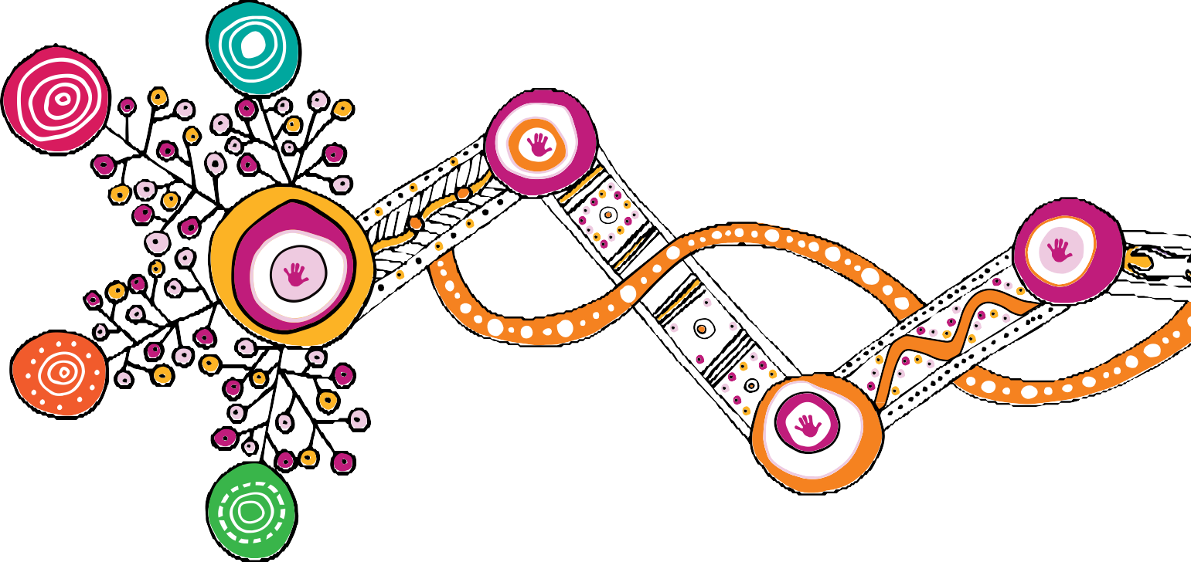

Changing Tracks

An action plan for Aboriginal and Torres Strait Islander
children and families 2020–2022

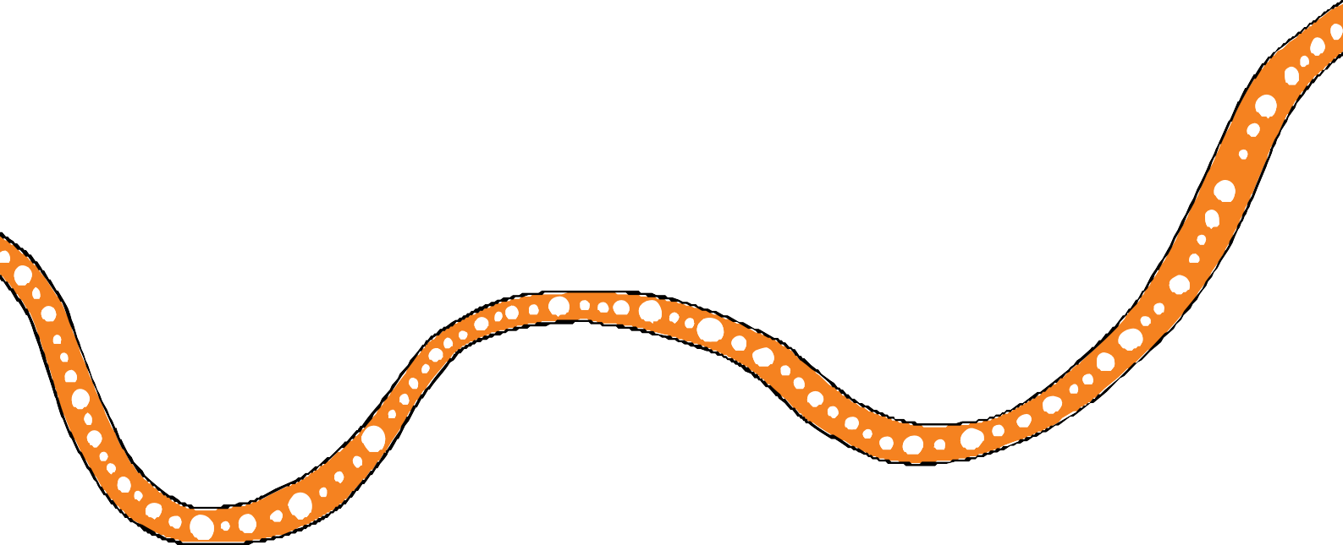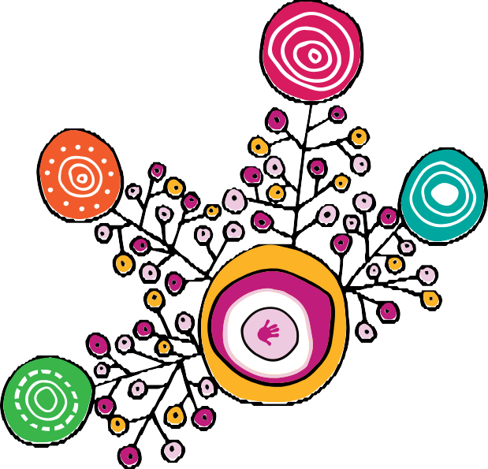

We respectfully acknowledge the First Nations people in the State of Queensland; we acknowledge the cultural and spiritual connection that Aboriginal and Torres Strait Islander peoples have with the land and sea.

We respectfully acknowledge Aboriginal people and Torres Strait Islander people as two unique and diverse peoples with their own rich and distinct cultures.

We pay our respects to Elders past and present as well as the existing and emerging leaders who walk together in partnership on this journey.

This action plan represents our shared commitment. Use of the word ‘we’ throughout refers to the shared voice of the Queensland Government and Family Matters Queensland, and reflects the combined voices of families and communities.

We acknowledge the contributions of Rachael Sarra for the original design of artworks and the creative leadership of Gilimbaa in this action plan.

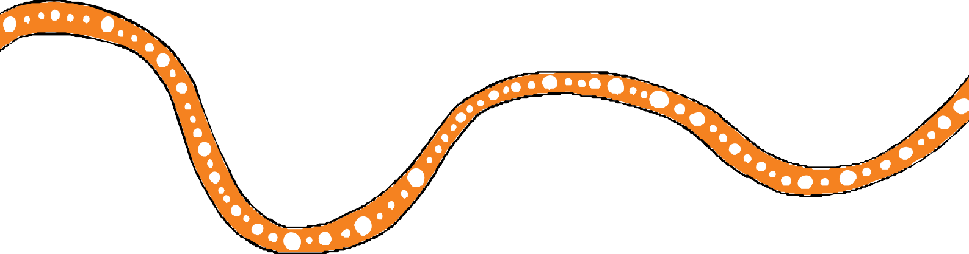Contents

Message from the Queensland Government, Family Matters Queensland and the
Queensland First Children and Families Board 2
Introduction 4
Building block 1: All families enjoy access to quality, culturally safe universal and targeted services necessary for Aboriginal and Torres Strait Islander children to thrive 14
Building block 2: Aboriginal and Torres Strait Islander peoples and organisations participate
in and have control over decisions that affect their children 18
Building block 3: Law, policy and practice in child and family welfare are culturally safe
and responsive 20
Building block 4: Government and community services are accountable to Aboriginal
and Torres Strait Islander peoples 24
Acronyms 26

1

Message from the Queensland Government, Family Matters Queensland and the Queensland First Children and Families Board

The Queensland Government and Family Matters Queensland are committed to working in partnership with communities and key stakeholders to implement Changing Tracks: An action plan for Aboriginal and Torres Strait Islander children and families 2020–2022 (Changing Tracks 2020–2022). This action plan is the second of seven plans to reach our vision under Our Way: A generational strategy for Aboriginal and Torres Strait Islander children and families 2017–2037.
The Changing Tracks action plans (2017–2019 and 2020–2022) focus on the changes needed to deliver the systems and policy settings required to eliminate the disproportionate representation of Aboriginal and Torres Strait Islander children in the child protection system by 2037 and to close the gap in life outcomes for Aboriginal and Torres Strait Islander children and families.
A key priority going forward will be the adoption of strategies to address systemic, social and policy barriers that have contributed to the disproportionate representation of Aboriginal and Torres Strait Islander children in the child protection system.
We are seeing positive changes as a result of Family Matters Queensland’s partnership with the Queensland Government to implement child and family reforms. The Family Matters Report 2019 (the Report) shows Queensland has the lowest rate of over-representation in out of home care nationally. The proportion of Aboriginal and Torres Strait Islander children in care has stabilised, after 14 consecutive years of increases in Aboriginal and Torres Strait Islander over-representation.
The Report also shows an improvement in our journey towards developing a culturally safe and responsive service system, with Queensland having by far the highest proportional investment in Aboriginal and Torres Strait Islander community-controlled services of all the jurisdictions that provided data for the Report.
While these emerging outcomes show promise and are to be celebrated, we cannot take our foot off the pedal. We know there is much more to be done to eliminate the disproportionate representation of Aboriginal and Torres Strait Islander children in the child protection system within a generation.
In Queensland, we reaffi our commitment to the National Family Matters vision and targets, and to working differently with Aboriginal and Torres Strait Islander peoples.
We will leverage the strength and resilience of the Aboriginal and Torres communities and families in Queensland. With guidance from and oversight by the Queensland First Children and Families Board and Family Matters Queensland, Changing Tracks 2020–2022 accelerates our efforts to create the foundations for change. It will establish a new track to ensure all Aboriginal and Torres Strait Islander children and young people in Queensland grow up safe, loved and cared for in family, community and culture. By 2023 we will have established the necessary systemic and structural transformation required to start to break the cycles of inter-generational disadvantage.
Over the course of this action plan we will grow our investment in community-controlled Aboriginal and Torres Strait Islander organisations to better reflect the proportion of Aboriginal and Torres Strait Islander people accessing these services and in recognition of the growing evidence of their
effectiveness in providing quality services and support to Aboriginal and Torres Strait Islander families experiencing vulnerability.

2

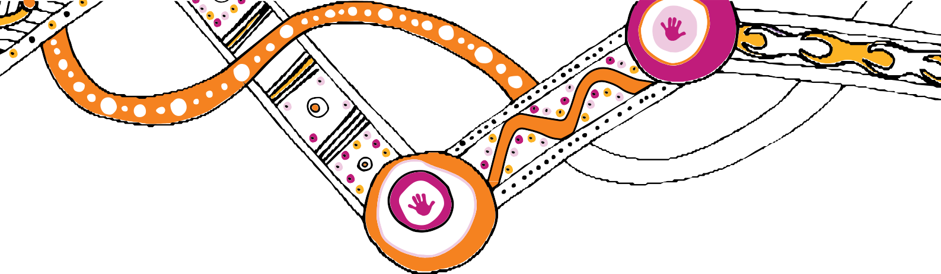Other key actions in Changing Tracks 2020–2022 include:
- implement delegated authority to permit one or more of the chief executive’s statutory functions or powers under the Child Protection Act 1999 in relation to an Aboriginal or Torres Strait Islander child to be delegated to the CEO of an Aboriginal and Torres Strait Islander community entity to make decisions for the child in relation to those matters
- embed family-led decision making across the key decision points of the child protection system
- embed active efforts to apply the Aboriginal and Torres Strait Islander Child Placement Principle across the child protection system
- apply the Wellbeing Outcomes Framework for Aboriginal and Torres Strait Islander children and young people in Queensland (Wellbeing Outcomes Framework) to ensure appropriately targeted investment across government and strengthen the accountability of Government and service providers for the safety and wellbeing of Aboriginal and Torres Strait Islander children and young people
- develop and implement the Queensland Aboriginal and Torres Strait Islander healing strategy to address the impact of intergenerational trauma, grief and loss, violence and abuse
- support Family Matters’ call for a National Aboriginal and Torres Strait Islander children’s strategy, overseen by an independent National Aboriginal and Torres Strait Islander Children’s Commissioner
- support Our Way partners in the call for a National Aboriginal and Torres Strait Islander children’s strategy, overseen by an independent National Aboriginal and Torres Strait Islander Children’s Commissioner.

This action plan continues our long term commitment to working together across government and the community to set the foundations for change across the child protection system to ensure Aboriginal and Torres Strait Islander children and young people grow up safe, loved and cared for in family, community and culture.

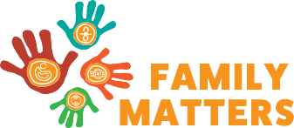Family Matters Queensland
Di Farmer MP
Minister For Child Safety, Youth and Women and Minister for the Prevention of Domestic and Family Violence

Professor Boni Robertson
Co-chair
Queensland First Children and Families Board
Mr Mick Gooda
Co-chair
Queensland First Children and Families Board

3

Introduction

Through Our Way: A generational strategy for Aboriginal and Torres Strait Islander children and families 2017–2037 (Our Way) the Queensland Government and Family Matters Queensland have committed
to work in partnership with communities and key stakeholders to eliminate the disproportionate representation of Aboriginal and Torres Strait Islander children in the child protection system by 2037 and to close the gap in life outcomes for Aboriginal and Torres Strait Islander children and families.
A key priority going forward will be the adoption of strategies to address systemic, social and policy barriers that have contributed to the disproportionate representation of Aboriginal and Torres Strait Islander children in the child protection system.
Changing Tracks 2020–2022 continues the Our Way journey towards a Queensland where all Aboriginal and Torres Strait Islander children and young people grow up safe, loved and cared for in family, community and culture.

In Queensland, the Family Matters building blocks and principles underpin everything that we do. Our role is to continue to work together to:
  - Apply the Family Matters principles:
    - Applying a child focused approach
    - Ensuring that Aboriginal and Torres Strait Islander peoples and organisations participate in and have control over decisions that affect their children
    - Protecting Aboriginal and Torres Strait Islander children’s right to live in culture
    - Pursuing evidence-based responses
    - Supporting, healing and strengthening families
    - Changing systemic racism and inequities
  - Support, enable and equip parents and carers with the tools and resources to ensure the health, safety and wellbeing of Aboriginal and Torres Strait Islander children and young people
  - Eliminate the disproportionate representation of Aboriginal and Torres Strait Islander children in the child protection system by 2037.

Family Matters — Strong communities. Strong culture. Stronger children

National Family Matters and Family Matters Queensland are part of an historic campaign led by more than 150 Aboriginal and Torres Strait Islander and non-Indigenous organisations across Australia who are committed to eliminating the disproportionate representation of Aboriginal and Torres Strait Islander children in statutory out-of-home care within a generation.
The Family Matters campaign in Queensland focuses on creating evidence-informed solutions to better enable family strengthening and children’s wellbeing and re-orientate service delivery from crisis intervention to prevention.
For more information visit www.familymatters.org.au

4

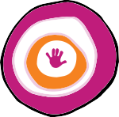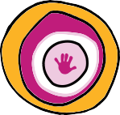Highlights for 2020–22

Changing Tracks 2020–2022 outlines specifi actions to continue to set the foundations for transformational change as well as consolidate and embed the actions achieved in the fi st action plan, Changing Tracks 2017–2019.

By the end of 2022:

The implementation of delegated authority will permit selected statutory powers or functions in relation to an Aboriginal and Torres Strait Islander child to be delegated to the CEO of an Aboriginal or Torres Strait Islander entity (Action 2.1)

We will have grown our investment in community-controlled Aboriginal and Torres Strait Islander services and their workforce to better reflect the proportion of Aboriginal and Torres Strait Islander people accessing these services (Action 3.1)

We will have continued to rebalance investment from statutory child protection to early intervention family support services so that families enjoy access to quality, culturally safe universal and targeted services necessary for Aboriginal and Torres Strait Islander children to thrive (Action 3.1)

All Aboriginal and Torres Strait Islander families will have the opportunity to participate in child protection decisions that affect their lives, including through an independent person or entity and the Family Participation Program (Action 2.2)

Aboriginal and Torres Strait Islander communities will have the opportunity to participate in the planning, design and delivery of services necessary for Aboriginal and Torres Strait Islander children to thrive (Action 2.4)

The Wellbeing Outcomes Framework for Aboriginal and Torres Strait Islander children and young people in Queensland (Wellbeing Outcomes Framework) will underpin our investment decisions, support greater collaboration and coordination across government and the community sector and provide greater consistency and transparency in how we measure progress towards our goals (Action 3.1)

We will see full compliance with the Aboriginal and Torres Strait Islander Child Placement Principle across the five system elements (legislation, policy, programs, processes and practice) of the family support system (Action 3.3)

The Queensland Aboriginal and Torres Strait Islander healing strategy will address the impact of intergenerational trauma, grief and loss, violence and abuse to help people create a different future (Action 3.5)

5

Our Way generational strategy at a glance

Vision Target
All Aboriginal and Torres Strait Islander children and young people in Queensland grow up safe and cared for in family, community and culture.

To close the gap in life outcomes for Aboriginal and Torres Strait Islander children and families and eliminate the disproportionate representation of Aboriginal and Torres Strait Islander children in the child protection system by 2037.

The outcome we want to achieve is that Aboriginal and Torres Strait Islander children experience parity across the following:

Culture and Connection Economic Empowerment Health
Wellbeing domains
Learning and Skills Home and Environment
Empowerment

Mental Health and Emotional Wellbeing
Safety

Building blocks

All families
1 enjoy access
to quality, culturally safe universal and targeted services necessary for Aboriginal and Torres Strait Islander children to thrive
Aboriginal
- and Torres
Strait Islander peoples and organisations participate in and have control over decisions that affect their children
Law, policy
- and practice
in child and family welfare are culturally safe and responsive
Governments
- and
community services are accountable to Aboriginal and Torres Strait Islander peoples

6

Who benefits

All Aboriginal and Torres Strait Islander children and families
Aboriginal and Torres Strait Islander children and families experiencing vulnerability and disadvantage
Aboriginal and Torres Strait Islander children and families in contact with family support and child protection systems
Aboriginal and Torres Strait Islander children in or leaving out-of-home care

Principles

- Applying a child focused approach
- Ensuring that Aboriginal and Torres Strait Islander peoples and organisations participate in and have control over decisions that affect their children
- Protecting Aboriginal and Torres Strait Islander children’s right to live in culture
- Pursuing evidence-based responses
- Supporting, healing and strengthening families
- Changing systemic racism and inequities

Implementation framework

Changing Tracks
First and second action plans (2017–2022)
Breaking Cycles
Third, fourth and fifth action plans (2023–2031)
Hitting Targets
Sixth and seventh action plans (2032–2037)

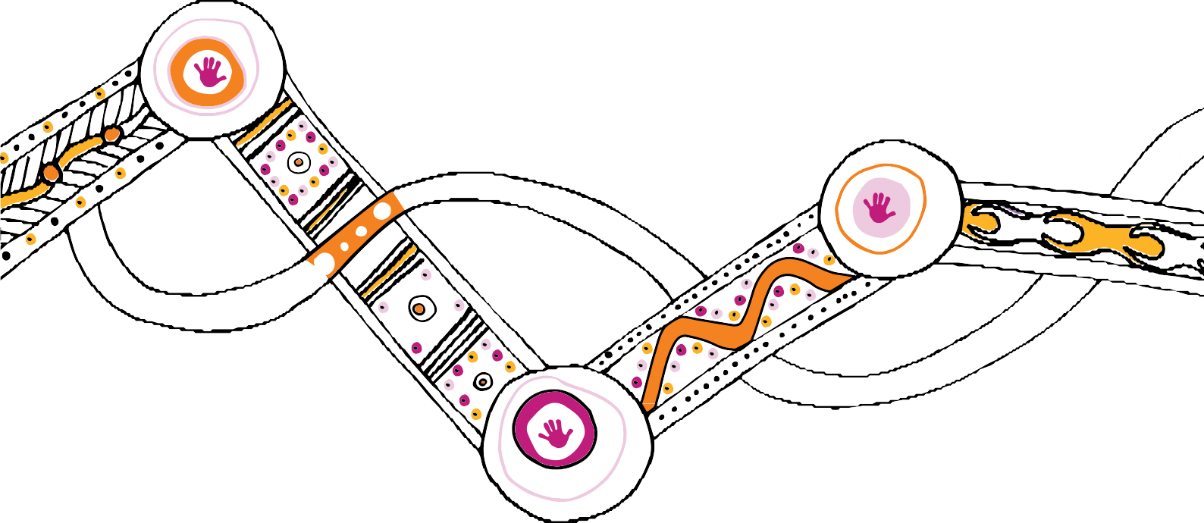

Ongoing monitoring, evaluation and review

7

What else is happening?

In identifying the actions for Changing Tracks 2020–2022, we recognise that across our lives, we interact with multiple service systems. To be effective, each service system needs to be working towards a shared goal of a Queensland where all Aboriginal and Torres Strait Islander children and young people grow up safe, loved and cared for in family, community and culture.

We acknowledge the complementary work to achieve improved outcomes for Aboriginal and Torres Strait Islander peoples in areas where they experience disadvantage and which directly impact outcomes for children and families:
  - Our Future State, Advancing Queensland’s Priorities: Give all our children a great start; Keep Queenslanders healthy; Keep Queenslanders safe; and Be a responsive government

Healing and rights

  - Tracks to Treaty Statement of Commitment, A Reframed Relationship between Aboriginal and Torres Strait Islander Queenslanders and the Queensland Government
  - Local Thriving Communities
  - Queensland Government Reconciliation Action Plan 2018-2021
  - Every Life, The Queensland Suicide Prevention Plan 2019-2029
  - Human Rights Act 2019

Health and wellbeing

  - Aboriginal and Torres Strait Islander Health and Wellbeing Services Plan 2018-2023
  - Deadly Kids Deadly Futures, Queensland’s Aboriginal and Torres Strait Islander Child Ear and Hearing Health Framework 2016-2026
  - Growing Deadly Families: Aboriginal and Torres Strait Islander Maternity Services Strategy 2019-2025
  - Aboriginal and Torres Strait Islander Mental Health Strategy 2016-2021
  - Making Tracks towards closing the gap in health outcomes for Indigenous Queenslanders by 2033: Investment Strategy 2018-2021
  - Shifting Minds: Queensland Mental Health, Alcohol and other Drugs Strategic Plan 2018-2023
  - Activate! Queensland 2019-2029 (Queensland Sport and Recreation Strategy)
  - Action on Ice, The Queensland Government’s plan to address use and harms caused by crystal methamphetamine (February 2018)

8

Housing

- Working Together for a Better Housing Future, Aboriginal and Torres Strait Islander Housing Action Plan 2019-2023

Safety

- The Framework for Action – Reshaping our Approach to Aboriginal and Torres Strait Islander Domestic and Family Violence
- Working Together, Changing the Story, Youth Justice Strategy 2019-2023 and Action Plan 2019-2021
- Prevent. Support. Believe. Queensland’s Framework to address Sexual Violence

Education

- Advancing Aboriginal and Torres Strait Islander education: An action plan for Queensland

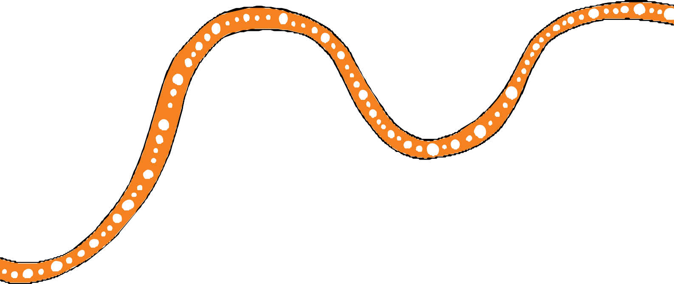9

Changing Tracks 2017–2019 established strong foundations for change
The first Changing Tracks action plan established strong foundations for change including establishing a new legislative framework that more effectively supports Aboriginal and Torres Strait Islander children and families who come into contact with the child protection system. Some of the highlights include:
  - establishment of the Queensland First Children and Families Board to provide guidance and oversee the implementation of the Our Way strategy and action plans and to hold government and partners accountable to the Aboriginal and Torres Strait Islander community. The Board brings together prominent leaders from diverse geographical locations across Queensland. Family Matters Queensland and the Directors-General of the Departments of Child Safety, Youth and Women (DCSYW) and Aboriginal and Torres Strait Islander Partnerships hold perpetual membership. The other eight positions are held by individuals who bring a vast range of expertise and a strong cultural perspective
  - the roll out of 33 community-controlled Aboriginal and Torres Strait Islander Family Wellbeing Services, making it easier for Aboriginal and Torres Strait Islander families to access support to strengthen social, emotional, physical and spiritual wellbeing, and safely care for and protect their children
  - the Child Protection Act 1999 was amended to:
    - support the rights of Aboriginal and Torres Strait Islander peoples to self-determination
    - embed the five elements of the Aboriginal and Torres Strait Islander Child Placement Principle
    - enable the Chief Executive to delegate functions or powers under the Child Protection Act 1999 in relation to an Aboriginal or Torres Strait Islander child to the CEO of an Aboriginal or Torres Strait Islander entity to authorise the CEO to make decisions for the child in relation to those matters
  - the development of a Wellbeing Outcomes Framework that defines wellbeing for Aboriginal and Torres Strait Islander children and young people in Queensland. The Framework will inform, shape and frame Queensland government investment in policies, programs and services that aim to improve the lives of Aboriginal and Torres Strait Islander children and young people in Queensland. It will also inform the impacts to be measured through
Our Way’s monitoring and evaluation framework
  - initiatives to strengthen connections with and voices of Aboriginal and Torres Strait Islander children and young people, parents and kin, to support community-controlled sector practice leadership and development, and to develop the cultural capability of DCSYW.
Continuing actions from Changing Tracks 2017–2019 include:
  - family and kin mapping for Aboriginal and Torres Strait Islander young people in care who are not already connected to family and kin
  - partnering with three discrete Aboriginal and Torres Strait Islander communities to build a coordinated, place-based universal and secondary service system
  - develop service delivery models for Aboriginal and Torres Strait Islander peoples based on the fi s from trials of domestic and family violence prevention and family support systems
  - review of child protection practices, including assessment and decision making tools.

10

Results from the 2018–2019 financial year indicate the child and family reforms are achieving good results in a number of key areas:
  - early evidence suggests a high level of success by community-controlled Family Wellbeing Services in de-escalating risks in Aboriginal and Torres Strait Islander families. This reinforces the known evidence of the improved outcomes for Aboriginal and Torres Strait Islander peoples when they can access culturally appropriate services
  - the rates of Aboriginal and Torres Strait Islander children being abused or neglected and in need of protection is decreasing
  - the proportion of Aboriginal and Torres Strait Islander children and young people in care living with kin increased from 36.5 per cent at 30 June 2013 to 42 per cent at 30 June 2019, while the number living in foster care or residential care decreased from 63.5 per cent at 30 June 2013 to 58.0 per cent at 30 June 2019.

The Elders told us ‘get it right at intake’. In response, the Moreton region introduced ‘The HALT Collective’. The Halt Collective brings together representatives from community led organisations and the Department of Child Safety, Youth and Women to apply a strong cultural lens to decision-making at intake. Ensuring the participation of community representatives in individual case decisions results in more appropriate responses for Aboriginal and Torres Strait Islander children and families.

There is more work
to be done
While considerable reform effort and investment is being committed to addressing the over-representation of Aboriginal and Torres Strait Islander children and young people in care, more needs to be done.
In Queensland, Aboriginal and Torres Strait Islander children and young people comprise
8%
of the population
aged 0–17 years
yet as at 30 June 2019, represented
42.7 %
of all children in care

11

What we know

More likely to have a shorter life span, with a

life expectancy gap
10.8 years less
8.6 years lessA
1.6 x more likely
to die during infancyB
3
more likely to be placed in
8. x
out-of-
home care
than non-Indigenous childrenC

the proportion of Aboriginal and Torres Strait Islander children and young people

in care, living with kin is
42%
at 30 June 2019D

2.6 x
more likely
to experience
very high/ high levels of psychological
distress
than non-Indigenous
peopleE

Aboriginal and Torres Strait Islander people are:

Economic Empowerment

more likely to experience
4.3x
unemployment
when aged 15–64 years than non-Indigenous peopleF

Home and Environment

Twice as likely
Learning and Skills
as non-Indigenous children to be
developmentally vulnerable
in early childhood, and continue to have

gaps in literacy and numeracy
throughout their school lifeG

more likely to live in
5.6 x
overcrowded households
than non-Indigenous householdsI

Less likely to be in formal education, with
87.2% of children

attending primary school
compared with 93.7%
of non-Indigenous childrenH

A: ROGS 2017 (Table EA.47); B: ROGS 2017 (Table EA54); C: DCSYW June 2019; D: DCSYW June 2019; E: NATSISS 2015 Table 23.3; F: NATSISS 2015 Table 20.3;
G: ROGS 2017, Table BA9 (data is for year 2015) (note actual ratio is 2:1). NAPLAN National Report ACARA (data is for year 2016); H: NIRA 2015-16, Table 13.3 (data
is for year 2016); I: National Aboriginal and Torres Strait Islander Social Survey, 2014–15,
28 x

more likely* to

be held in
youth
detention
than their non- Indigenous peersJ
3.6x

more likely
to be a
victim of violence
than non-Indigenous people K

Table 24.3; J: DJAG YJ Performance and Reporting (data is for year 2018–2019); K: QGSO Reported victims of offences against the person, Queensland, 2014–15.
- On an average day in the year 2018–2019 Department of Youth Justice, Youth Justice Performance and Reporting

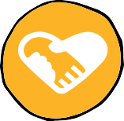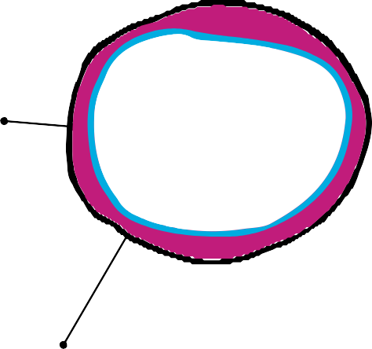
12

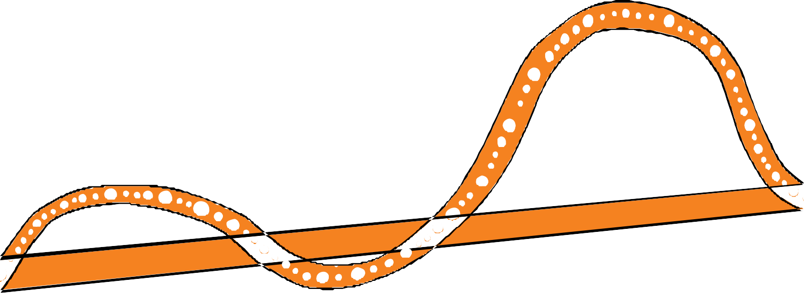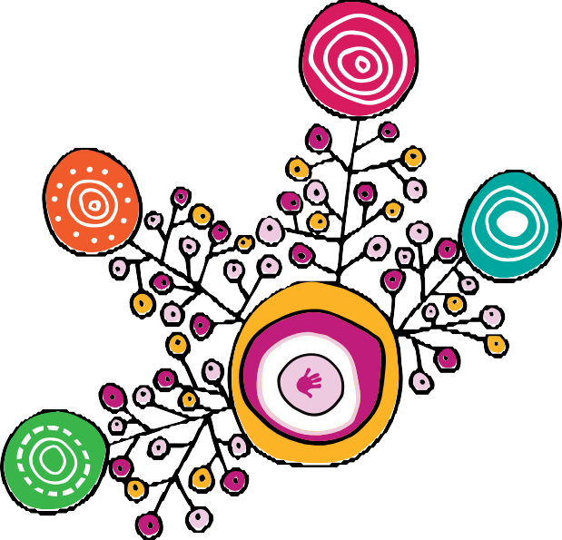

The intent of the second action plan is to continue setting the foundations for change needed to support Aboriginal and Torres Strait Islander children, young people and families and to consolidate and embed the actions achieved in the first action plan

It includes 24 targeted actions to continue our 20-year journey towards:

Vision — all Aboriginal and Torres Strait Islander children and young people in Queensland grow up safe, loved and cared for in family, community and culture

Target — to close the gap in life outcomes for Aboriginal and Torres Strait Islander children and families and eliminate the disproportionate representation of Aboriginal and Torres Strait Islander children in the child protection system by 2037

13

Changing tracks for children, young people and families

Building block 1: All families enjoy access to quality, culturally safe universal and targeted services necessary for Aboriginal and Torres Strait Islander children to thrive

We know that access to culturally responsive universal and secondary services is critical to helping families care for their children safely at home.

The Advancing Queensland Priority — Give all our children a great start — recognises that nothing is more important than doing our best to ensure the next generation of
Queenslanders are healthy, resilient and ready to be productive members of society.

We have seen how the first few years of a child’s life shape and determine their development, wellbeing and successes in adulthood. In these formative years, basic learning and key developmental milestones occur including: developing independence, building cultural connections and conversational skills and interacting more fully with the wider community, such as making friends and entering school.1 Ensuring children in Queensland thrive as part of a healthy, vibrant society is our ethical, social and economic responsibility.

We know that cultural connectedness is one of the best protective factors for keeping children safe within their families, and the importance of the role of mothers, fathers, kin and community. When Aboriginal and Torres Strait Islander parents are empowered and supported by services that are accessible, culturally responsive and safe, and the importance of culture and connection is deeply understood, Aboriginal and Torres Strait Islander children and families are more likely to thrive.

We saw over the past three years that access to community-controlled Aboriginal and Torres Strait Islander Family Wellbeing Services resulted in improved outcomes for children and families.

Over the next three years, we will continue to embed community voices into place-based planning, design and delivery of services. The wellbeing of children and young people will be central to all decisions and based on community strengths, community-identified needs and priorities. These decisions will be data informed and evidence based.

This will be supported by continued investment in community-controlled organisations and their workforce. There will be an increased focus on best practice, culture, healing and greater coordination and cooperation across government.

Government and all community organisations will be accountable for the wellbeing outcomes achieved by Aboriginal and Torres Strait Islander children, families and young people.

We will continue to improve the support for young people transitioning from care, recognising that parents, kin and community play an important role in supporting young adults through further education and training, finding a job, financial and emotional support and in providing a safety net for life’s difficult periods.

In recognition of the important role housing plays in the wellbeing of Aboriginal and Torres Strait Islander children and young people, Aboriginal and Torres Strait Islander peoples experiencing barriers to housing will be a priority cohort for access to social housing assistance.

14

Actions to ensure all families enjoy access to quality, culturally safe universal and targeted services necessary for Aboriginal and Torres Strait Islander children to thrive

Builds on
Evidence
Action
Lead2

Action 3.1 Changing Tracks 2017–2019
Program data shows that community- controlled Aboriginal and Torres Strait Islander Family Wellbeing Services are almost twice as effective at keeping children out of the system than other services
It is now well established that children growing up in poverty are more likely to experience adverse child experiences that are linked to child welfare involvement3
A child’s quality of care, the availability of learning opportunities and their exposure to a wide range of stressors are all associated with experiencing poverty4
1.1 Enhance community- controlled Aboriginal and Torres Strait Islander Family
Wellbeing Services, with a focus on youth justice and domestic and family violence
DCSYW
Action 3.5 Changing Tracks 2017–2019

Action 2.4 Changing Tracks 2017–2019
The proportion of Aboriginal and Torres Strait Islander children who are
considered developmentally vulnerable is 65 per cent5
The Deadly Ears Program has estimated that between 40–50 per cent of young children in some remote Indigenous communities may be experiencing some degree of hearing loss at any one time6
In very young children this can affect the development of speech, language and social skills
As they grow older it can affect school readiness, communication skills, learning abilities and educational outcomes
These issues then combine to impact employment prospects and a range of other outcomes throughout life
1.2 Enhance the Be Well Learn Well program being delivered in eight remote communities that have a high level of developmental vulnerability among Aboriginal and Torres
Strait Islander children to ensure current and future generations of Aboriginal and Torres Strait Islander children in Queensland will be able to listen, learn and reach their full potential
DoE

15

16

Changing tracks for children, young people and families

Action 4.3 Changing Tracks 2017–2019
Participating in education, training and employment is a protective factor. It enhances families’ economic capacity to care for their children, reduces the risk of poverty and homelessness, enhances the social and emotional wellbeing of children and families and mitigates the risk of families and children entering the child protection system
1.3 Increase the participation of unemployed Aboriginal and Torres Strait Islander parents and young people exiting long term care in skills development and vocational education and training under the Skills for Queensland – Great training for quality jobs strategy
DESBT

Connecting Care to Recovery 2016–2021
Mental health and substance abuse disorders such as anxiety, depression and alcohol use causes approximately 19 per cent of the total health burden in the Aboriginal and Torres Strait Islander population7
Research demonstrates that parental substance misuse is one of the most commonly identified risk factors for child abuse and neglect8
1.4 In planning for mental health, alcohol and other drug treatment services consider culturally safe responses to meet the needs of Aboriginal and Torres Strait Islander people, families and communities
Qld Health

Qld Suicide Prevention Plan 2019–
Aboriginal and Torres Strait Islander people are 2.7 times more likely to experience high levels of psychological distress than non-Indigenous people9
The suicide rate in Aboriginal and Torres Strait Islander peoples is twice that of the non-Indigenous population and suicide occurs at much younger ages
1.5 Develop an Aboriginal and Torres Strait Islander mental health and wellbeing program and deliver youth resilience and suicide prevention projects
DATSIP
2029

Aboriginal and Torres Islander Housing Action Plan
Access to safe, affordable housing helps Aboriginal and Torres Strait Islander families and young people achieve better wellbeing outcomes and can reduce contact with the child protection system
In 2016-2017, 3772 Aboriginal and Torres Strait Islander young people between the ages of 10 and 24 years accessed specialist homelessness services in Queensland 10
Child safety data for 2018–2019 indicates that domestic and family violence was a risk factor in 45 per cent of Aboriginal and Torres Strait Islander households in which child safety concerns were substantiated with a completed investigation and assessment
1.6 Implement culturally- responsive pathway planning and case coordination to connect people to the support they need to improve their housing and wellbeing outcomes
DHPW

Priority actions to address youth sexual violence and abuse
Aboriginal and Torres Strait Islander young people are twice as likely as non- Indigenous young people to be victims of youth sexual violence
1.7 Deliver an Aboriginal and Torres Strait Islander-specific place-based trial to address youth sexual violence and abuse as part of the Government’s priority actions to address
this issue
DCSYW

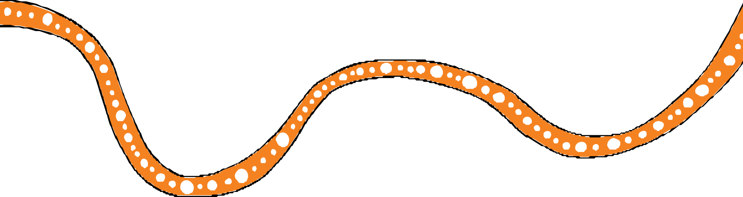Advancing education: an action plan for education in Qld
17
Young people released from detention face barriers to successful reintegration to community, including the ability to continue their education or training.
This project addresses the educational needs of young people aged 10–17 in the youth justice system and those at-risk of disengaging or needing to re-engage with education
1.8 Implement culturally- responsive and developmentally appropriate literacy and numeracy training options
for young people through Vocational Training Queensland
DoE

Changing tracks for children, young people and families

Building block 2: Aboriginal and Torres Strait Islander peoples and organisations participate in and have control over
decisions that affect their children

The Our Way strategy and action plans are underpinned by the Queensland Government’s commitment to Aboriginal and Torres Strait Islander peoples’ self-determination and enabling individual and family-led decision making and choice.
We must all work together to maximise the participation of families to identify and take control of their healing and support needs through the development and implementation of plans that reflect the hopes and goals they have for their children.
The Wellbeing Outcomes Framework recognises that wellbeing for Aboriginal and Torres Strait Islander people incorporates broader issues of social justice, equity and rights. One of the eight wellbeing domains is empowerment, which refers to children and young people having and being able to have a voice in the communities and environments in which they live, learn and work.
The Wellbeing Outcomes Framework is centred on what Aboriginal and Torres Strait Islander children and young people need to thrive but also reflects what children and young people want for themselves.
The Advancing Queensland Priority — Keep Queenslanders healthy — recognises that both healthy bodies and healthy minds improve wellbeing. We know that empowerment is a key component of healthy minds.
The implementation of the Local Thriving Communities framework and approach will strengthen community voice and local decision making in the planning, design and delivery of place-based services. Studies show that successful community engagement in the design and delivery of public services strengthens community capacity and results in services that are more effi ient, effective and sustainable. The evidence suggests savings of up to six times the investment made in new approaches.11

Actions to ensure Aboriginal and Torres Strait Islander peoples and organisations participate in and have control over decisions that affect their children.

Builds on
Action
Evidence
Lead
2.1 Implement delegated authority to permit one or more of the chief executive’s functions or powers under the Child Protection Act 1999 in relation to an Aboriginal or Torres Strait Islander child to be delegated to the chief executive offi er of an Aboriginal or Torres Strait Islander entity to authorise the CEO to make decisions for the child in relation to those matters
This gives practical effect to the principle in the Act that recognises the right of Aboriginal and Torres Strait Islander people to self- determination
Aboriginal and Torres Strait Islander people have the highest stakes in the safety and wellbeing of their own children and the effect that their removal has on families and communities
DCSYW/
QATSICPP

Action 4.2 Changing Tracks 2017–2019

18

2.2 Embed the Aboriginal and Torres Strait Islander family-led decision | The intent of the Family Participation Program is to provide a culturally | DCSYW | Action 6.2 Changing
making model across the child | safe way to support Aboriginal |  | Tracks
protection continuum to ensure | and Torres Strait Islander parents, |  | 2017–2019
culturally safe responses to child | families and children to participate
protection matters | in child protection decisions that
 | affect their lives. A key function of
 | the Family Participation Program is
 | the facilitation of an independent
 | Aboriginal and Torres Strait Islander
 | family-led decision making process
 | to give authority to parents, families
 | and children to solve problems and
 | lead decision making
2.3 Pilot youth justice Aboriginal and Torres Strait Islander Family- | Aboriginal and Torres Strait Islander young people are 28 times more | DYJ | Working Together,
Led Decision Making processes | likely to be held in youth detention |  | Changing
in four locations to increase | than their non-Indigenous peers. |  | the Story,
cultural authority in identifying | The trials aim to reduce the over- |  | Youth Justice
and responding to the needs of | representation of Aboriginal and |  | Strategy
Aboriginal and Torres Strait Islander | Torres Strait Islander young people |  | 2019–2023
young people in the youth justice | in the youth justice system by |  | and Action
system | empowering Aboriginal and Torres |  | Plan 2019-
 | Strait Islander families to make |  | 2021
 | positive decisions to change their
 | child’s behaviour. The trials will
 | provide safe and ongoing cultural
 | and practical support to enable self-
 | determination in finding solutions
 | to a young person’s offending
 | behaviour
2.4 Implement the Local Thriving Communities framework to create | Government will work in partnership with communities to plan, co-design | All agencies | Tracks to Treaty
the enabling and authorising | and deliver services to improve
environment that supports | outcomes for Aboriginal and Torres
communities, including young | Strait Islander children and families
people, to make decisions about
their own future

19

Changing tracks for children, young people and families

Building block 3: Law, policy and practice in child and family welfare are culturally safe and responsive

To eliminate the disproportionate representation of Aboriginal and Torres Strait Islander children in the child protection system within a generation we will continue to build the foundations for change through our law, policy and practice.

As part of the Advancing Queensland Priorities the Queensland Government has committed to being responsive, to make sure that Queenslanders feel like it is easy to
do business with their government.

To support the commitments in this action plan:
  - laws, policies and practice must be culturally responsive to ensure best outcomes for Aboriginal Torres Strait Islander children and families
  - Aboriginal and Torres Strait Islander families must be actively engaged in decisions that affect their families across the child protection system
  - Aboriginal and Torres Strait Islander peoples are involved in the co-design and delivery of policies, programs and services to Aboriginal and Torres Strait Islander families and children
  - the cultural strengths, responsibilities, connections and leadership of Aboriginal and Torres Strait Islander peoples will be recognised, respected and resourced.

We will continue to invest in Aboriginal and Torres Strait Islander community-controlled services and the people who work there to improve service outcomes for Aboriginal and Torres Strait Islander children and families. The recent evaluation of intensive family support services found that access to specialist supports in the community for particular needs, such as domestic violence, mental health supports, trauma-focused therapies and other specialist services was often lacking. This is a particular issue in rural and remote areas or smaller regional centres and the resulting lack of service cohesion was the most common barrier to families taking up and sustaining involvement with support services.

Community ownership contributes to authority and autonomy over all aspects of a project;
builds the commitment and enthusiasm of all people involved in the program, including collaborators; and contributes to building community capacity so that communities can address their own needs.

The establishment, existence and continued success of Aboriginal and Torres Strait Islander community-controlled organisations is the result of Aboriginal and Torres Strait Islander community effort to organise, advocate and promote positive community participation in the lives of people experiencing vulnerability.

Going forward, the Wellbeing Outcomes Framework will inform, shape and frame
whole-of-government investment in policies, programs and services that aim to improve the lives of Aboriginal and Torres Strait Islander children and young people in Queensland.

20

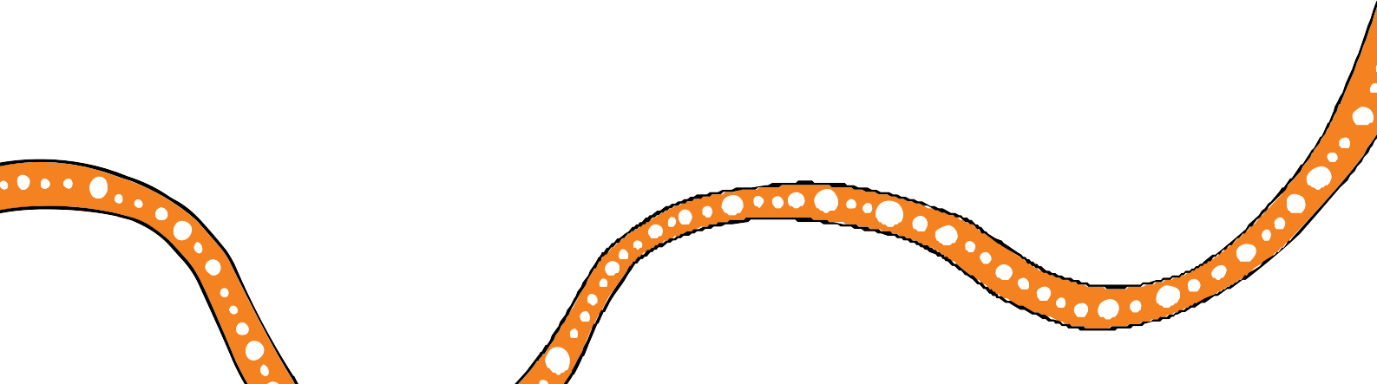

The framework is comprised of eight interconnected wellbeing domains which represent all the areas of a child and young person’s life that impact their wellbeing:
- Culture and Connections: Our children are strong in culture
- Economic Empowerment: Our children have access to every opportunity
- Health: Our children are strong and healthy
- Mental health and Emotional Wellbeing: Our children are hopeful
- Learning and Skills: Our children learn, develop and thrive
- Home and Environment: Our children live in safe and healthy homes
- Empowerment: Our children are heard
- Safety: Our children are safe
The notion of wellbeing is thought to encompass an individual’s freedom to: help themselves and to influence social change, shape their own destiny, and as a group, actively pursue goals or values they regard as important, determine what wellbeing looks like themselves and not be based on predetermined assumptions.12 There is an increasing recognition that subjective
measures of wellbeing (such as those provided by self-reports of life satisfaction or happiness) have an important role to play in policy development and evaluation.13

Our law, policy and practice will also be developed through a healing lens with the development of the healing strategy and implementation plan.

Children involved in the child protection system have often experienced neglect and abuse resulting in trauma that impacts their health and wellbeing. Actions that promote mental health and physical wellbeing in children and young people will assist families involved with the child protection system to care safely for their children at home and contribute to achieving the targets for the Advancing Queensland Priority — Keep communities safe.

Families are essential to children’s experience of, and connection with, their culture and thus their healing. Aboriginal and Torres Strait Islander peoples learn and experience culture and spirituality through their families: whether through knowledge, stories, and songs from parents, grandparents, Elders, and uncles and aunts, and through everyday lived experience of shared values, meaning, language, custom, behaviour and ceremonies.

21

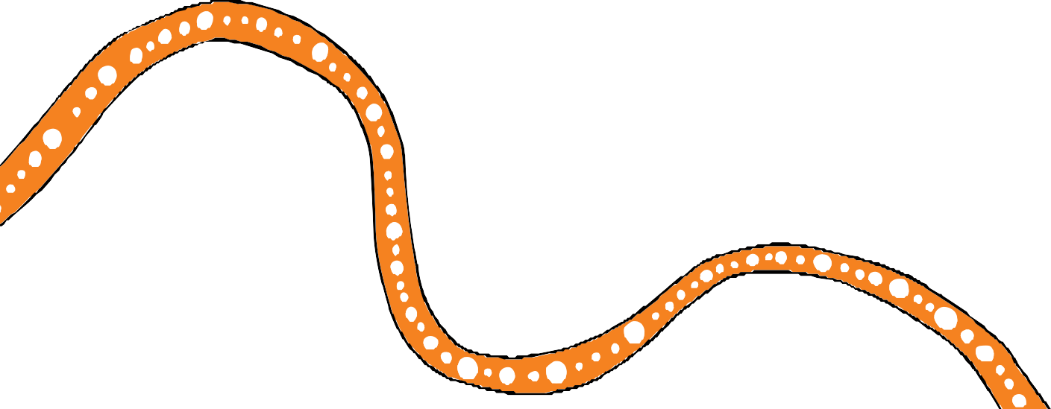Changing tracks for children, young people and families

Actions to ensure our law, policy and practice in child and family welfare are culturally safe and responsive

Action | Evidence | Lead | Builds on
3.1 Apply the Wellbeing Outcomes Framework to inform government | Consistent application of the Wellbeing Outcomes Framework | DCSYW | Action 6.4 Changing
investment, policies, programs and | and complementary investment |  | Tracks
services | principles provides an opportunity |  | 2017–2019
 | to achieve life-changing results for
 | Queensland’s Aboriginal and Torres
 | Strait Islander children and young
 | people through better, smarter and
 | more effective investments
3.2 Implement the Queensland Aboriginal and Torres Strait Islander | The ongoing success of the sector relies on the capacity and capability | DCSYW/ QATSICPP | Action 6.6 Changing
Child Protection Peak Professional | of the people who work within it and |  | Tracks
Scholarships Program to improve the | a workforce that is representative of |  | 2017–2019
quality of family services provided by | the clients accessing services
community-controlled services
3.3 Embed active efforts to implement and give full effect to | The Aboriginal and Torres Strait Islander Child Placement Principle | All agencies | Aboriginal and Torres Strait
all five elements of the Aboriginal | is made up of five elements to |  | Islander Child
and Torres Strait Islander Child | enhance and preserve Aboriginal |  | Placement
Placement Principle across the | and Torres Strait Islander children’s |  | Principle
five system elements of the family | sense of identity, their connection
support system (legislation, policy, | to their culture, heritage, family and
programs, processes and practice) | community. The Child Protection Act
 | 1999 requires the application of the
 | Principle to the administration of
 | the Act in relation to Aboriginal and
 | Torres Strait Islander children

22

Action 4.1 Changing Tracks 2017–2019
3.4 Partner with QATSICPP to develop and implement an Aboriginal and Torres Strait Islander Kinship program, inclusive of relevant services, that:
- connects children in care with kin and Aboriginal and Torres Strait Islander culture
- enables and supports kin to care for children to prevent ongoing statutory intervention
- enables children who require ongoing statutory intervention to be cared for by kin wherever possible and safe to do so
Currently only 42 per cent of Aboriginal and Torres Strait Islander children in care live with Aboriginal and Torres Strait Islander kin, this increases to 42.3 per cent living with kin when non-Indigenous kin are included
DCSYW

Action 6.11 Changing Tracks 2017–2019
3.5 Co-design and implement a Queensland Aboriginal and Torres Strait Islander healing
strategy to address the impact of intergenerational trauma, grief and loss, violence and abuse
The evidence tells us that strategies to address Aboriginal and Torres Strait Islander disadvantage will continue to fail unless underpinned by trauma informed healing approaches that recognise the devastating impacts
of colonisation and subsequent government policies14
DCSYW

3.6 Enact legislation providing legal recognition to Torres Strait Islander families’ traditional child rearing practice
Generations of Torres Strait Islander children have been raised in supportive and loving extended family environments
Legal recognition of this ancient and enduring cultural practice will acknowledge the importance of Torres Strait Islander culture and
cultural decision-making processes in Torres Strait Islander community and family life
DATSIP

Queensland Cross-Agency Strategy and Action Plan
3.7 Work with Aboriginal and Torres Strait Islander communities to increase the birth registration rate of children aged 0–10 years
Birth registration allows access to a birth certificate, without which a
person is susceptible to a number of significant obstacles over the course of their life, all related to proving their identity, personal particulars and legal relationships. Not having a birth certificate is a barrier to accessing basic rights and privileges
DJAG

23

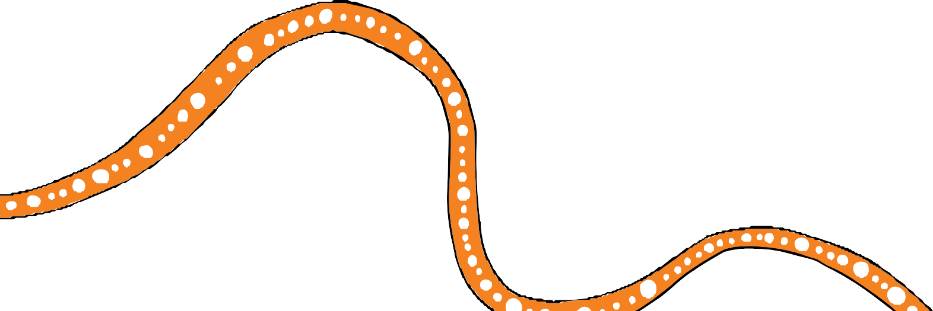Changing tracks for children, young people and families

Building block 4: Government and community services are accountable to Aboriginal and Torres Strait Islander peoples

Governments and community organisations will work together to share power
and responsibility with Aboriginal and Torres Strait Islander leaders. Governance structures and practices will be developed to ensure services have a deep cultural understanding, and are based on the needs and aspirations of Aboriginal and Torres Strait Islander peoples.

We remain committed and accountable to the long-term vision of the strategy and ensure that every action we take contributes to enabling Aboriginal and Torres Strait Islander peoples to lead solutions so children grow up safe, loved and cared for in family, community and culture.

The application of the Wellbeing Outcomes Framework, investment principles and healing strategy, together with the Family Matters building blocks and principles, will underpin the approach to measurement, evaluation, reporting and governance over the course of this action plan.

We will continue to explore options for the establishment of a centre of excellence to:
  - provide a legitimate evidence base for service design and delivery
  - inform government decision making regarding investment
  - enable government to invest in best practice initiatives and programs.

We recognise the important role the Queensland First Children and Families Board plays in ensuring government and community services are accountable to Aboriginal and Torres Strait Islander peoples. A key challenge moving forward is supporting the Board to continue to guide and influence these reforms, creating the space for truth telling and for the hard conversations to happen. Over the next three years we will work to improve support for the Board including succession planning and the development of emerging leaders.

24

Actions to ensure Government and community services are accountable to Aboriginal and Torres Strait Islander peoples

Action | Evidence | Lead | Builds on
4.1 Continue to support the | The Board provides independent | DCSYW | Action 6.1
Queensland First Children and | advice and guidance as well as |  | Changing
Families Board | operating as an authorising and |  | Tracks
 | oversight body to hold the Queensland |  | 2017–2019
 | Government and partners accountable
4.2 Continue to explore options | What is described as Aboriginal and | DCSYW | 6.8
for the establishment of a centre | Torres Strait Islander culture is largely | QATSICPP | Changing
of excellence to build the evidence base for what works for Aboriginal | viewed through the lens of people from  non-Indigenous cultures |  | Tracks 2017–2019
and Torres Strait Islander child and
family reforms
4.3 Evaluate the Changing Tracks | Monitoring and evaluation will allow | DCSYW
action plan 2017–2019 to measure | us to identify those initiatives that are | QFCFB
the change (impact) in the lives of | successful, effective and meaningful
children and families as a result of | in addressing issues of child safety,
the initiatives in Changing Tracks | and make changes to, or cease,
2017–2019 | those activities that are inefficient or
 | ineffective
 | The approach to monitoring and
 | evaluation will be informed by the
 | QFCFB and based on the Wellbeing
 | Outcomes Framework
4.4 Develop annual progress | Annual progress reports will ensure | DCSYW | QFCFB
reports to ensure the strategy | our actions and impacts are delivering | QFCFB | Changing
and action plans are responsive | the intended outcomes against key |  | Tracks
to the needs of the Queensland | indicators and that we remain on track |  | Progress
Government and community | towards achieving our vision |  | Report
and reflect the Family Matters |  |  | May 2017–
Queensland partnership |  |  | December
 |  |  | 2018
4.5 Support Our Way partners in | While the Queensland government | DCSYW | The Family
the call for a national Aboriginal | continues to implement Our Way, |  | Matters
and Torres Strait Islander | in partnership with Family Matters |  | Report
children’s strategy, overseen by an | Queensland and the QFCFB, the scale |  | 2019
independent national Aboriginal | and complexity of issues driving the
and Torres Strait Islander Children’s | over-representation of Aboriginal and
Commissioner | Torres Strait Islander children in child
 | protection systems is so immense,
 | it requires national consistency and
 | commitment

25

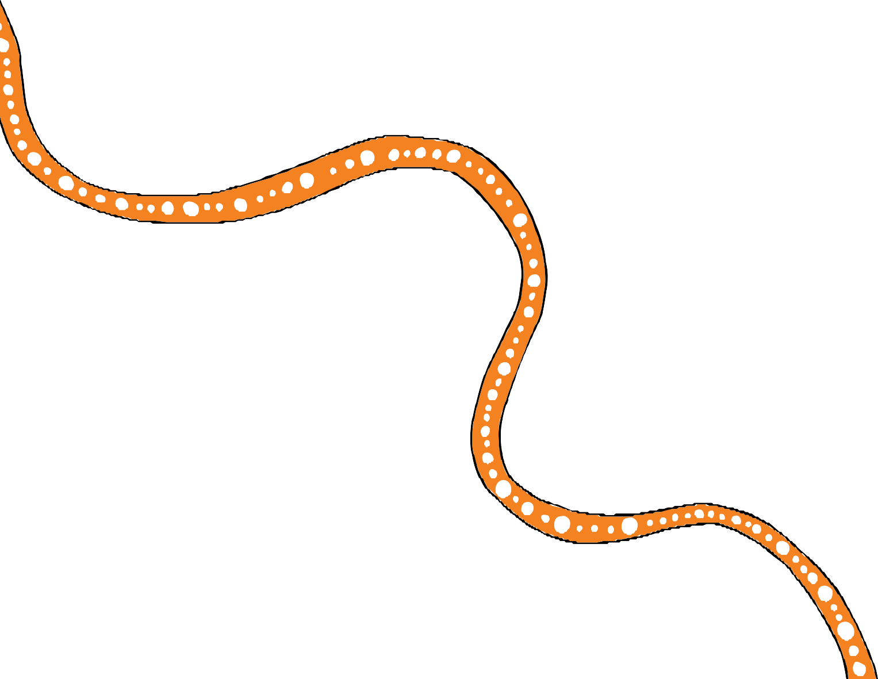

Acronyms

DATSIP Department of Aboriginal and Torres Strait Islander Partnerships DCSYW Department of Child Safety, Youth and Women
DESBT Department of Employment, Small Business and Training DHPW Department of Housing and Public Works
DJAG Department of Justice and Attorney-General

DoE Department of Education

DYJ Department of Youth Justice

QATSICPP Queensland Aboriginal and Torres Strait Islander Child Protection Peak QFCFB Queensland First Children and Families Board

26

References
- Children’s Health Queensland, Aboriginal and Torres Strait Islander Health and Wellbeing Services Plan 2018–2023
- Note: “Lead” means the agency or organisation with primary accountability for delivering the action and may include planning, resourcing, managing partnerships, monitoring, reporting and evaluation
- Family Matters Report 2019, p.g. 50
- Ibid.
- The Australian Early Childhood Educational Development Experience Research Project explores the impact of early learning experiences, both at home and in early education and care services, on young children’s development and learning. The project aims to build a picture of children’s activities in the years before they start school and the impact of these activities on their development. The domains are: physical health and wellbeing; social competence; emotional maturity; language and cognitive skills; communication skills and general knowledge.
- Deadly Kids Deadly Futures 2016–2026 policy framework.
- Children’s Health Queensland, Aboriginal and Torres Strait Islander Health and Wellbeing Services Plan 2018–2023
- Australian Institute of Family Studies, 2017
- The health and welfare of Australia’s Aboriginal and Torres Strait Islander peoples: June 2015,
p.g. 50, https://www.aihw.gov.au/reports/indigenous-health-welfare/indigenous-health-welfare-2015/ contents/determinants-of-health-key-points
- Australian Institute of Health and Welfare, 2018
- Boyle D., Slay, J. and Stephens, L. Public Services Inside Out: Putting co-production into practice, National Endowment for Science Technology and the Arts (NESTA), 2010, p. 4,
website: <http://www.civilsociety.org.au/public-services-inside-out.pdf>
- Klein, E. ‘A critical review of the capability approach in Australian Indigenous policy’,
CAEPR Working Paper no. 102, 2015, Centre for Aboriginal Economic Policy Research, ANU College of Arts & Social Sciences
- Manning, Ambrey and Fleming, ‘Indigenous wellbeing in Australia: Evidence from HILDA’, CAEPR Working Paper no. 101, 2015, Centre for Aboriginal Economic Policy Research, ANU College of Arts and Social Sciences. p.g. 1
- The Healing Foundation, A Theory of Change for Healing, 2019

27

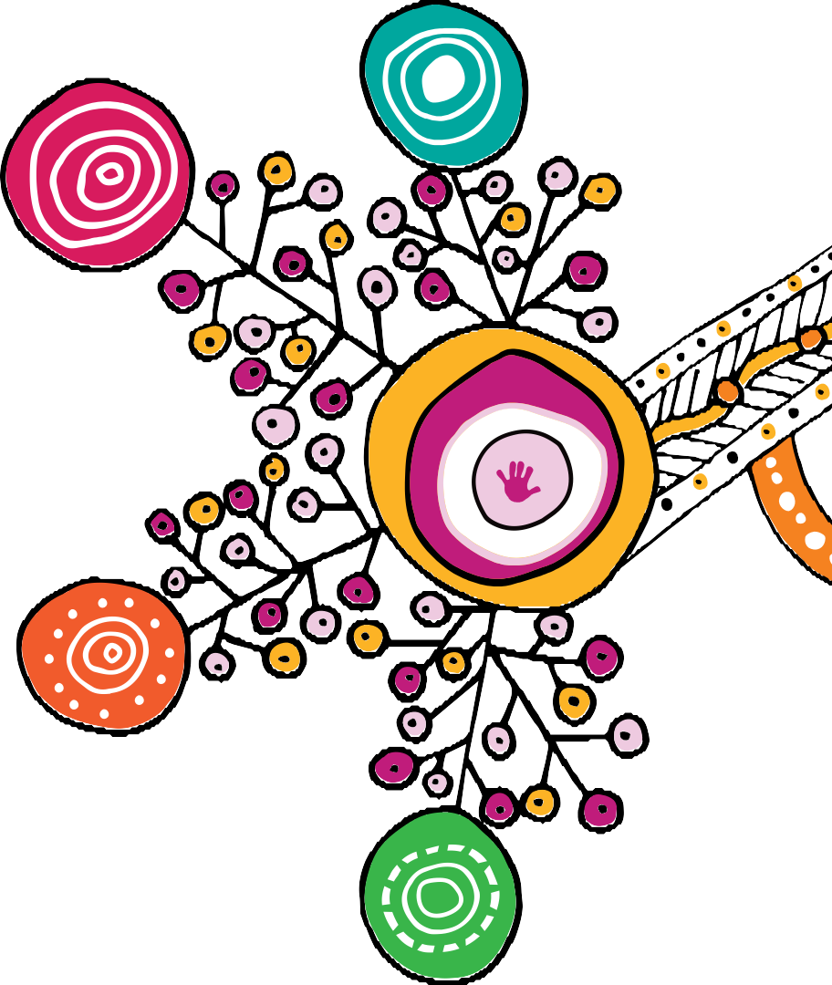

Story of the motif
The motif artwork was created by Rachael Sarra, an Indigenous artist and designer from creative agency Gilimbaa. Rachael originates from the Bunda People in Goreng Goreng country.

The motif design is a reflection of equal partners joining together in conversation and positive action. It represents a clear and focused pathway that began as the dispersed energy of many that has now fused to channel clarity, momentum, and strength. It shows the power of unity and simplicity that evolves from complexity. The artwork shows the journey of the child, depicted as the hands, connected to and supported by structures that nurture and guide.
Through the woven orange line it acknowledges culture, kin and the strength of learning from the past to act in the present and grow for the future.

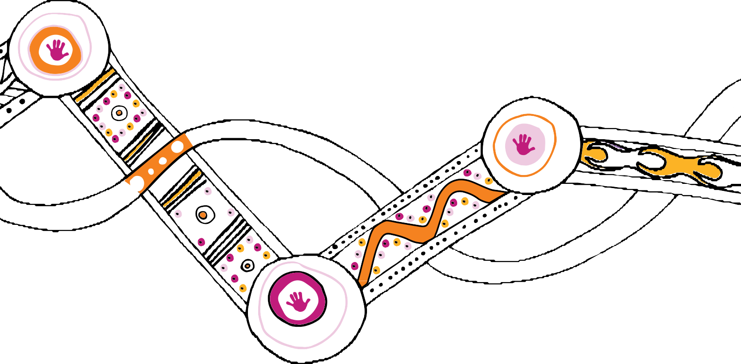

The text in this publication is licensed under a Creative Commons Attribution-NonCommercial-ShareAlike
4.0 International

The artwork in this publication is the property of the Queensland Government (Department of Child Safety, Youth and Women) and is licensed under a Creative Commons Attribution-NonCommercial-NoDerivatives
4.0 International

Visit http://creativecommons.org.au/ for more information about Creative Commons licences.

© The State of Queensland (Department of Child Safety, Youth and Women) 2018

Copyright protects this publication. Excerpts may be reproduced with acknowledgement of the State of Queensland (Department of Child Safety, Youth and Women).

Department of Child Safety, Youth and Women Locked Bag 3405, Brisbane QLD 4001

www.csyw.qld.gov.au

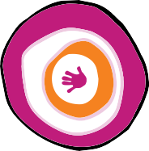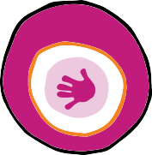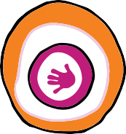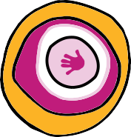0766_NOW2019

