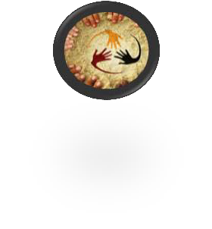
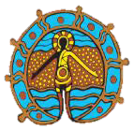
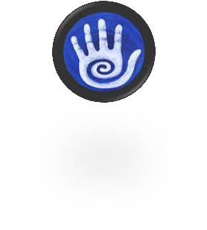
Queensland Care Services Outcomes Framework

Vision : Children and young people in care are safe and healthy, have a sense of belonging and wellbeing, and achieve to their potential

Safe & Nurtured
Domains

Connected

Achieving

Healthy

Resilient

Children and young people feel cared for and nurtured in stable environments, safe from abuse, neglect, violence and threat
Aspirations
Children and young people feel a strong sense of identity and belonging, have stable and long lasting relationships with family and friends and are connected to culture and community
Children and young people learn and develop to their full potential

Principle of cultural integrity in care
Children and young people make healthy lifestyle choices and access health care services
Children and young people have strong social and interpersonal skills and feel confident to pursue life goals and manage challenges

Culturally responsive and safe care is about being part of a family, community and extended network and knowing where you belong.
Culture and identity as a concept is dynamic and to be prioritised as part of every child’s day to day life (SNAICC 2011)

Outcomes | - Protected from abuse, neglect  and exposure to violence  - Nurtured and cared for  - Living in stable and predictable environments | - Positively connected to family,  culture and community  - Feel a sense of identity and belonging | - Attend and engage in education  - Meeting developmental milestones  - Engage in, and benefit from, recreational activities  - Developing independence and life skills | - Physically healthy  - Emotionally and mentally healthy  - Leading an active and healthy lifestyle | - Feel confident and have social skills  - Possess coping skills and an ability to manage adversity  - Display positive and appropriate behaviour
Critical Success Indicators | Children and young people will live  in homes where:  - They are not being harmed and they are physically safe  - Their material needs are met  - They feel cared for, nurtured and valued  - Their dignity and rights are respected  - They lead a violence free life | Children and young people will:  - Have quality relationships with family, friends and other significant people  - Know their life history and have a sense of identity  - Feel connected and have a sense of cultural and spiritual belonging to their community  - Have opportunities to engage in social, cultural and community events and activities | Children and young people:  - Are ready for school at entry age  - Attend and engage in schooling  - Achieve national educational standards  - Have age and developmentally appropriate life skills  - Develop and progress personally, socially and educationally  - Have career aspirations | Children and young people:  - Access services and treatment that meet their physical, dental, sexual and mental health needs  - Access services and treatment that meet needs related to a disability or their development  - Experience improvements to their health and wellbeing  - Do not misuse drugs and alcohol  - Learn to independently make healthy lifestyle choices | Children and young people:  - Access services and treatment that meet their therapeutic needs  - Have positive relationships and treat other people with respect  - Pursue recreational and extra-curricular activities  - Engage in decision-making about their lives  - Contribute to and support the community and others  - Engage in positive and law-abiding behaviour  - Have confidence and are able to successfully deal with life challenges  - Have goals and feel optimistic about their future

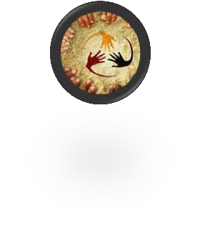
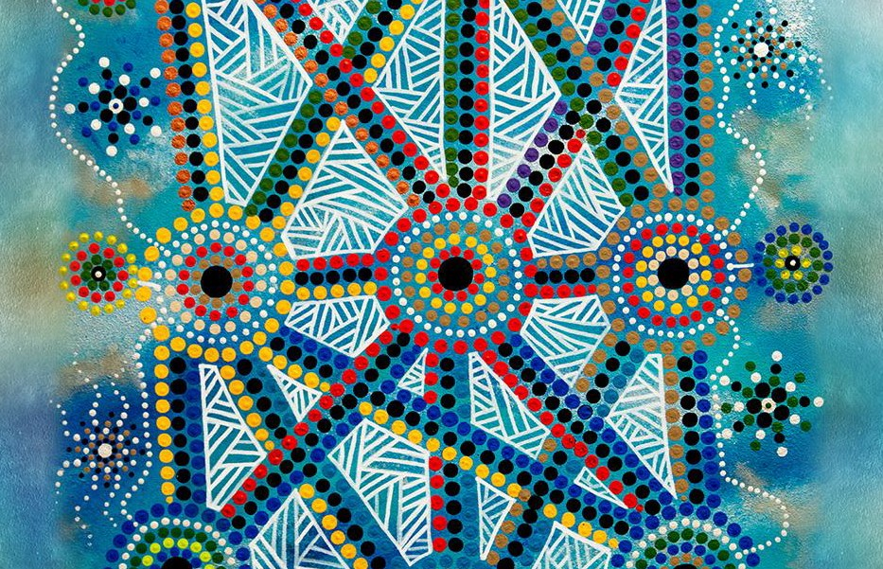
MEASURES OF SUCCESS

Safe & Nurtured
Domains

Connected

Achieving

Healthy
Resilient

- Length of time in placement
- Permanent placement
- Number of placements to date
Child Measures
- Substantiated standards of care matters
- Do not experience
violence or trauma

- Children are stable in placements
- Children in permanent homes
Service Measures
- Number of placements to date
- Substantiated standards of care matters

- Children are stable in
their placement
Organisational Measures
- Children in permanent homes
- Substantiated standards of care matters
- Length of time in placements
- Positive and supportive relationships
- Lives with their siblings
- Lives with kinship carer
- Regular family contact
- Regular engagement in community activity
- Regular visit to community
- Has a cultural support plan including information from the individual, family and community perspective
- Lives with a carer from the same cultural background
- Has a comprehensive record of their family through genogram and ecomap including parents, mob, ancestors, family, community, and country

- Children have positive and supportive relationships
- Children living with siblings
- Children living with kinship carers
- Children having regular family contact
- Children living with carer from same cultural background
- Children engaged in community activities
- Children with cultural support plan including information from the individual, family and community perspective
- Children visiting their community
- Children who have information about land, totem, language, history, stories and custom
- Length of time in placements

- Children have positive and supportive relationships
- Children living with siblings
- Children living with kinship carers
- Children having regular family contact
- Children living with carer from same cultural background
- Children engaged in community activities
- Children with cultural support plan including information from the individual, family and community perspective
- Children visiting their community
- Children who have information about land, totem, language, history, stories and custom
- Length of time in placements
- Attachment to school
- Attends school , Kindergarten or early childhood education regularly or is engaged in training or employment
- Most recent overall NAPLAN score at or above national minimum standard
- Academic performance steady or improving
- Transition to independence planning
- Identifies possible career or future hopes and the necessary steps to achieve these
- Has access to resources for adulthood, including safe accommodation

- Children have attachment to school
- Children are attending school Kindergarten or early childhood education regularly or is engaged in training or employment
- Children are at or above the NAPLAN minimum standard
- School exclusions
- Transition to independence planning

- Children have attachment to school
- Children are attending school Kindergarten or early childhood education regularly or is engaged in training or employment
- Children are at or above the NAPLAN minimum standard
- School exclusions
- Transition to independence planning
- Overall health
- Immunisation schedule up to date and in accordance with the National Immunisation Program
- Has a comprehensive health and development assessment
- Has a child health passport
- Physical activity and nutritional consumption meets
national recommendations
- Has had a dental check-up within 12 months
- Has access to health care including general, mental, dental, sexual and allied health care
- Alcohol and drug use has minor impact

- Children fully immunised
- Children with comprehensive health and development assessments
- Children with a child health passport
- Children meeting recommended physical activity and nutritional consumption
- Children are engaging in sport regularly
- Children with a dental check-up within 12 months
- Children have access to health care including general, mental, dental, sexual and allied health
- Young people using alcohol and drugs with minor impact

- Children are fully immunised
- Children have comprehensive health and development assessments
- Children with a child health passport
- Children meeting recommended physical activity and nutritional consumption
- Children with a dental check-up within 12 months
- Children have access to health care including general, mental, dental , sexual, allied health
- Young people using alcohol and drugs with minor impact
- Self-regulation and prosocial behaviour
- Social and emotional confidence
- Has access to therapeutic services
- Participated in the development/review of their current case plan
- Regular social/recreation activities
- No escalation in behavioural issues at
school or child care
- Participated in transition to independence planning and have plans for adulthood
- No or reduced involvement in illegal activities

- Children’s social and emotional confidence
- Children accessing therapeutic services
- Children’s participation in the development and review of their case plan
- Children engaged in social and recreational activities
- Young people’s participation in their transition to independence planning
- No or reduced involvement in illegal activities

- Children’s social and emotional
confidence
- Children accessing therapeutic services
- Children’s participation in development and review of case plan
- Children engaged in social and recreational activities
- Young people’s participation in their transition to independence planning
- No or reduced involvement in illegal activities

