Queensland Government fourth annual progress report
Royal Commission into Institutional Responses to Child Sexual Abuse
December 2021

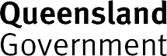

Copyright
This publication is protected by the Copyright Act 1968.
© State of Queensland 2022.
Licence
This work is licensed by the Department of the Premier and Cabinet under a Creative Commons Attribution (CC BY)
4.0 International licence. To view a copy of this licence, visit: https://creativecommons.org/licenses/by/4.0/
You are free to copy, communicate and adapt this publication, as long as you attribute appropriately, including:
- The name of the publication “Queensland Government fourth annual progress report Royal Commission into Institutional Responses to Child Sexual Abuse”
- A link to the work if you have sourced it online
- The copyright licence statement above
- Indicate if you have made changes to the work.

Contents
Message from the Minister 2
Overview 4
Our approach to implementation 5
Snapshot of 2021 progress 7
2021 Update from the Truth, Healing and Reconciliation Taskforce 10
Theme 1: Prevention and growing safer organisations 13
2021 Highlights 14
Looking forward 22
Theme 2: Protecting children and young people 23
2021 Highlights 24
Looking forward 32
Theme 3: Healing and support 33
2021 Highlights 34
Looking forward 39
Information about support services 40

Message from the Minister
It is my privilege to present the Queensland Government’s fourth annual progress report on implementation of recommendations by the Royal Commission into Institutional Responses to Child Sexual Abuse (Royal Commission).

The annual progress report outlines the Queensland Government’s work over 2021 to continue to implement the extensive reforms recommended by the Royal Commission. At the heart of these reforms are the lived experiences of thousands of courageous
Queenslanders who have come forward to share their experiences, determined to make a difference in the lives of children today.
In Queensland, we ensure our implementation of Royal Commission recommendations is informed by people with lived experience through our Truth, Healing and Reconciliation Taskforce (the Taskforce). Mr Robert (Bob) Atkinson AO APM continues to chair the Taskforce and this year welcomed new members. The Taskforce has been travelling across the state on its Listening Tour of community forums and I thank each Taskforce member for their contribution to this important work in 2021.
The annual progress report outlines the Queensland Government’s many significant achievements to give effect to the Royal Commission’s findings and recommendations. Many of these achievements are the culmination of several years of work and consultation.
This year, we continued to focus on the Royal Commission’s 10 child safe standards. Queensland Government agencies are incorporating the child safe standards into our work with children, and we have made good progress with our project to identify options for regulation and oversight. Thank you to everyone who participated in the Growing child safe organisations in Queensland consultation process earlier in the year. Your feedback and views are continuing to inform this work.
In late 2021, we saw the release of two national strategies, Safe and Supported: The National Framework for Protecting Australia’s Children and the National Strategy to Prevent and Respond to Child Sexual Abuse, which commit us to working together with the Federal Government over the next 10 years to make Australia safer for children.
On 5 July 2021, the responsibilities of Queenslanders to report child sexual abuse to police were strengthened when new criminal offences of failure to report belief of a child sexual offence and failure to protect a child from a child sexual offence came into effect. We also introduced amendments to Queensland’s blue card system to enhance its protections to children.
Protecting and supporting children in the child protection system is a priority for the Queensland Government. Amendments to the Child Protection Act 1999 were introduced into the Legislative Assembly to strengthen children’s rights and voices and establish a

carers register. We are working on improving our approach to kinship care by developing a new stand-alone program tailored to the support needs of family caring for family. This work will continue over the next few years.
We continued our commitment to Our Way: A generational strategy for Aboriginal and Torres Strait Islander children and families 2017–2037 (Our Way) in partnership with Family Matters Queensland. We have started implementation of delegated authority in early adopter sites on the Sunshine Coast and Rockhampton, and our investment in Aboriginal and Torres Strait Islander Family Wellbeing Services is increasing culturally safe support to Aboriginal and Torres Strait Islander children and families and diverting them from the child protection system.
The Queensland Government has now been participating in the National Redress Scheme for over three years. Over the past year, we have continued our focus on encouraging Queensland non-government institutions to participate in the National Redress Scheme, to ensure as many eligible Queenslanders as possible have access to redress. We are also working with the Federal Government and state and territory governments to improve the operation of the National Redress Scheme and respond to the findings of its second year review.
Queensland Government agencies are implementing trauma-informed strategies and practices to better respond to people with lived experience. Training has been a theme of our activity this year, with training programs to support trauma-informed responses being rolled-out in the Queensland Police Service, Victim Assist Queensland, Queensland Corrective Services and Housing and Homelessness Services.
As well as training police in their work with people with lived experience, we are supporting witnesses with the commencement of the pilot Queensland Intermediary Scheme in Cairns and Brisbane. In addition, women’s experiences of Queensland’s criminal justice system are being considered by the Women’s Safety and Justice Taskforce, which will provide a report to the Attorney-General and Minister for Justice by June 2022.
We have come a long way over the past four years in progressing the reforms recommended by the Royal Commission and there is more to do. As recommended by the Royal Commission, our commitment to annual reporting will conclude in 2022 with our fifth and final annual progress report. However, our work embedding the Royal Commission’s reforms will not end next year. Our work to grow child safe organisations, protect children and support people with lived experience will continue well beyond 2022.

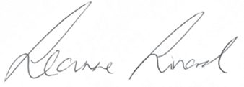

The Honourable Leanne Linard MP
Minister for Children and Youth Justice and Minister for Multicultural Affairs

Overview
Over its five-year inquiry, the Royal Commission into Institutional Responses to Child Sexual Abuse (Royal Commission) heard of the many and systemic failings of institutions to prevent, detect and appropriately respond to child sexual abuse. The Royal Commission made a total of 409 recommendations which weave together a far-reaching and ambitious reform agenda to fundamentally change how we see and respond to institutional child sexual abuse in Australia.
The Royal Commission’s 409 recommendations are contained in four reports:
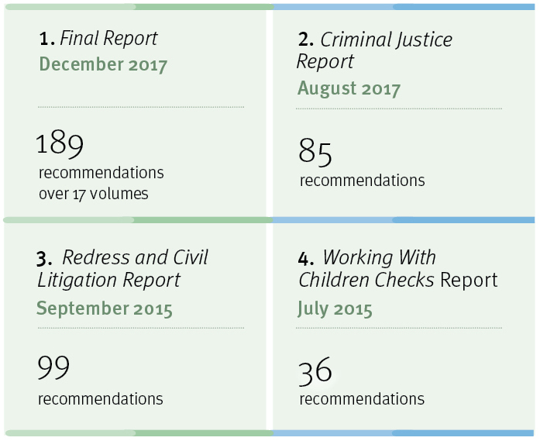

The Royal Commission’s recommendations for reform are complex, inter-related and encompass all institutions engaging with children and young people. The Royal Commission has called for action from federal, state and territory governments, non- government institutions as well as the broader community. Many recommendations require long-term and sustained work to embed new practices, develop new laws and build new systems of regulation and oversight. Some recommendations aim for national approaches to prevent child sexual abuse and support the healing of people with lived experience of institutional child sexual abuse.

Our approach to implementation
Of the 409 recommendations made by the Royal Commission, 317 are directed at the Queensland Government, either in full or in part.
In Queensland’s 2020 annual progress report, we introduced a new way of understanding and organising these recommendations across three key themes. These themes encapsulate our approach to our Royal Commission reforms and have been carried through in this report.
The three key themes are:
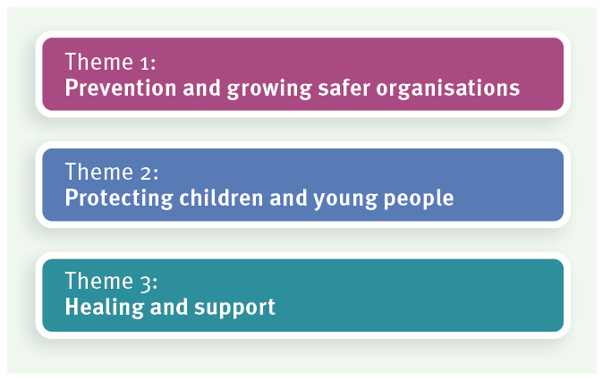

Prevention and growing safer organisations is focused on not repeating the mistakes of the past. This theme aims to grow child safe organisations and support the community to ensure they are better equipped to keep children and young people safe. This theme includes our work on implementing the Royal Commission’s child safe standards and the development of national approaches including the National Strategy to Prevent and Respond to Child Sexual Abuse and Safe and Supported: The National Framework for Protecting Australia’s Children.
Protecting children and young people includes prevention and better detecting and responding to child sexual abuse when it occurs in institutions now. This includes improving reporting and information sharing and making our responses to children and young people sensitive to the trauma they have experienced. It also covers enhancements to the criminal justice system recommended by the Royal Commission to better protect children and young people.
Healing and support recognises the profound and ongoing impact of institutional child sexual abuse on people with lived experience. The focus of this theme is taking responsibility for the mistakes of the past by our participation in the National Redress Scheme, reforms to civil litigation and by improving how support services and the criminal justice system respond to people with lived experience. Under this theme of healing and support, we are also responding to the complexities of responding to children with harmful sexual behaviours.

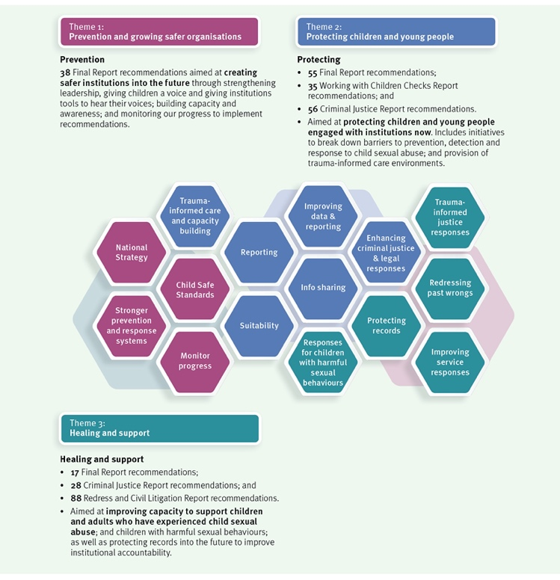
The diagram below further explains how our themes align with the 317 Royal Commission recommendations directed to the Queensland Government, either in full or in part.

Snapshot of 2021 progress
The Queensland Government has now completed 183 of the 317 recommendations directed to the Queensland Government, either in full or in part, by the Royal Commission. These recommendations are summarised below.
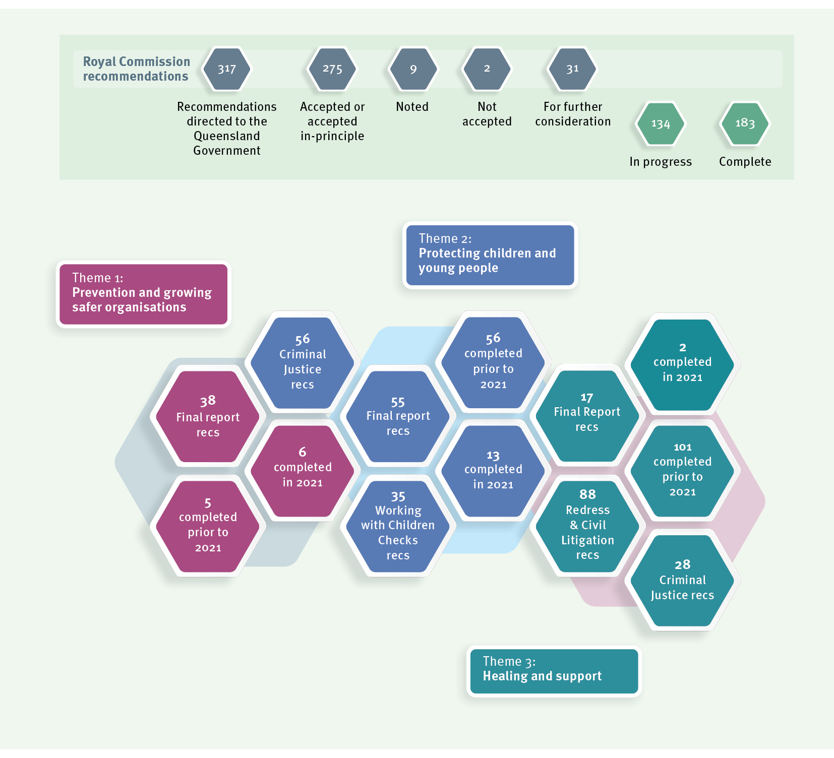

in 2021

This report outlines the Queensland Government’s actions over 2021 to contribute to the path set out by the Royal Commission. It shows how we are building on the substantial work of the last three years as outlined in our previous annual reports. These reports can be found here: www.cyjma.qld.gov.au/about-us/reviews-inquiries/queensland- government-response-royal-commission-institutional-responses-child-sexual-abuse.
The Royal Commission’s recommendations are far reaching and span all government agencies that interact with children. This report reflects work from a range of Queensland Government agencies, including the Department of the Premier and Cabinet; Queensland Treasury; the Department of Justice and Attorney-General; Department of Education; Queensland Health; the Queensland Police Service; the Department of Children, Youth Justice and Multicultural Affairs; the Department of Seniors, Disability Services and Aboriginal and Torres Strait Islander Partnerships; and the Department of Communities, Housing and Digital Economy.
This report also describes our collaboration with the Federal Government and state and territory governments, including through the Community Services Ministers’ meeting, the Education Ministers’ meeting and the Ministers’ Redress Scheme Governance Board. Reports by the Federal Government on national work can be found here: www.childabuseroyalcommissionresponse.gov.au.

The Queensland context
Best practice shows the need to continually improve our services and responses to children and young people. While we work our way through the Royal Commission’s recommendations, the Queensland Government remains committed to progressing reforms and initiatives that have come from reviews and inquiries that have been conducted here in Queensland.
Many of these Queensland initiatives focus on some of our most vulnerable children and young people — children and young people who are in contact with the child protection and youth justice systems. These reforms include Supporting Families, Changing Futures, which flow from recommendations of the Queensland Child Protection Commission of Inquiry; the Queensland Family and Child Commission (QFCC) reviews of the blue card and foster care systems; and the Independent Review of Youth Detention.
These reforms, including the Royal Commission’s recommendations, are aligned towards a shared purpose. Together, they aim to keep Queensland children and young people safe and supported to reach their full potential.
We know that we need to apply the lessons learned from all these reviews and inquiries. To ensure comprehensive and cohesive responses, we have been working to deliver on recommendations in a way that builds on and progresses the shared aims and intent of each review and inquiry.

Our commitment to annual reporting
As recommended by the Royal Commission, and in line with the Federal Government and other state and territory governments, we have committed to tabling an annual progress report on Queensland Government implementation of Royal Commission recommendations for five consecutive years.
Our 2021 annual progress report is our fourth report, with our commitment to annual reporting concluding with our 2022 annual progress report.
Our efforts across our three themes of prevention and growing safer organisations; protecting children and young people; and healing and support will continue well beyond 2022.

2021 Update from the Truth, Healing and Reconciliation Taskforce
The Truth, Healing and Reconciliation Taskforce (the Taskforce) was established in 2018 to advise the Queensland Government on the implementation of Royal Commission reforms.
The Taskforce is chaired by Mr Bob Atkinson, AO APM, former Queensland Police Commissioner and Commissioner for the Royal Commission, and includes membership of four people with lived experience of institutional child abuse, two representatives of services that support people with lived experience, one representative of out-of-home care providers and one religious institution representative. In 2021, Taskforce membership was expanded to include a representative of an organisation that supports children and young people.
During 2021, the Taskforce met formally five times, focused on three priorities of:

1. implementation of the Royal Commission recommendations;
2. increasing community awareness of institutional child abuse, its impact and the work of the Royal Commission; and
3. the National Redress Scheme.

- Implementation of the Royal Commission recommendations
Queensland is in a unique position in our implementation of Royal Commission recommendations because we can draw on the expertise and lived experience of Taskforce members.
In 2021, the Taskforce was consulted on a range of Royal Commission recommendations including:
- the development of the Queensland Intermediary Scheme pilot program, noting the far-reaching impact this scheme may have for people with lived experience;
- implementation of child safe standards by Queensland Government departments; and
- the Queensland project underway to develop options for regulation and oversight of child safe standards in Queensland, as well as a Queensland reportable conduct scheme.
More information about these initiatives can be found further in this report.

- Community awareness

Listening Tour
In February 2020, the Taskforce launched its statewide Listening Tour with its first community forum in Toowoomba. With further forums placed on hold in 2020 due to the impact of the COVID-19 pandemic, 2021 has seen the re-establishment of the Taskforce’s Listening Tour.
The purpose of the Listening Tour is to raise awareness of institutional child abuse and its impact; hear from people with lived experience, their supporters and service providers about the implementation of Royal Commission reforms; and provide information on the National Redress Scheme. The Taskforce acknowledges the contributions of knowmore Legal Service and Lotus Place (Redress Support Services) in delivering the forums.
Over 2021, the Taskforce held forums in Cairns, Townsville, Rockhampton, the Sunshine Coast and the Gold Coast. Over 300 people across Queensland have participated in these forums.
While in these locations, the Taskforce took the opportunity to connect with services and to hear from them about the work they are doing in Queensland. These conversations focused on out-of-home care as well as supporting Forgotten Australians and people with lived experience. Similar meetings were also held in the Brisbane area.

Presentations
During 2021, Mr Bob Atkinson, Taskforce Chair, led Taskforce presentations at the:
- Second Vulnerable Persons Conference in Toowoomba, hosted by the University of Southern Queensland (May 2021);
- Fourth National Child Protection Forum in Darwin via audio-visual link (July 2021); and
- Daniel Morcombe Foundation’s Changing Futures Forum (September 2021).
Mr Atkinson was also a keynote speaker at the Australian Society of Archivists national conference in September 2021.

Truth, Healing and Reconciliation Grants program
As part of our response to the Royal Commission, the Queensland Government established the Truth, Healing and Reconciliation Grants Program. The purpose of the grants program is to support activities that contribute to truth telling, healing and reconciliation in Queensland and that partner with people with lived experience.
The Department of Children, Youth Justice and Multicultural Affairs delivers the grant program, with representatives from the Taskforce holding positions of Special Advisors on the evaluation panels. In 2021, Taskforce members provided advice on two Truth, Healing and Reconciliation Grant Program rounds.

- National Redress Scheme
People with lived experience continue to talk with Taskforce members about the operation of the National Redress Scheme, and it continues to be a priority area of work for the Taskforce. In addition to providing information about the National Redress Scheme at its community forums, work of the Taskforce in 2021 included:
- participating in the training of 20 senior executive officers across the Queensland Government to support them to provide meaningful and trauma-informed direct personal responses as part of the National Redress Scheme;
- providing advice to the Department of Children, Youth Justice and Multicultural Affairs about the delivery of counselling and psychological care which is a Queensland Government responsibility in the National Redress Scheme; and
- sharing views with the Department of Children, Youth Justice and Multicultural Affairs on the Federal Government’s second year review of the National Redress Scheme.
During 2021, the Taskforce continued to talk with people with lived experience about what matters to them. For Taskforce members, it remains a privilege to hear from people about their experiences and the impact of institutional child abuse on their lives. While remaining confidential, the Taskforce reflects these discussions in the advice it gives to the Queensland Government.

Looking forward
Looking forward, the Taskforce plans to:
- continue to provide advice to the Queensland Government on implementation of Royal Commission recommendations;
- continue to hear from people with lived experience, their supports and service providers from across the state;
- continue its role as Special Advisors to the Truth, Healing and Reconciliation Grants Program with the grants program also concluding in 2022; and
- provide advice to the Minister for Children, Youth Justice and Minister for Multicultural Affairs on the themes arising from the Taskforce’s Listening Tour.
Consistent with the commitment to annual reporting concluding in 2022, the operation of the Taskforce is scheduled to conclude in 2022.

Theme 1: Prevention and growing safer organisations

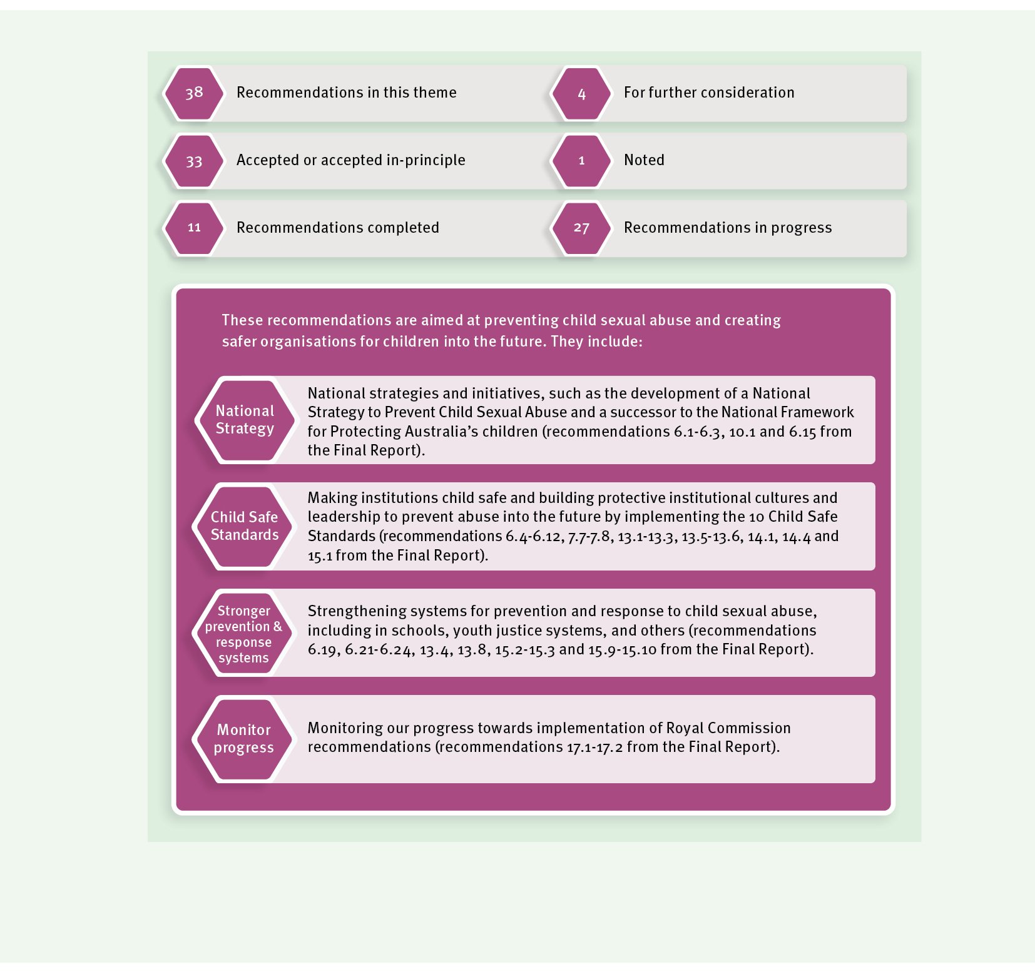

Child safety and wellbeing is embedded in organisational leadership, governance and culture.

Policies and procedures document how the organisation is safe for children and young people.

Implementation of the national child safe principles is regularly reviewed and improved.
Physical and online environments promote safety and wellbeing while minimising the opportunity for children and young people to be harmed.
Staff and volunteers are equipped with the knowledge, skills and awareness to keep children and young people safe through ongoing education and training.

Processes to respond to complaints and concerns are child focused.
People working with children and young people are suitable and supported to reflect child safety and wellbeing values in practice.

Equity is upheld and diverse needs respected in policy and practice.

Families and communities are informed and involved in promoting child safety and wellbeing.
Children and young people are informed about their rights, participate in decisions affecting them and are taken seriously.

2021 highlights
In this report we use the terms ‘child safe standards’ and ‘National Principles’ to broadly refer to the Royal Commission’s 10 child safe standards and the National Principles for Child Safe Organisations.
The Royal Commission made a range of recommendations, across several of its reports, about institutions implementing the 10 child safe standards. This included recommendation 6.7 that the child safe standards should be adopted as part of the National Principles for Child Safe Organisations (National Principles), developed by the Community Services Ministers’ Meeting, and endorsed by the former Council of Australian Governments (COAG).
The National Principles incorporate the Royal Commission’s child safe standards, and as they were endorsed by COAG on 19 February 2019, recommendation 6.7 was completed in 2019.
This means when we are talking in this report about the ‘child safe standards’ and ‘National Principles’ we are talking about 10 standards, or principles, that were designed by the Royal Commission to grow child safe organisations.

Figure: National Principles for Child Safe Organisations (source: National Office for Child Safety https://childsafety.pmc.gov.au/resources/national-principles-child-safe-organisations-poster)

Child safe standards
In our first annual progress report in 2018, the Queensland Government accepted the child safe standards as informing best practice for departments that provide services to children.

Snapshot of child safe standards in the Queensland Government
In 2021, Queensland Government departments have continued to incorporate child safe standards into our work including:
- The Department of Education’s continuing commitment to the safety and wellbeing of children and young people is showcased through the Aware. Protective. Safe Strategy (the Strategy). The Strategy was developed and released in 2020 and is featured in our third annual report. Since then, the Department of Education has continued to work on the Strategy with a second version in August 2021. In addition, the Department of Education released the Child Safe Environment Map and Child Safe Environment Report, further reinforcing how we are building on our existing child safe environment by implementing the National Principles.
- During 2021, the Department of Education provided information to principals and staff in state schools to ensure school leaders and school staff are aware of the National Principles and how they can be implemented within schools to build child safe organisations. The Department of Education has also provided information to non-state schools through relevant unions and peak bodies. Work is underway overseeing the implementation of the child safe standards in the non-state schooling sector, with input from key stakeholders.
- In 2021, the Department of Education published a dedicated section within the Student Protection guidelines to address the diverse needs of students with disability, including students with complex communication needs or cognitive disability.
- Children’s Health Queensland Hospital and Health Service reviewed the Keeping Kids Safe: Children Health Queensland’s Child and Youth Risk Management Strategy and its associated documents including the Keeping Kids Safe Statement of Intent and Code of Conduct for Interacting with Children and Young People. Keeping Kids Safe acknowledges that all children have the right to be safe from harm, everywhere, anytime and places the safety and wellbeing of children as our highest priority.
- The Department of Children, Youth Justice and Multicultural Affairs has developed a Roadmap to Embedding the National Principles for Child Safe Organisations (the Roadmap). The Roadmap sets out existing initiatives aligned with the National Principles and identifies further actions to ensure the National Principles are embedded in our work. Most of these actions are planned for delivery or completion during 2022.
- As part of the Skilling Queenslanders for Work initiative, the Department of Employment, Small Business and Training has developed a fact sheet to assist community-based providers implement and adhere to the National Principles. The Operating Standards for Young People Under 18 fact sheet is part of the Skilling Queenslanders for Work provider kit and is available online. The Skilling Queenslanders for Work initiative funds training and support for people seeking employment including young people.

- Queensland Fire and Emergency Services’ Safety for Children Risk Management Strategy supports implementation of blue cards across the service. Queensland Fire and Emergency Services is continuing blue card screening for approximately 28,000 staff and volunteers that fall under Queensland’s blue card legislation. As at 30 June 2021, 91 per cent of this workforce hold a blue card. This includes 99.5 per cent of the Fire and Rescue Service, 97.6 per cent of the State Emergency Service and 86.5 per cent of the Rural Fire Service. Queensland Fire and Emergency Services continues to support staff and volunteers who need to apply for their blue card to be able to continue in their role of protecting the community.
- The Department of Tourism, Innovation and Sport (Sport and Recreation) is committed to implementing the National Principles across departmental policies, procedures and practices, including through the Child and Youth Risk Management Strategy and Guidelines. Sport and Recreation is continuing to review policies and procedures to ensure they align with and implement the National Principles. We publish and promote a range of resources on the Queensland Government website to support the sport and active recreation industry in its obligations to protect children, young people and adults from harm.
- The Department of Justice and Attorney-General is committed to being a child safe institution where service delivery upholds the safety, wellbeing and best interests of children and young people. We have identified opportunities to strengthen our child safe culture and are working on actions to align relevant policies, practices and training with the child safe standards.
- The Department of Transport and Main Roads School Crossing Supervisor Scheme ensures all School Crossing Supervisors are compliant with the child safe standards.
- The Department of Communities, Housing and Digital Economy continues to strengthen its commitment to the integration of child safe standards in existing policies, procedures and operational practices.

Improving regulation and oversight
In our 2020 report, we described two projects that had recently commenced in Queensland to progress implementation of child safe organisations.
The Queensland Government is looking at options for potential regulation and oversight of child safe standards across Queensland (led by the Department of Children, Youth Justice and Multicultural Affairs), as well as scoping options for a Queensland reportable conduct scheme (led by the Department of Justice and Attorney-General).
During 2021, these projects were progressed together with both departments working closely on a coordinated and integrated response. Earlier in the year, we released the consultation paper, Growing child safe organisations in Queensland to support targeted consultation with peak bodies and other representative organisations in the sectors the Royal Commission recommended should comply with child safe standards.

The views of stakeholders are informing the development of options for potential regulation and oversight of child safe standards across Queensland, as well as options for a Queensland reportable conduct scheme. We are continuing to scope these options to determine the best way forward for Queensland.

Online safety in schools
The Department of Education supports every child and young person in Queensland state schools to learn and engage safely when online. We recognise that keeping children and young people safe online is a shared responsibility and is not something that can be achieved without the combined efforts of schools, families, communities, elders and government.
In its Final Report, the Royal Commission made several recommendations relating to online safety in schools. While we are still working on some of these recommendations, this year we completed the Royal Commission’s recommendations that the Office of the eSafety Commissioner develop an online safety framework and resources (recommendation 6.22) and that states and territories introduce centralised mechanisms to support schools when online incidents occur (recommendation 6.23). When making this recommendation, the Royal Commission recognised the work of Queensland’s Training’s Cyber Safety and Reputation Management Unit and recommended states and territories consider adopting this model.
We have adopted the eSafety Commissioner’s online safety framework and developed a range of resources to support online safety education, awareness and incident prevention. Following review, new behaviour procedures, student code of conduct and appropriate use of social media policy have been released and supported by a state-wide professional development program. We regularly share information, current challenges and resources with peak bodies to assist the non-state schooling sector.
In addition, with the rise of technology and increasing access for young people, and in response to the Royal Commission, we have developed Online Safety in Queensland State Schools. Online Safety in Queensland State Schools provides guidance on how we respond to online issues and support schools, students, parents and the community to keep young people safe online.

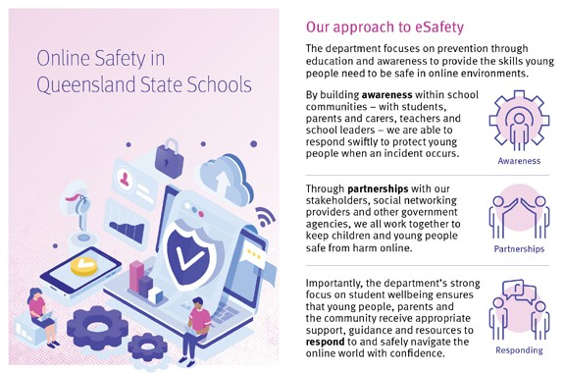

We will continue to create physical and online environments that promote the safety and wellbeing of children and young people, while minimising the opportunity for harm. Enhanced opportunities for cyber-safety education will be explored through the review of the Australian Curriculum with support from our Cyber Safety and Reputation Management Unit.
We are still working on the Royal Commission’s recommendations regarding a nationally consistent curriculum for online safety education in schools and education and training on child sexual abuse prevention. In relation to these recommendations (6.19 and 6.21):
- Online safety education is included in the Australian Curriculum (Prep to Year 10) and the Queensland Senior Curriculum (Years 11-12). The Department of Education is supporting Queensland schools implement this curriculum by:
- monitoring research on best practice in online safety education to review existing programs and resources for currency and to provide advice for schools; and
- distributing eSafety resources to children, parents and schools to promote and support access to the resources of the Office of eSafety Commissioner.
The Federal Government has commissioned the Australian Institute of Family Studies to develop nationally consistent guidance for teachers and principals for preventing and responding to child sexual abuse. We will continue this work with the Australian Institute of Family Studies and when it is finished, we will determine the appropriate options for implementation and distribution to Queensland schools.

Child safe boarding schools and student hostels
The Department of Education prioritises the safety and wellbeing of students in residential facilities. As recommended by the Royal Commission, we will continue to support boarding and hostel providers to provide child safe environments for Aboriginal and Torres Strait Islander students.
The Queensland Student Hostel Support Scheme provides financial assistance to community-run hostels that deliver accommodation for geographically isolated students who need to board away from home to attend school. The Queensland Government has accepted in-principle the recommendations of the Royal Commission that relate to hostels, including the implementation of the child safe standards.
In addition to the recommendations of the Royal Commission, the Queensland Government has accepted the Queensland Anti-Cyberbullying Taskforce recommendation that hostel staff have training and competencies to prevent and respond to cyberbullying, based on best practice standards. Hostels are required to have acceptable policies and procedures in place which demonstrate implementation of the National Principles and are required to have implemented cyberbullying training in the first half of 2022.

Child safe youth detention centres
The Royal Commission found that contemporary youth detention settings pose present and future challenges for the safety and wellbeing of young people. This is because these environments are characterised by a significant power imbalance between adult staff and young people and connections to outside supports and family members can be variable.
Following the release of Working Together Changing the Story: Youth Justice Strategy 2019– 2023 in December 2018, the Queensland Government remains committed to reforming the Queensland youth justice system and keeping communities safe.
In December 2020, the new 32 bed West Moreton Youth Detention Centre at Wacol commenced operating. As a smaller centre, the West Moreton Youth Detention Centre enables a holistic approach to young people and includes enhanced safety and security to maximise the safety of young people.
Safety and security have also been enhanced in the Cleveland and Brisbane Youth Detention Centres through upgraded infrastructure and new accommodation units. In line with recommendations by the Royal Commission, common areas within youth detention centres have closed circuit television (CCTV) coverage and body worn cameras have been implemented for operational staff.
The Department of Children, Youth Justice and Multicultural Affairs remains committed to supporting young people in youth detention to have their voices heard through internal and external complaints mechanisms.
In relation to the oversight of youth detention centres, the Department of Children, Youth Justice and Multicultural Affairs continues to facilitate the access of various internal and external oversight bodies to centres, young people and staff as well as records and

documents. External oversight includes the Office of the Public Guardian, the Queensland Ombudsman, the Queensland Human Rights Commission and the Crime and Corruption Commission with internal oversight consisting of the Youth Detention Inspectorate and the Professional Standards Unit.
Further work is underway to strengthen external oversight of youth detention centres. On 28 October 2021, we introduced the Inspector of Detention Services Bill 2021 into the Legislative Assembly. The Bill is to establish the independent Inspector of Detention Services to oversee youth detention centres, community corrections centres, prisons, work camps and watch houses.

A child safe Australia
Following delays due to the COVID-19 pandemic, 2021 has seen the release of two national approaches to child protection, as recommended by the Royal Commission, with the release of Safe and Supported: The National Framework for Protecting Australia’s Children 2021-2031 (Safe and Supported) and the National Strategy to Prevent and Respond to Child Sexual Abuse 2021–2030 (National Strategy).
We will continue to work on Safe and Supported and the National Strategy for the next 10 years. The finalisation of Safe and Supported and the National Strategy means we can now complete recommendations 6.1, 6.2, 6.3 and 6.15, with this work transitioning to ongoing implementation.

Safe and Supported: The National Framework for Protecting Australia’s Children 2021–2031 During 2021, the Department of Children, Youth Justice and Multicultural Affairs worked with the federal Department of Social Services, state and territory governments, the Secretariat of National Aboriginal and Islander Child Care (SNAICC) and the Aboriginal and Torres Strait Islander Leadership Group on the development of Safe and Supported. The Community Services Ministers’ Meeting launched Safe and Supported on 8 December 2021.
Safe and Supported is the successor to the previous National Framework for Protecting Australia’s Children 2009–2020. It aims to make significant and sustained progress in reducing the rates of child abuse and its intergenerational impacts through four focus areas:
- Focus Area 1: A national approach to early intervention and targeted support for children and families experiencing vulnerability or disadvantage;
- Focus Area 2: Addressing the over-representation of Aboriginal and Torres Strait Islander children in child protection systems;
- Focus Area 3: Improving information sharing, data development and analysis; and
- Focus Area 4: Strengthening the child and family sector and workforce capability.
Safe and Supported will be implemented through two five-year action plans over 2022–2026 and 2027–2031. There will also be an Aboriginal and Torres Strait Islander specific action plan to recognise the unique strengths and needs of Aboriginal and Torres Strait Islander children, families and communities.
Safe and Supported can be found at: www.dss.gov.au/our-responsibilities/families-and- children/programs-services/protecting-australias-children.

National Strategy to Prevent and Respond to Child Sexual Abuse 2021–2030
During 2021, the Queensland Government worked with the National Office for Child Safety and state and territory governments on the development of the National Strategy. On 27 October 2021, the Federal Government launched the National Strategy.
The National Strategy is the first time federal, state and territory governments have come together in a shared commitment to prevent child sexual abuse in all settings and support people with lived experience.
The aim of the National Strategy is to protect children from child sexual abuse, support people with lived experience and reduce the risk, extent and impact of child sexual abuse and related harms in Australia.
The National Strategy has a 10-year lifespan and will be implemented through a series of action plans. The first National Action Plan will run for four years from 2021 to 2024, and includes five priority themes:
- Theme 1: Education and building child safe cultures;
- Theme 2: Supporting and empowering victims and survivors;
- Theme 3: Enhancing national approaches to children with harmful sexual behaviours;
- Theme 4: Offender prevention and intervention; and
- Theme 5: Improving the evidence base.
The Queensland Government’s participation in the National Strategy builds on the stand we have taken against sexual violence through Prevent. Support. Believe. Queensland’s Framework to address Sexual Violence, and makes sure we continue to have a dedicated focus on preventing and responding to child sexual abuse in Queensland.
As recommended by the Royal Commission (recommendation 10.1), the National Strategy includes the issue of children with harmful sexual behaviours. We are working on responses to children with harmful sexual behaviours and there is more to do before we can complete this recommendation.
The National Strategy can be found at: www.childsafety.pmc.gov.au/what-we-do/national- strategy-prevent-child-sexual-abuse.

Prevention education in Queensland schools
The Royal Commission recommended the National Strategy include prevention education through schools to increase children’s knowledge of child sexual abuse and strengthen self-protective skills and strategies.
While the National Strategy has been developing, the Australian Curriculum, Assessment and Reporting Authority has been reviewing the Australian Curriculum. Within the Australian Curriculum, the Health and Physical Education learning area provides opportunities for all students to build their understanding of identity, relationships, sexuality, mental health, wellbeing, safety, ethical decision-making, rights, equality and respect within all relationships.

The Department of Education has provided feedback on the draft revised Australian Curriculum including feedback on respectful relationships education. The revised Australian Curriculum is due for release in 2022.
All Queensland state schools are required to provide health and wellbeing education, including respectful relationships education, as part of the Australian Curriculum or as part of the school’s pastoral care program. All Queensland schools have access to the Department of Education’s Prep to Year 12 respectful relationships education program to support delivery of respectful relationships education and sexuality education.
The Department of Education is undertaking a review of our respectful relationships education program to strengthen education on sexual consent education, help seeking strategies and reporting of sexual assault in Queensland schools. We will review and update existing education programs for currency and to strengthen support for schools and teachers, once the refinements to the Australian Curriculum content are released in 2022.

Policing online safety
Throughout 2021, the Queensland Police Service continued to chair Operation Griffin which is the national child protection policing committee. Operation Griffin provides advice to the Serious and Organised Crime Coordination Committee and has contributed to the development of the National Strategy. As recommended by the Royal Commission, the Queensland Police Service will continue to support and contribute to national capability for coordinated, best practice law enforcement responses to online child sexual abuse.

Looking forward
In 2022, the Queensland Government will continue our work to prevent child sexual abuse and grow child safe organisations by:
- continuing to implement child safe standards and national principles in Queensland Government departments;
- determining suitable options for potential regulation and oversight of the application of child safe standards by child safe organisations and scoping options for a reportable conduct scheme;
- transitioning to implementation of Safe and Supported: The National Framework for Protecting Australia’s Children 2021–2031 and the National Strategy to Prevent and Respond to Child Sexual Abuse 2021–2030; and
- improving respectful relationships education in Queensland schools.

Theme 2: Protecting children and young people
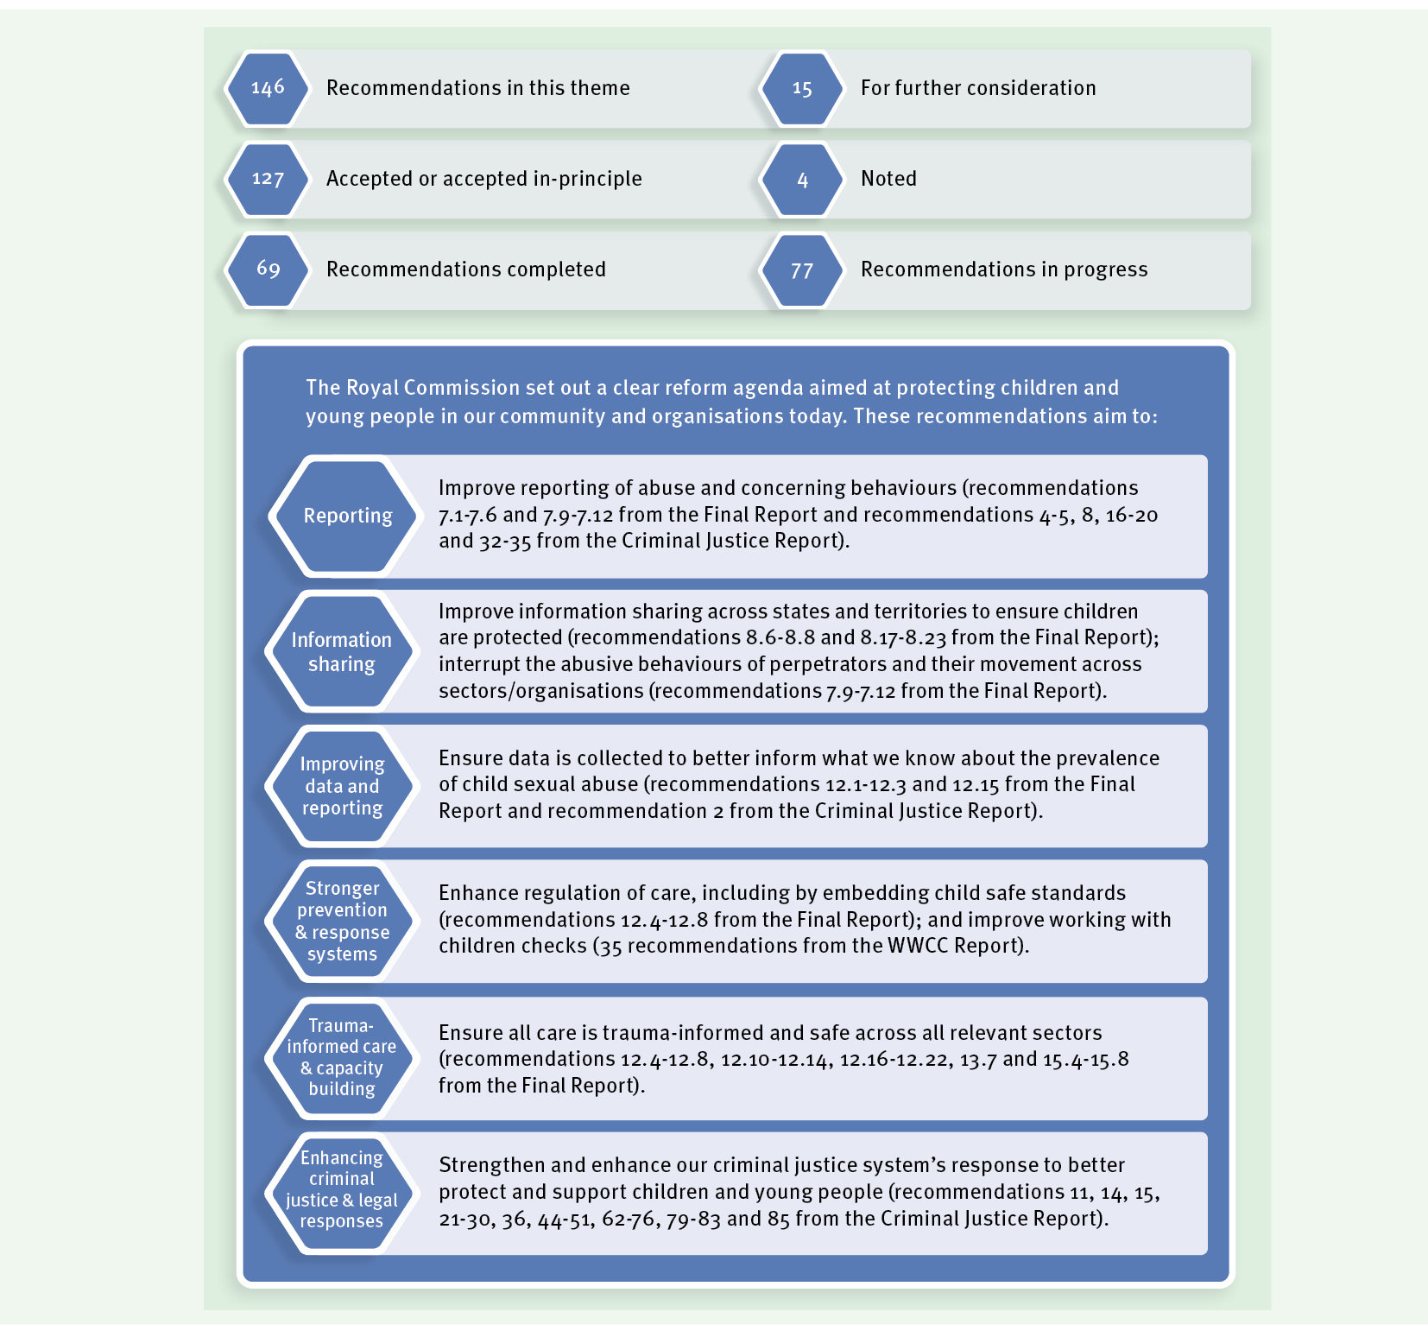

2021 Highlights
The Queensland Government continues to reform the criminal justice system’s response to child sexual abuse and to better support people with lived experience.

Protecting children with the commencement of new offences
In our 2020 annual progress report, we noted that a number of Royal Commission recommendations were implemented with the passage of the Criminal Code (Child Sexual Offences Reform) and Other Legislation Amendment Act 2020 in the Legislative Assembly on 8 September 2020.
While most of these amendments commenced on 15 September 2020, the new offences of failure to report belief of a child sexual offence and failure to protect a child from a child sexual offence came into effect on 5 July 2021.
The new reporting offence mandates that all adults, unless they have a reasonable excuse, must report to police information that causes them to believe on reasonable grounds, or ought reasonably have caused them to believe, a sexual offence has been committed against a child by another adult. The offence explicitly applies to information gained in connection with a religious confession. This means we can now complete recommendations 33 to 36 from the Criminal Justice Report.
In relation to blind reporting, the Department of Justice and Attorney-General has considered these recommendations and consulted the judiciary, government departments and legal and other stakeholders. With the finalisation of this work, recommendations 16 to 19 can now be completed.
In addition, on 15 September 2021, the Child Protection Reform and Other Legislation Amendment Bill 2021 was introduced into the Legislative Assembly. Clause 61 of the Bill responds to recommendation 8 of the Royal Commission’s Criminal Justice Report by clarifying when a notifier’s identity can be disclosed to a law enforcement agency. This amendment aims to assist the investigation of criminal offences against children and young people and safeguard the safety, welfare and wellbeing of a child or young person. As work is underway on implementation, our response to this recommendation has moved from for further consideration to accept in-principle.

Protecting children by enhancing the Queensland blue card system
In our 2020 annual progress report, we highlighted the introduction of the ‘No Card, No Start’ requirement which means that people now need a blue card before they can start working with children.
On 15 September 2021, we introduced further amendments to the Working with Children (Risk Management and Screening) Act 2000 (WWC Act) to facilitate Queensland’s participation in the Working with Children Check National Reference System. These amendments will allow Blue Card Services to mutually recognise an adverse decision

about a person which is in effect in another jurisdiction. This means that a person who is currently prohibited from working with children in another state or territory will be prohibited from working with children in Queensland.
These amendments meet one of the objectives of the Royal Commission which is to achieve greater transparency and consistency in worker screening decision-making across Australia.
Other amendments introduced during 2021 that will further enhance the protections afforded by the blue card system include:
- enabling Blue Card Services to request domestic violence information from police as part of a blue card assessment;
- elevating a number of Commonwealth Criminal Code offences (including child sexual abuse offences and offences relating to organ trafficking) to the serious and disqualifying offence framework under the WWC Act;
- redesigning the categories of regulated employment and regulated business under the WWC Act for licensed care services to better reflect the contemporary service delivery model used by services such as greater outsourcing to contractors and subcontractors; and
- enabling a licensee to have greater visibility over the blue card status of each person performing a risk-assessed role for their service which is operated under the licence.
In addition, worker screening for the National Disability Insurance Scheme (NDIS) commenced in Queensland on 1 February 2021. As part of the new system, a combined application process has been implemented which allows a person to apply for both a blue card and disability worker screening clearance through a single application. Information sharing arrangements have also been expanded so that the blue card and disability worker screening systems can share certain information with each other, as required.
Our 2020 report noted that an online processing system for the blue card system went live on 31 August 2020. This means that applicants for a blue card can now apply and pay for their card online, which has reduced processing timeframes for most people.
Most applications processed are for people who do not have any assessable information (e.g. police or disciplinary information) or their assessable information is of a less complex nature and generally will not impact their ability to work with children.
Between 31 August 2020 and 30 June 2021, the average processing time for online applications made by people without any form of assessable information was three business days. The average processing time for online applications made by people with less complex police information was 14 business days.
As both of these averages are within the benchmarks set by the Royal Commission and represent processing timeframes for most people who apply for a blue card, we are now able to complete recommendation 27 from the Royal Commission’s Working with Children Checks Report.

For people who have more complex assessable information, processing timeframes for blue card applications can be lengthy. This is because such applications require a comprehensive assessment and collation of relevant information. It is also important that applicants are given an opportunity to respond to the material gathered, as required under natural justice principles.

Protecting children through information sharing and reporting
The Queensland Government has been progressing work to increase the breadth of information that is available when determining a person’s suitability to work with children and young people.

A Queensland reportable conduct scheme
The Department of Justice and Attorney-General has been working on options for a Queensland reportable conduct scheme, in collaboration with the Department of Children, Youth Justice and Multicultural Affairs who are developing options for implementation and oversight of child safe standards in Queensland. During 2021, we consulted government and non-government stakeholders to assess sector readiness, and the potential cost and resource implications of a reportable conduct scheme. This work may inform further consideration by government on options for a reportable conduct scheme.

Nationally consistent carers registers
The establishment of a legislative framework for a carers register is an interim local response to the Royal Commission’s recommendations that states and territories establish nationally consistent carers registers.
On 15 September 2021, the Child Protection Reform and Other Legislation Amendment Bill 2021 was introduced into the Legislative Assembly. The Bill proposes to amend the Child Protection Act 1999 to establish a legislative framework for a carers register which will include information about current and former approved foster and kinship carers; provisionally approved carers; applicants for carer certificates; adult household members of carers; and persons associated with licensed care services and applicants for a licence to provide a licenced care service.
It is proposed the Child Protection Regulation 2011 will also be amended to specify the information that must be recorded in the register. This is intended to capture the minimum information recommended by the Royal Commission while maintaining flexibility to implement the outcomes of any national discussions, and specific requirements for Queensland.

Ensuring robust human resource management policies and procedures in school The Department of Education has strengthened screening, recruitment and performance reviews for staff with:
- the implementation of the blue card ‘No Card, No Start’ requirement;
- amending role descriptions to include explicit statements related to child safety; and
- strengthening teacher registration arrangements in line with the Royal Commission’s recommendations and the National Review of Teacher Registration.

The Department of Education is also developing resources to induct, train and support voluntary placement students, vocational and tertiary placement students, and adult vocational education and training of students to reflect child safety and wellbeing values in practice.
Reporting to police
Our 2020 annual report included information about the online sexual assault reporting form developed by the Queensland Police Service. The online reporting form provides another way for adults to report sexual assault to police. The Queensland Police Service will continue to consult with relevant groups including sexual assault support services to encourage reporting by all groups in the community including Aboriginal and Torres Strait Islander peoples. With this work well underway, we are now in a position to complete recommendation 5 in the Criminal Justice Report.

Protecting children and young people in care
During 2021, the Department of Children, Youth Justice and Multicultural Affairs has continued to implement strategies to protect children and young people in care.

Proposed legislative changes to strengthen children’s rights and voices
As mentioned earlier in this report, the Child Protection Reform and Other Legislation Amendment Bill was introduced into the Legislative Assembly on 15 September 2021. The Bill proposes to change the Child Protection Act 1999 to strengthen children’s rights and voices, including their ability to participate in decisions about their lives. It will also make Queensland the first jurisdiction in Australia to legislate to require children to be given the opportunity to participate in policy and program development and service design.
The focus on participation within the Bill reflects the findings of the Royal Commission which highlighted that children being able to express their views and meaningfully participate in decision-making are core elements of child safe organisations.

Policy and practice changes to protect children
In previous annual reports, we have described reforms designed to improve the quality of care we provide to children and young people in foster care, kinship care and residential care. During 2021, we have continued this work with:
- The Hope and Healing Framework continues to provide the foundation of care to children and young people in residential care services. This trauma-informed practice framework is complemented by Minimum Qualification Standards which were introduced for residential care staff by the Queensland Government in 2019.
- Our ongoing investment of nearly $5 million per annum in Next Step Plus After Care services. Next Step Plus supports young people in their transition to independence including support to access targeted and therapeutic services, based on the individual needs of the young person. Next Step Plus works with young people 15 to 25 years of age.

- Resourcing the Specialist Service program within Child Safety to support young people with complex needs. Work of this team includes ensuring all eligible children and young people have access to high quality plans through the NDIS as well as identifying and responding to the therapeutic needs and supports required by children and young people. Recently, the Department of Children, Youth Justice and Multicultural Affairs updated our Positive Behaviour Support and Managing High Risk Behaviour policies which guides how we respond to children and young people with challenging behaviours stemming from their experience of trauma.
Building on this work, we have made further progress in 2021. We are completing the following three recommendations (12.6, 12.12 and 12.17), although we acknowledge this work is ongoing:
- Carer screening and assessment processes have been strengthened by expanding mandatory checks that must be completed for foster and kinship carers, as well as the ‘No Card, No Start’ blue card requirements which apply to all residential carers. The Department of Children, Youth Justice and Multicultural Affairs closely monitors foster and kinship carers and licensed care providers to ensure carers are the right people to care for children. This work also relates to recommendations from the Queensland Family and Child Commission’s Keeping Queensland’s children more than safe: Review of the foster care system and completes recommendation 12.6 from the Royal Commission. Carer screening will be further strengthened with the development of nationally consistent carers registers.
- The Department of Children, Youth Justice and Multicultural Affairs responds to the needs of children in care with harmful sexual behaviours in several ways. We continue to provide Queensland Health with approximately $20 million per year to deliver Evolve Therapeutic Services (Evolve). Evolve provides mental health therapeutic interventions for children and young people in care with complex psychological and behavioural issues including harmful sexual behaviours. In addition, our Practice Advice and Support team assists and supports with decision-making for children with harmful sexual behaviours. As this work is part of our ongoing practice, we can now complete recommendation 12.12.
- In Queensland, kinship carers are eligible for the same financial support as foster carers. As kinship carers already have a significant relationship with the child or young person they are caring for, training is provided to kinship carers on a case-by-case basis, depending on the needs of the child or young person. The needs of both the child and young person, including connection to family, and the support needs of the kinship carer is routinely considered in care arrangements. As this work is part of our ongoing practice, we can now complete recommendation 12.17.
In 2022, we will continue our efforts to improve foster care. We are working with PeakCare Queensland to adapt the Hope and Healing Framework for foster carers to strengthen a trauma-informed approach to foster care.

In addition, we will continue our focus on supporting Queensland kinship carers. The Queensland Government recognises the important role of kinship and relative carers and we are working to increase the percentage of children and young people able to be cared for by family.
In 2021, we commenced a new place-based approach to improve how we identify kinship and relative carers. In addition, we are working with the Queensland Aboriginal and Torres Strait Islander Child Protection Peak to develop and test a new stand-alone kinship care program tailored to the support needs of family caring for family. This work will continue over the next few years and we anticipate the program will be in place by June 2023.

Supporting Aboriginal and Torres Strait Islander peoples
The Queensland Government continues our commitment to Our Way: A generational strategy for Aboriginal and Torres Strait Islander children and families 2017–2037 (Our Way) in partnership with Family Matters Queensland. Through the second action plan Changing Tracks 2020–2022, we continue to work towards eliminating the disproportionate representation of Aboriginal and Torres Strait Islander children and families in the child protection system.
The Queensland First Children and Families Board continues to oversee, guide and advise on Our Way implementation; monitor and evaluate progress; provide advice on investment; and hold the Queensland Government and its partners accountable.
As the Royal Commission heard that Aboriginal and Torres Strait Islander children and young people are safest when they are connected to their families, communities and culture, the Royal Commission recommended the full implementation of the Aboriginal and Torres Strait Islander child placement principle.
We are embedding the Aboriginal and Torres Strait Islander child placement principle in Queensland through:
- Delegated authority which enables the powers and functions of the Child Safety chief executive for an Aboriginal and Torres Strait Islander child to be transferred to the chief executive officer of an Aboriginal and Torres Strait Islander organisation.
- In partnership with the Queensland Aboriginal and Torres Strait Islander Child Protection Peak and Aboriginal and Torres Strait Islander organisations (Refocus and Central Queensland Indigenous Development) we have commenced implementation of delegated authority in early adopter sites on the Sunshine Coast and Rockhampton.
- We have placed culture at the centre of the design, development and implementation of our new case management system, Unify. Unify supports a practice change that enables active effort in the application of the Aboriginal and Torres Strait Islander child placement principle.

The delivery of the Aboriginal and Torres Strait Islander family-led decision-making model by the Aboriginal and Torres Strait Islander Family Participation Program contributes to culturally safe responses to child protection issues and supports Aboriginal and Torres Strait Islander families to participate in child protection decision- making processes.
Aboriginal and Torres Strait Islander Family Wellbeing Services are increasing culturally safe support to Aboriginal and Torres Strait Islander children and families and diverting them from Child Safety.
We are also reviewing, in collaboration with Griffith University and the Queensland Aboriginal and Torres Strait Islander Child Protection Peak, our family risk evaluation tool as it relates to risk assessment and decision-making for Aboriginal and Torres Strait Islander children and families.
As well as embedding the Aboriginal and Torres Strait Islander child placement principle in practice, our priority is to support families to care for their children at home. Queensland leads Australia in our investment in the Aboriginal and Torres Strait Islander community- controlled sector and we are committed to increased investment over time. Early evidence from the evaluation of our Family Wellbeing Services suggests these services are supporting Aboriginal and Torres Strait Islander children and families and diverting them from Child Safety.
Reaffirming our long-standing commitment, and in accordance with the Closing the Gap Agreement, the Queensland Government remains committed to supporting the growth and development of Aboriginal and Torres Strait Islander organisations through:
- Investing $2 million over four years from 2019-20 to support practice development including the employment of regional roles to support program implementation, sector development and the operation of a community of practice.
- Investing $280,000 per annum to support scholarships for up to 26 people to undertake the Griffith University Graduate Diploma program each year.
- Funding the Queensland Aboriginal and Torres Strait Islander Child Protection Peak to develop online training for the Aboriginal and Torres Strait Islander Family Participation Program facilitating Aboriginal and Torres Strait Islander family-led decision-making.
- Recurrent funding of $700,000 per annum to support capability and capacity development of Aboriginal and Torres Strait Islander organisations on Cape York.
- Establishing a joint working group, including representatives from the Queensland Aboriginal and Torres Strait Islander Child Protection Peak, to review our responses to pregnant women and explore the role and capacity of the Aboriginal and Torres Strait Islander community-controlled sector to support pregnant women, infants and their families.

Improving data in child protection
The Department of Children, Youth Justice and Multicultural Affairs continues to provide data to the Australian Institute of Health and Welfare as part of the Child Protection National Minimum Data Set. This work helps establish national reporting about safety in care, as recommended by the Royal Commission.
We are committed to improving future data collection and reporting by working with the Federal Government and states and territories to achieve more comprehensive national reporting of safety in care data. Our new case management system, Unify, will help us better capture and report data to complete implementation of the Royal Commission’s recommendations.
Throughout 2021, we continued to improve the quality of data identifying children with a disability and Aboriginal and Torres Strait Islander children. In 2022, we will continue to work with the Productivity Commission, the Australian Institute of Health and Welfare, the Federal Government and states and territories on national reporting for the ‘improved health and wellbeing of the child’ indicator in the Report on Government Services, as well as national reporting on the 22 national Aboriginal and Torres Strait Islander Child Placement Principle indicators, as endorsed by the national Children and Families Secretaries Group.

Protecting children and young people in youth detention
The Queensland Government recognises the over-representation of Aboriginal and Torres Strait Islander young people in the youth justice system and detention. Youth detention centres are committed to a range of strategies to provide for the cultural safety of Aboriginal and Torres Strait Islander young people including:
- recruitment of Aboriginal and Torres Strait Islander staff at all levels of the agency;
- embedding culturally safe practices into policies and procedures;
- maximising opportunities for young people to connect with their culture through programs and access to family and community; and
- continual improvement in the cultural competency of all staff.
Examples of initiatives to foster cultural safety in youth detention include Young Black and Proud and Black Chicks Talking. These are group counselling-style programs which aim to support Aboriginal and Torres Strait Islander young people learn more about their culture and develop a strong sense of identity.
Queensland’s youth detention centres are committed to providing the safest environment possible for young people. Our policies and procedures embed a human rights focus and are highly detailed to ensure appropriate decisions are made with young people about their accommodation, behavioural management, interventions and therapeutic support.
Youth detention centres operate under a trauma-informed practice framework which aims to provide young people with safety as a foundation for therapeutic work. Therapeutic interventions may be provided by on-centre psychologists, Queensland Health Child and Youth Mental Health Services, or community-based therapeutic service providers. Youth detention staff collaborate with health professionals across disciplines

and agencies to ensure therapeutic interventions and supports are tailored to young people with specific needs and vulnerabilities. Queensland Health’s Navigate Your Health initiative works to address health issues for young people in child protection and youth justice systems in some locations. The Mental Health Transition Project in Greater Brisbane provides support services for Aboriginal and Torres Strait Islander young people with severe and complex mental health issues to transition from the Brisbane Youth Detention Centre into the community.
Youth detention centres are complex environments and require skilled staff. Youth detention staff receive contemporary training on trauma-informed and restorative practices as well as access ongoing professional development. Part of this professional development involves building staff capacity to recognise the needs of young people with disability, mental health issues, alcohol or other drug problems and young people from culturally and linguistically diverse backgrounds.

Looking forward
In 2022, the Queensland Government will continue our work to protect children and young people by:
- continuing to look for opportunities to strengthen Queensland’s blue card system;
- continuing the development of options for a Queensland reportable conduct scheme;
- progressing work on the establishment of a Queensland carers register in preparation for further national work to develop nationally consistent carers registers;
- continuing national work on strengthening teacher registration requirements;
- progressing legislative reform to strengthen children’s rights and voices in the child protection system;
- adapting the Hope and Healing Framework to foster care;
- developing a new stand-alone kinship care program tailored to the support needs of family caring for family which includes a specific model for kinship care for Aboriginal and Torres Strait Islander children and families;
- continuing work to embed the Aboriginal and Torres Strait Islander child placement principle in practice including through delegated authority arrangements;
- working in collaboration with the Federal Government and state and territory governments on national reporting of the ‘improved health and wellbeing of the child’ indicator in the Report on Government Services as well as national reporting on the 22 national Aboriginal and Torres Strait Islander child placement principle indicators; and
- responding to the specific needs of Aboriginal and Torres Strait Islander young people in youth detention as well as the needs of young people with disability, mental health issues, alcohol and drug issues and young people from culturally and linguistically diverse backgrounds.

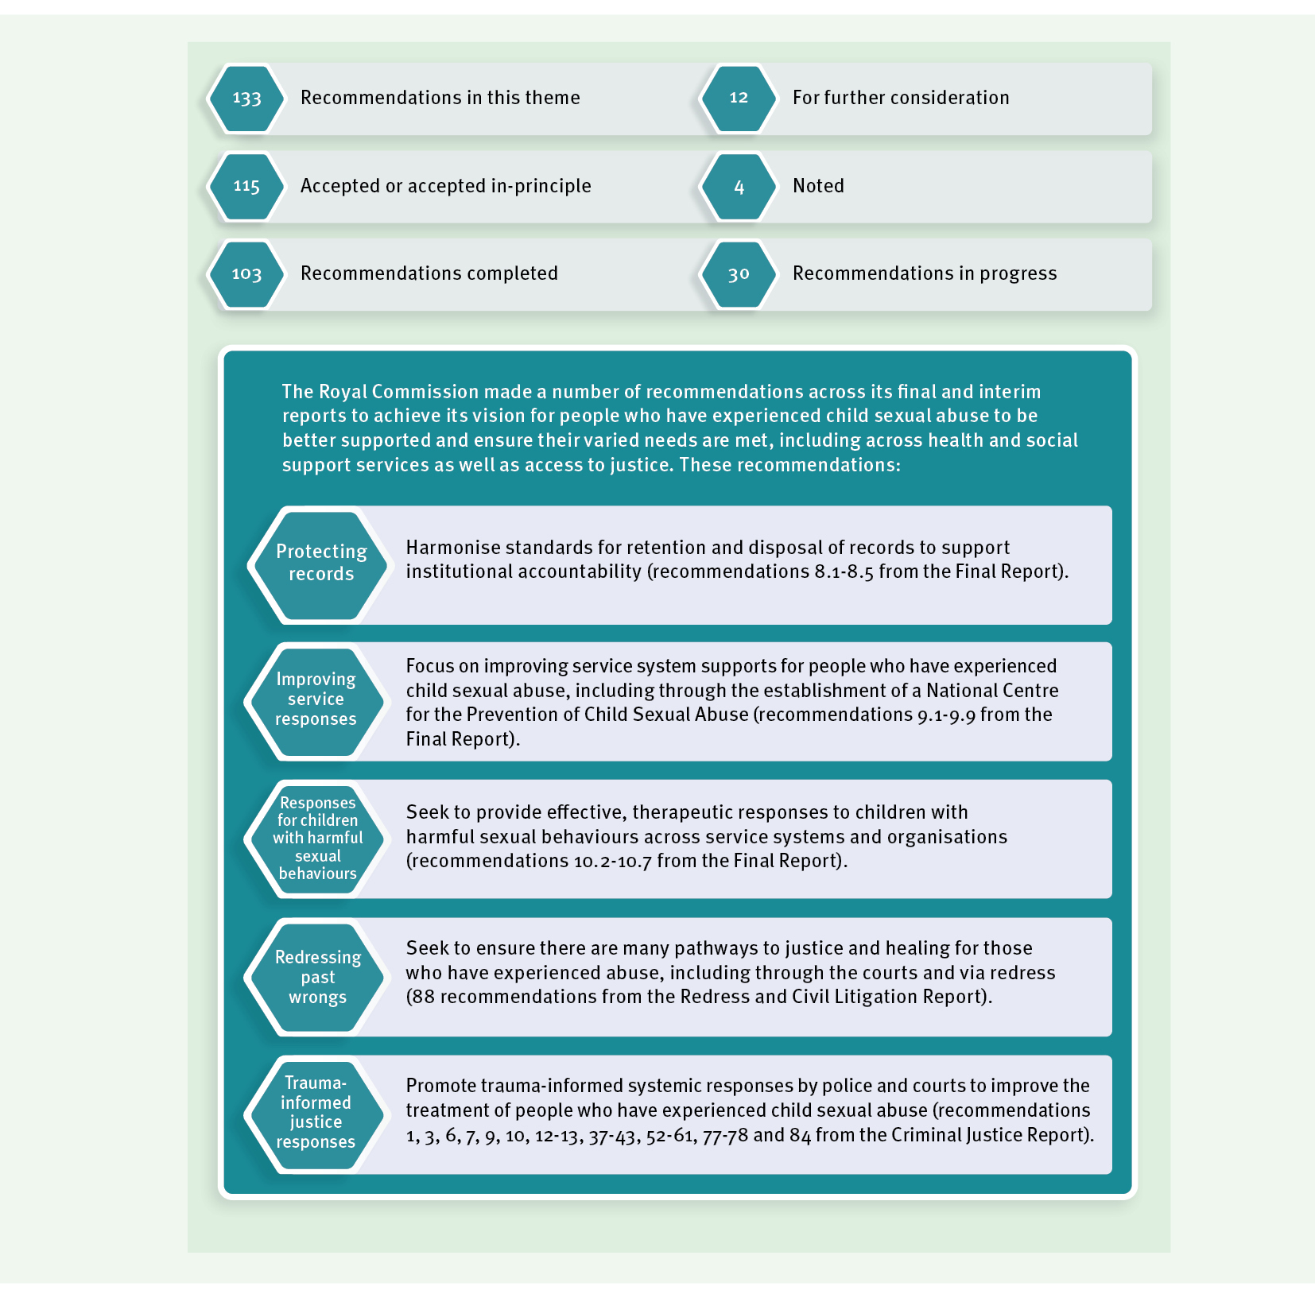
Theme 3: Healing and support

2021 highlights
Healing with Aboriginal and Torres Strait Islander peoples
The Royal Commission found that for Aboriginal and Torres Strait Islander peoples, the historical legacy of colonisation further compounds past and contemporary experiences of child sexual abuse in institutions.
In response to the historical legacy of colonisation, the Queensland Government has committed to reframing the relationship with Aboriginal and Torres Strait Islander Queenslanders in partnership with First Nations people, families and communities.
We have established a Treaty Advancement Committee to advance the Path to Treaty process and will establish a $300 million treaty fund as a major investment in reconciliation and healing. A key component of this Path to Treaty will be a process of Truth Telling and Healing.

Participation in the National Redress Scheme
Throughout 2021, the Queensland Government has maintained our commitment to ensuring people with lived experience of institutional child sexual abuse have access to justice and healing through the National Redress Scheme for people who have experienced institutional child sexual abuse (National Redress Scheme).
As at 31 December 2021, 2,333 applications had been received which identify a Queensland Government agency or entity as potentially responsible for the sexual abuse. Nationally, as at 31 December 2021, 13,194 applications had been received, with 7,178 payments totalling $617.7 million.
During 2021, the Queensland Government has continued to work with the Federal Government and states and territories on ways to improve the operation of the National Redress Scheme. With the release of the final report of the second year review of the National Redress Scheme on 24 June 2021, our national focus has turned to considering the review findings and its 38 recommendations.
We continue to work with non-government institutions to encourage their participation in the National Redress Scheme. We have seen a strong response in Queensland, with many institutions stepping up to their responsibilities and either joining or publicly committing to joining. We will maintain this commitment over the life of the National Redress Scheme to ensure as many eligible Queenslanders as possible have access to redress.
As a participating institution, the Queensland Government is responsible for delivering direct personal responses to redress applicants who choose to engage with us. This is a solemn responsibility, and we make every effort to ensure this is as meaningful and sensitive as possible.
Under the National Redress Scheme, state and territory governments are responsible for the counselling and psychological care element of redress. The Queensland Government continues to facilitate access to counselling and psychological care for redress applicants when requested.

Sexual violence prevention and support for people with lived experience
As mentioned earlier in this report, the 10-year National Strategy to Prevent and Respond to Child Sexual Abuse (National Strategy) includes a dedicated focus on supporting and empowering people with lived experience and enhancing a national approach to children with harmful sexual behaviours.
The National Centre for the Prevention of Child Sexual Abuse (National Centre) will work with the Federal Government and states and territories on the implementation of aspects of the National Strategy. With the establishment of the National Centre in 2021, we will now complete recommendation 9.9.
As we implement the National Strategy, particularly over its first four-year action plan, we will continue to consider how we respond in Queensland to sexual violence in our community. Our Prevent. Support. Believe. Queensland’s Framework to address Sexual Violence (the Framework) provides the overarching policy framework for this work.
On 26 October 2021, we released the Framework’s first action plan which includes a number of actions with a strong focus on trauma-informed approaches to meet the needs of people with lived experience. This is consistent with the principles in the Framework that:
- the choice and dignity of all people who have experienced sexual violence should be at the centre of all responses; and
- systems and services should be accessible, integrated, trauma-informed and culturally responsive.
The Department of Justice and Attorney-General continues to support people with lived experience of sexual violence. In the 2021-22 financial year, we invested $12 million in sexual assault support services across the state to provide immediate and ongoing trauma- informed support to adults and young people to help them heal from their experiences.
We also continue to implement the Youth Sexual Violence and Abuse initiative with an investment of $12 million over four years to June 2022. This includes:
- enhancements for existing sexual assault services and child sexual abuse counselling services to provide additional trauma-informed counselling and support for young people who have experienced sexual violence or child sexual abuse;
- three place-based youth sexual violence prevention trials in Toowoomba, Bundaberg and Yarrabah; and
- evaluation and research activities.
As previously mentioned in this report, the Queensland Police Service has developed an online sexual assault reporting form and is continuing to consult with relevant groups to encourage reporting of all groups in the community including prisoners and former prisoners. This work means we can complete recommendation 6 from the Criminal Justice Report.
The Queensland Government is engaging with the Royal Commission into Violence, Abuse and Exploitation of People with Disability and welcomes its examination of these issues. We note its final report is due on 29 September 2023.

Snapshot of trauma-informed service delivery across Queensland Government agencies
Many people with lived experience who came forward to the Royal Commission described difficulties in accessing mainstream services. The Royal Commission saw trauma-informed approaches as an emerging but promising practice to address these difficulties by making mainstream services more sensitive to the needs of people with lived experience.
Although we completed the Royal Commission’s recommendation (recommendation 9.8) in 2020, Queensland Government agencies responsible for the delivery of human services continue to implement trauma-informed approaches including:
- Queensland Health acknowledges the immediate and long-term consequences of trauma and its complex, cumulative and intergenerational impact. Within mental health, alcohol and other drugs services, Queensland Health is committed to providing trauma- informed care by embedding the principles of leadership and governance; education and training; supervision and support; and evaluation and improvement.
- Queensland Health’s First Nations health equity reform agenda seeks to drive systemic and sustainable change across the health system in Queensland. By embedding Aboriginal and Torres Strait Islander-led models of service delivery, we seek to ensure Aboriginal and Torres Strait Islander peoples in Queensland have access to holistic, culturally safe, trauma-informed and responsive health care, free from racism and integrated across primary, secondary and tertiary health care settings.
- In April 2021, historic and significant reforms commenced to embed Queensland Health’s commitment to achieving First Nations health equity into legislation and establish a requirement for the voices, lived experiences and cultural authority of Aboriginal and Torres Strait Islander peoples to drive the design and delivery of health services at the local level. Each of the 16 Health and Hospital Services in Queensland are now required to include First Nations representation on their boards and develop and implement a First Nations Health Equity Strategy, co-designed, co-owned and co-implemented in partnership with Aboriginal and Torres Strait Islander stakeholders by 30 April 2022.
- Queensland Health’s Mental Health Community Support Services program supports Aboriginal and Torres Strait Islander peoples experiencing moderate to severe mental illness by providing healing informed models of care, tailored to the needs of the individual. The program is delivered by Aboriginal and Torres Strait Islander community- controlled health services in collaboration with Queensland Health.
- The Indigenous Mental Health Intervention Program supports Aboriginal and Torres Strait Islander peoples in custody in Woodford Correctional Centre, Brisbane Women’s Correctional Centre and Southern Queensland Correctional Centre. The program is underpinned by Aboriginal and Torres Strait Islander views of health and mental health including the interconnections between spiritual, social, emotional, cultural and physical wellbeing. The service is complemented by an Aboriginal and Torres Strait Islander non-government organisation providing transitional support at release and for the person’s first six months in the community.

- In May 2021, all Victim Assist Queensland staff received training in working from a trauma-informed approach. This training will be provided to all staff annually and we will soon develop a plan to implement and embed trauma-informed practice across the agency. In addition, the recent review of the Victims Services Funding Program emphasised the importance of case management and supporting people to access assistance and navigate the criminal justice system. The tender process for services under this program closed on 2 August 2021 and required all organisations to outline how they will provide trauma-informed service delivery. New contracts with organisations will be in place from July 2022.
- In response to the Royal Commission, Queensland Corrective Services delivered a ‘working with trauma workshop’ to psychologists and counsellors. As many women in correctional centres have experienced child sexual abuse and/or violence, Queensland Corrective Services is adopting a gender-responsive, trauma-informed approach to support women escape the cycle that led to crime.
- As previously mentioned in this report, the Department of Children, Youth Justice and Multicultural Affairs is working with PeakCare Queensland to adapt the Hope and Healing Framework to foster carers.
- In recognition of how many young people in youth detention have experienced trauma, trauma-informed practice is paramount in youth detention centres. Youth detention centres are subject to a policy and procedure review cycle to ensure they operate in an evidence-informed way, in accordance with contemporary best practice as well as recommendations from oversight bodies.
- As part of the Queensland Housing Strategy 2017-27, the Department of Communities, Housing and Digital Economy continued our efforts to embed trauma-informed and person-centred approaches to policy and services to Queenslanders in housing need. A Trauma-informed Care Learning Program was implemented in 2020–21 for service delivery staff across Queensland to raise their awareness of the effects of trauma and assist them to respond to people with empathy and sensitivity. The program empowers staff to feel equipped and confident to have person-centred conversations as part of a continuing shift towards holistic service provision.
- We are also collaborating with service partners to build and strengthen trauma- informed networks and systems, and communities of practice, including the establishment of a network of Trauma Lens Champions and case conferencing. A review of policies, procedures and service delivery frameworks in line with a trauma-informed and trauma-sensitive approach is also in development.

Trauma informed criminal justice responses
Our 2020 annual report highlighted the Queensland Government’s $1.5 million investment in the development and implementation of a training package in the Queensland Police Service. Developed by the University of Queensland, this training is being progressively rolled out to police officers from the rank of constable to inspector. The purpose of the training is to better focus the police response on the person with lived experience and incorporate trauma-informed approaches.

A team has been established at the Queensland Police Service Academy and this project will extend over four years, with completion expected in June 2023. The Queensland Police Service will also work on incorporating trauma-informed and victim-focused principles into other relevant training programs.

Women’s Safety and Justice Taskforce
The Women’s Safety and Justice Taskforce (the Taskforce) was established in March 2021 to independently examine and report on its findings in relation to:
- how best to legislate against coercive control as a form of domestic and family violence and the need for a new offence of ‘commit domestic violence’; and
- other areas of women’s experience in the criminal justice system.
As part of its Terms of Reference, the Taskforce may consider policing and investigative approaches, including the collection of evidence and specialist training and trauma- informed responses to people with lived experience. In undertaking its review, the Taskforce is to have regard to a trauma-informed approach that considers the lived experience of women who are involved in the criminal justice system. The Taskforce will provide a report to the Attorney-General and Minister for Justice on women’s experience in the criminal justice system by June 2022.

Queensland’s pilot intermediary scheme begins
In our 2020 annual progress report, we highlighted that the legislative framework to support the establishment of a Queensland pilot intermediary scheme was established by the Criminal Code (Child Sexual Offences Reform) and Other Legislation Amendment Act 2020.
The Queensland Intermediary Scheme formally commenced in Brisbane and Cairns on 5 July 2021 as a pilot program.
Intermediaries are typically speech pathologists, occupational therapists, psychologists and social workers who assist police and the courts to obtain the best evidence from witnesses with communication difficulties. Intermediaries assess the witness’ communication needs and provide practical advice on the best way to communicate with the witness.
A consortium led by the Australian Catholic University will undertake a process and outcome evaluation of the pilot program. An interim evaluation report analysing the first 12 months of operation is due to be delivered in October 2022, followed by the final report due at the conclusion of the two-year pilot program in October 2023.

Keeping the spotlight on record keeping
In our 2020 annual report, we highlighted as one of our achievements the release of the Guideline on creating and keeping records for the proactive protection of vulnerable persons (guideline) and accompanying disposal authorisations. The guideline was developed in response to Royal Commission recommendations 8.1 to 8.4 and in recognition of its findings that poor recordkeeping has contributed to the failures of institutions to identify and respond to child sexual abuse, and has exacerbated distress and trauma for many people with lived experience.

The guideline and disposal authorisations apply to all Queensland public authorities and can be used as a best practice resource for non-government institutions (e.g. Independent Schools Queensland). Since the release of the guideline in March 2020, the Queensland State Archives has been working to promote the advice with public authorities. This has included facilitating workshops with several agencies to assist them to understand their specific recordkeeping requirements when interacting with people who are vulnerable.
In addition, the Queensland State Archives has also released a range of accompanying promotional advice including Frequently Asked Questions, short videos, magazine articles, webinars and has published a series of social media releases about the advice.
Nationally, we continue to work with the National Archives of Australia and the Council of Australasian Archives and Records Authorities, as part of a working group, to ensure a consistent approach to record retention and to provide guidance in response to these recommendations.
Further work is underway by the Department of Education and Queensland State Archives in relation to record keeping for non-state schooling sectors. Both the Education and Training Sector Retention and Disposal Schedule and the General Retention and Disposal Schedule are currently being reviewed. Draft guidelines for non-state schools have been developed and will be reviewed in consultation with Queensland State Archives to determine the equivalence to standards applicable to government schools in relation to the creation, maintenance and disposal of records relevant to child safety and wellbeing, including child sexual abuse.

Looking forward
In 2022, the Queensland Government will continue our work to support healing and assist people with lived experience by:
- continuing on our journey with the Path to Treaty process in Queensland;
- continuing our participation in the National Redress Scheme including our work with the Federal Government and state and territory governments to improve the scheme and encourage non-government institutions to join the scheme;
- implementing Prevent. Support. Believe. Queensland’s Framework to address Sexual Violence through the Framework’s whole-of-government action plan 2021-22;
- continuing to embed trauma-informed approaches to the delivery of services to Queenslanders including the training of Queensland police officers;
- developing and implementing Health Equity Strategies in each Hospital and Health Service to address structural and systemic inequalities and enable culturally safe and accessible health services;
- continuing the pilot intermediary scheme in Brisbane and Cairns;
- considering the outcomes of the Women’s Safety and Justice Taskforce; and
- continuing our work to promote best practice record keeping practices.

Information about support services
There are support services available to those who need assistance. If immediate assistance is required, 24-hour support is available through:
- Lifeline: 13 11 14
- 1800 Respect: 1800 737 732
- MensLine Australia: 1300 789 978
Lotus Place is a dedicated support service and resource centre for Forgotten Australians and can be contacted via phone on 3347 8500. For more information, please visit the Lotus Place website www.lotusplace.org.au.
Free legal advice and information about the justice or redress pathways available to survivors of institutional child sexual abuse can be accessed through knowmore, on 1800 605 762. For more information, please visit the knowmore website www.knowmore.org.au.
Further advice and resources for support regarding child sexual abuse can be found online by visiting www.qld.gov.au/community/getting-support-health-social-issue/ support-victims-abuse/child-abuse/child-sexual-abuse/child-sexual-abuse-help.

