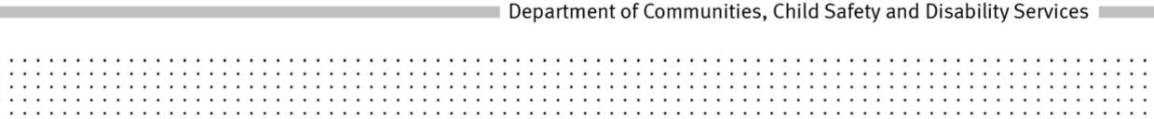
POLICY
Title: Recognising a man as the biological father of an adopted person when providing adoption information
Policy No: CPD621-3
Policy Statement:
The Department of Communities, Child Safety and Disability Services will recognise a man as a biological father of an adopted person for the purposes of section 250 (d) of the Adoption Act 2009 when information establishes that, based on the balance of probabilities; it is more likely than not that he is the person’s biological father.
Principles:
- The wellbeing and best interests of an adopted person, both throughout childhood and the rest of his or her life, are paramount considerations in all adoption matters.
- Whenever information available satisfies the Department of Communities, Child Safety and Disability Services that based on the balance of probabilities a man is an adopted person’s biological father, information will be provided to and about him, under the Adoption Act 2009, as applicable.
Objectives:
To ensure an adopted person is provided with information about a man named as his or her father and a father is provided with information about his son or daughter who was adopted when available information satisfies the Department of Communities, Child Safety and Disability Services that based on the balance of probabilities, the man is the person’s biological father.
To provide support to delegated officers making a decision under the Adoption Act 2009, section 250(d) regarding whether, based on the balance of probabilities, it is more probable than not that a man is an adopted person’s biological father.
Scope:
This policy applies to applications for adoption information, made in accordance with the Adoption Act 2009, part 11, where the applicant seeks to rely on section 250 (d) in circumstances where:
- a man is not shown as the adopted person’s father in the register of births under the Births, Deaths and Marriages Registration Act 2003 or
- a man did not consent to the adoption or the need for his consent was not dispensed with or

- no other records available to the Department of Communities, Child Safety and Disability Services indicate the man accepted paternity of the adopted persons before or after the adoption.
In order to recognise a man as the biological father of an adopted person under
section 250 (d) the chief executive must be satisfied on the balance of probabilities it is more probable than not that a man is an adopted person’s biological father.
Consideration will be given to all information available to the Department, relevant factors and any publicly available information.
Roles and Responsibilities:
Adoption Services will:
- consider information in adoption records, publicly available information and information provided by any other person, on its merits to determine whether, based on the balance of probabilities, it is more likely than not that a person is an adopted person’s biological father
- provide any necessary information, support or counselling to persons seeking information that is considered necessary given the circumstances of each case.
Authority:
Adoption Act 2009, sections 250, 256, 257, 259,263, and 265
Delegations:
Regional Executive Director, South East Region
Regional Director, South East Region
Manager, Adoption Services
Team Leader, Adoption Services

Records File No.: CHS/16721
Date of approval: 06 June 2013
Date of operation: 06 June 2013
Date to be reviewed: 06 June 2016
Office: Department of Communities, Child Safety and Disability Services
Help Contact: Child Protection Development
Links:
Adoption Practice Manual
Related Adoption Policies:
The wellbeing and best interest of the child in adoption (626)
Rescinded policies:
2.6 CHS-16721 Establishing the identity of a biological father for the purposes of adoption information
621-1 Recognising a man as the biological father of an adopted person when providing adoption information
Margaret Allison
Director-General

