Activity 1 – slide 5 – Parental Reflection?

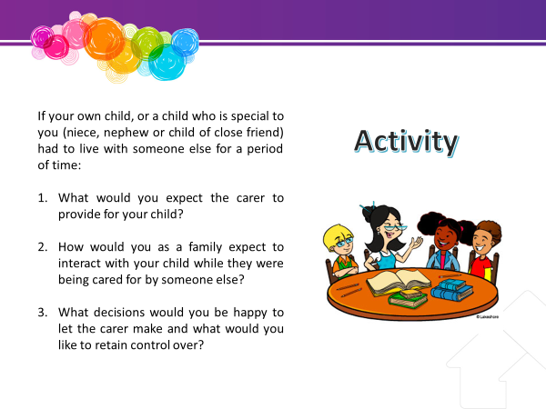
Time – 10 mins
Resources – pen and paper

Show Slide “Activity”
We will start with an exercise to illustrate how the child’s family may be feeling when their child is placed in care and to start to think about what parents might expect of a carer caring for their child.
Ask participants to work individually for 5 minutes.
Ask for any volunteers to report to the group some of their answers.
At the end of the module return to this activity and let them review their answers.
It should highlight the importance of maintaining meaningful connections between children and their families.

Activity 2 – slide 8 – Applying the Statement of Standards

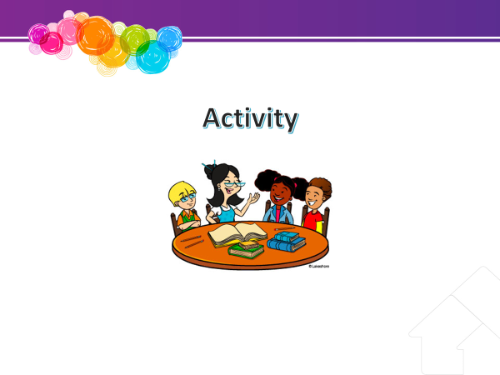
Time – 10 mins
Resources
- pen and paper,
- CSPM Procedure – Provide and review care: Meeting the Statement of Standards

Handout - Refer to Handout “Statement of Standards”.
An experienced carer may lead
As well as the Principles of the Act the Statement of Standards are a legal obligation that carers must meet.
Trainers can use their own activity.
Example:
- Place the standards around the room.
- Give participants a sheet of paper to write down how they might address a standard.
- Ask the participant to describe a standard then stick their strategy next to the standard on the wall.
- Discuss as a group, which were harder or easier.
After reading through the Statement of Standards please note down one way to meet each of the Standards. The practice resource: Meeting the Statement of Standards can be found in the CSPM procedure – Provide and review care (link above)
Discuss feedback in the larger group. Facilitate a thorough group discussion of how the standards can be met noting examples.
If time permits.

Ask participants to identify any challenges they might have in meeting the Statement of Standards and ask others for suggestions to resolve these.

An experienced carer may lead. e.g.- financial difficulties may reduce the carers ability to pay for counselling, dental care, no recreation activities in the area the child likes, don’t want contact with family, no culturally appropriate people in the family, limited behavioural intervention skills.

Where there are examples provided suggest that these could be incorporated into a placement agreement which you will discuss next.

Brainstorm- slides 11 & 12
What information do you think you may need before accepting a care arrangement?

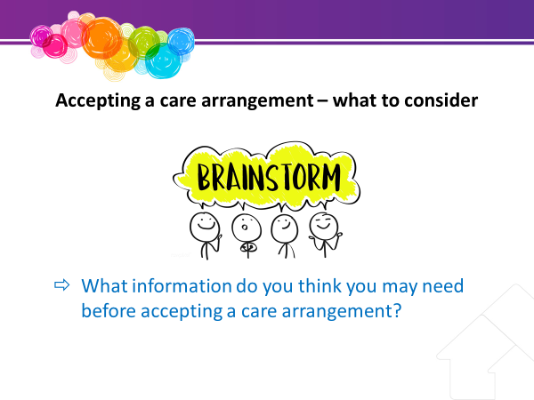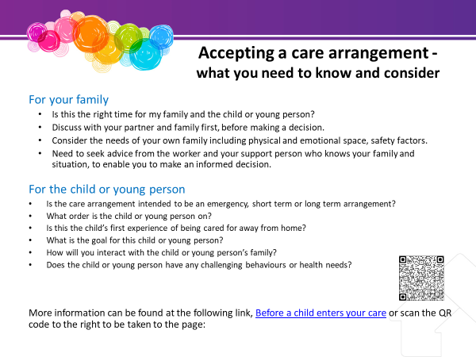
Time – 15 mins
Resources
- pen and paper
- handout – Accepting a care arrangement – what to consider & checklist

Ask participants to discuss the information they might need before saying yes to a care arrangement?
Ensure that the following is covered:
- Show Slide 12 and
- provide handout Accepting a care arrangement – what to consider & checklist
Some of the information that is important to ask and to consider includes:
- The need to obtain information on the child or young person to ensure that you can meet their needs, without causing undue problems for your own family. Obtain this from the worker over the phone or in person. e.g., behavioural risk factors, ongoing appointments

- Is this the right time for my family (holidays, Christmas, exams)?
- Age and sex of the child or young person?
- Reason for the care arrangement?
- Is the care arrangement intended to be emergency/short term/long term?
- What intervention or order is the child on?
- What are the key aspects of that intervention that I need to know?
- Religion/culture of the child?
- What school does the child attend?
- Is this the child’s first experience of being cared for away from home?
- How frequent is family contact and who is it with?
- Is the child on any medication?
- Do you have the child’s Medicare number?
- Are there any special dietary requirements?
- Are there any medical or counselling appointments required?
- Are there any behaviours that I need to know about?
- What is the goal for this child or young person?
- How will you interact with the child or young person’s family?
- Who is the child’s case worker or who is it best to talk to?
- Need to seek advice from the worker and your support person who knows your family and situation, to enable you to make an informed decision.

- Discuss with your partner and family first before deciding. Consider the needs of your own family including physical and emotional space, safety factors. How will this child and care arrangement impact on my family?
Emphasise the following point:
Consider the decision carefully as placement breakdown can increase feelings of rejection for children and young people. Placement breakdowns can also leave you and your family members with a feeling of failure and guilt.

Optional Activity
Trainers can role play accepting a care arrangement.

Optional Activity – slide 15 & 16 – What is it like to be looked after by strangers?

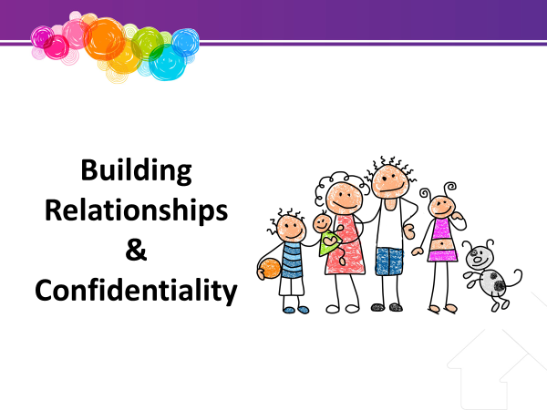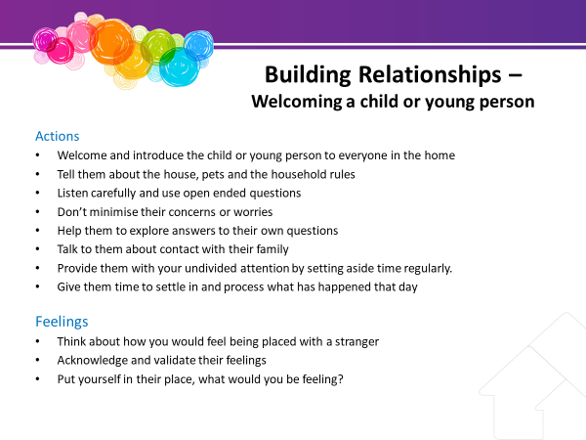
Time – 10 mins
Resources - pen and paper

Optional Activities- what is it like to be looked after by strangers?
Ask each participant to imagine they are a child whose parents suddenly can’t care for them for a while. You are not sure why this is.
You are taken to someone’s house by a worker whom you don’t know.
How would you be feeling? Jot these feelings down. Now turn to the person next to you and discuss with them what would make it easier for you?
Role play –trainers can role play welcoming a child and then a young person and discuss some of the differences.

Report back to the larger group and discuss things you can do to welcome children and young people to your home.
Ensure that the information contained on slide 16 is discussed.

Brainstorm- slides 25
Privacy and confidentiality – What can and can’t be shared

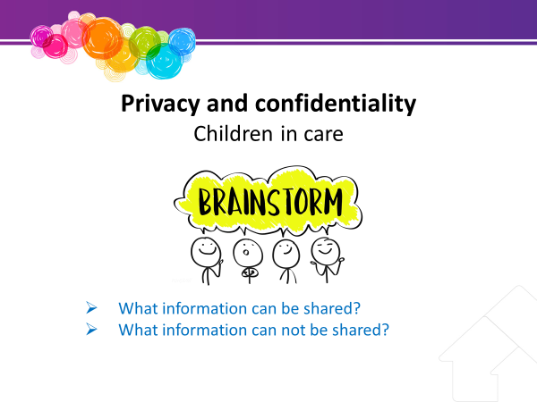
Time – 10 mins
Resources - nil

Activity: As a group brainstorm:
- What information can be shared?
Example:
- Tell a neighbour that sometimes Johnny needs assistance with his homework.
- Ask a friend for help with getting an appointment with a specialist for Amy.
- Tell family at a BBQ that sometimes Brodie gets angry and aggressive, and they might need to respond to his behaviour in a particular way.
Highlight that sharing confidential information between government entities may be appropriate (and authorised by legislation) where this relates to protection of the child and provision of relevant services.

For example, a CSO can discuss the child’s needs, including information about their family history that is relevant to those needs, with a teacher from the Education Queensland in order to enhance support. A foster carer may also be told this information.
- What information cannot be shared?
For example:
- Tell a neighbour that sometimes Johnny needs assistance with his homework because he is intellectually impaired as a result of his mother’s alcoholism.
- Ask a friend for help with getting an appointment with a specialist for Amy because she has psychological issues after being sexually abused by her stepdad.
- Tell family at a BBQ that sometimes Brodie gets angry and aggressive because he finds contact with his biological parents upsetting. However, it might be important to share this information with his teacher, so they can understand and help him to deal with those issues.

Brainstorm- slides 31
Cultural Support Plan – requirements by carers

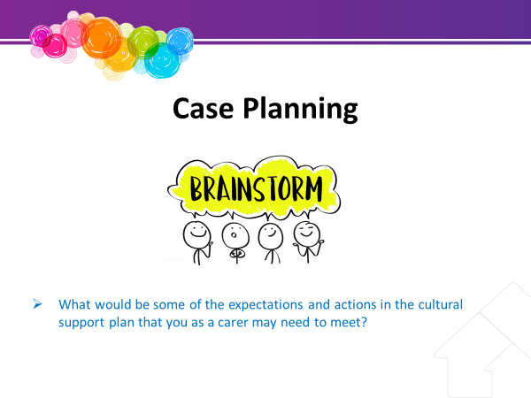

Time – 5 mins
Resources - nil

Trainers can discuss some examples or ask participants to brainstorm some of the expectations and actions in the cultural support plan that carers might have to meet.
i.e.
- Helping children and young people engage in appropriate cultural activities and activities that hold significance for that child or young person
- Assisting with transport to family contact and/or helping the child or young person keep in contact with their family
- Being aware of significant cultural practices for the child or young person
Explore who the carer might talk to for assistance in meeting these actions.
i.e.
- Child or young person’s parents or family
- Cultural practice adviser
- CSO
- Safety and Support network

Brainstorm- slides 33
Connecting with family and community – carer’s role

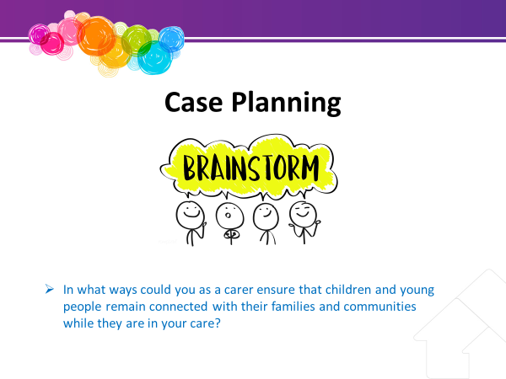
Time – 5 mins
Resources - nil

Brainstorm with participants
Discuss examples ways that you could ensure children remain connected with their families and communities while they are in your care.
Ask what supports might be required to be able to do this?
How do you maintain connections with your own extended family and community?

Activity 3 – slide 35 – Decisions parents make

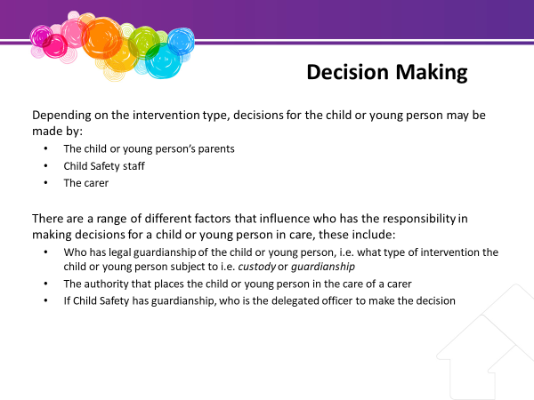

Time – 10 mins
Resources – pens and whiteboard

Ask participants to think of the range of decisions that parents normally make every day about their children.
Write these on the board.

We will talk later today (in Activity review) about the types of decisions you might make but first we will talk about what decisions and needs the child requires and where these are recorded.

Activity 4 – slide 41 – Review activity -Decisions parents make

Time – 5 mins
Resources – pens and whiteboard

Review activity – return to the whiteboard where participants discussed the decisions parents make for children. Discuss each one and who might be responsible if the child was in care – the carer, Child Safety staff, parents, child.

Brainstorm- slides 44
How could you assist a child or young person to develop a positive self esteem

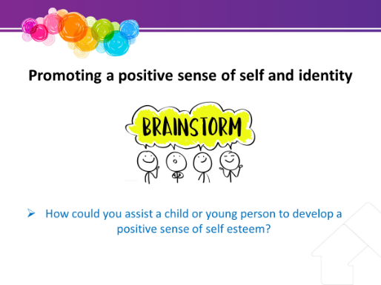
Time – 10 mins
Resources – pens and whiteboard

Experienced carer can have input into this session.
Ask participants to consider ways to assist children and young people develop positive self-esteem.
Ensure the following is covered:
  - Establish a trusting relationship by being honest, consistent and reliable.
  - Show that you accept them - even if you do not accept all of their behaviour.
  - Let them know that you respect their individuality – that they are unique.
  - Give regular praise and concentrate on positive things about them.
  - Listen and give regular time and attention. Make some time each week to give the child or young person undivided attention.
  - Build on their own strengths and interests – extracurricular activities that will build self-image.
  - Help them increase their skills in solving personal problems and praise them each time you see them resolve something.
Ask the group for examples of each of the above.

OPTIONAL ACTIVITY or ROLE PLAY
- Divide participants into groups of 3-5 each. Present the following scenario OR
- a role play could be used in the below scenario. Ask a participant to volunteer to be the young person and a presenter can be the carer. The aim of this exercise is to demonstrate ways to promote a positive sense of self and work out ways to deal with situations themselves. Good communication techniques can be demonstrated again.
Scenario - A young person says to you “I don’t want to go to school because other children are teasing me about being in foster care”.

Discuss how you could you respond in a way that:
Life diaries are a great way to help build the self-esteem and sense of self for children and young people in care.
The ‘Information for existing carers’ webpage and information sheets have some information around life diaries and the internet has a range of activities to enhance self-esteem and a positive sense of self.
- helps the young person accept their feelings
- assists them take steps to deal with the situation
- encourages them to seek resources from other places
- encourages positive self-esteem.

Facilitate feedback to the larger group.

Possible responses –
- talk about feelings and acknowledge these
- help the young person talk through all the options in dealing with the issue with other children
- help her sort out what she would like to tell other children about being in care
- help her think who else could assist with this
- highlight positive aspects of her responses.

Brainstorm- slides 49
How do you advocate for your own child, or children in your family?

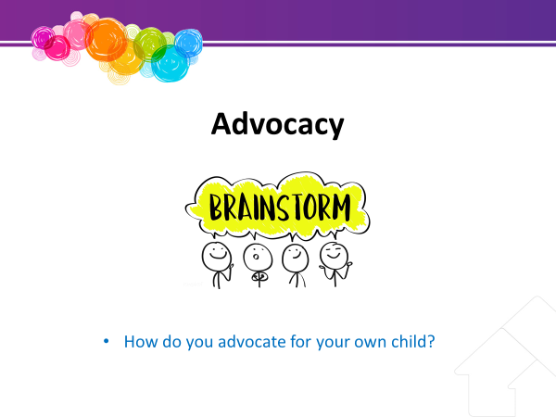

Time – 5 mins
Resources – pens and whiteboard

Scenario based activity / small group activity

How do you advocate for your own children and family?

Give examples
- What are some of the reasons you need to do this?
- What made it possible to get successful outcomes?
- Why would it be important to advocate for a child or young person in care?

Activity 5 – slide 53 – Revise - Parental Reflection?

Time – 5 mins
Resources – pens and whiteboard

Ask the participant to return to the first exercise of the day and review their answers.
Ask them to jot down if there were any other parts of the training that they hadn’t originally considered.
Ask for any volunteers to report back to the group.

