Module two
Understanding the past for a child or young person
Session Plan

3 Hours

Method of Delivery
Assessment
Learning Outcomes

Lecture
Small / large groups
Brainstorm
Activities

The assessment necessary for each participant will be based on:
- Participation in discussions and training activities
- Completion of worksheets at the end of the session
- Completion of self-assessment proformas
At the end of this module participants will be able to:
- Understand the basic developmental stages of childhood and adolescence
- Understand what attachment means for a child, and how separation impacts on attachment
- Identify the types of losses that may be experienced by children who come into care

- Understand the experience of abuse and how it impacts on children
- Demonstrate understanding of behaviour management options

Handouts – multiple copies of:
- Child development and trauma | Child Protection Manual print off the website before training | - ChildDevelopmentAndTraumaGuide.pdf (dcp.wa.gov.au)
- FS 11 Maintaining family contact | - Experience of sexual abuse - handout
- Case Studies – 1, 2 & 3 | - Attachment – Matching Activity
- Indicators of Child Sexual Abuse - handout | - Copy of the Child Protection Act 1999
- Myths and facts about sexual abuse - handout | - Positive Behaviour Support policy
- Attachment & Grief and loss – handout  - Promoting positive behaviours | - Considerations when caring for Aboriginal & Torres Strait Islander children & young people
- My Body Belongs To Me [Animated Short Film] - YouTube | - Source posters from local child health agencies displaying developmental stages of childhood

- Power Point slides
- Whiteboard/pens
- Cardboard boxes (if applicable for alternative activity)
Resources can be obtained from CSSC staff or via a search of the Child Safety internet, Infonet or within the CSPM.

Resources

Resources can be obtained from CSSC staff or via a search of the Child Safety Internet or within the Child Safety Practice Manual

2 mins | Acknowledgement of Country  I would like to respectfully acknowledge the Traditional Owners of the land on which we are meeting today and acknowledge that Aboriginal and Torres Strait Islander peoples are the custodians of this country and recognise their connections to land, sea, water and sky. We pay our respects to Insert Local tribal/language group, their continued culture and to their Elders past, present as well as those emerging leaders of tomorrow.  Pause  Thank you
 | Show slide 1  Distribute name tags | Slide 1  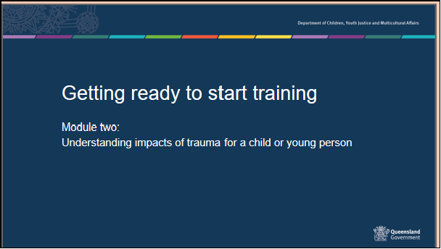
25 mins | Housekeeping, introductions, and training assessment expectations  Housekeeping details – provide the location of exits and toilets, information on breaks and catering, arrangements for smokers and phone messages. Include fire, evacuation and emergency exit and meeting points as well as any other WH&S procedures required.  Introducing each other - Use your own icebreaker or the example below  Get participants to introduce themselves to the person sitting next to them and tell them one fun activity they have done with a child or young person. Report back to the group.

Group Rules

These should be sourced from the group - ask what people would need from the group in order to feel comfortable. Ensure that the following are covered:

- Confidentiality – any information that is shared in the group will be confidential to the group – however, link to the need to respect confidences in a placement situation.
- Mutual respect and tolerance for a diversity of opinions, cultural backgrounds, and experiences.
- Punctuality and respectful processes in discussion

 | Show slide 2  Overall aim of Foster Carer Training: Getting ready to start training.  Getting ready to start training is presented in 4 modules of 3 hours each.  - Context of Foster Care Module one-.  - An understanding of the process of how children and young people come into care and the impact of this process, and why children and young people require a care arrangement.  - Understanding the past for a child or young person- you are here  - An understanding of trauma and related behaviours for a child or young person who is in care arrangement.  - Early days in a care arrangement  - Developing knowledge and skills required to meet the physical, emotional and social needs of children and young people in care and an understanding of the importance of participation by children and young people and their families in decision making.  - Quality care - working together  - Have an understanding of the importance of partnerships between children, their families, foster and kinship carers and workers, (both in the government and non-government sectors), and their roles and responsibilities when working together as a team. | Slide 2  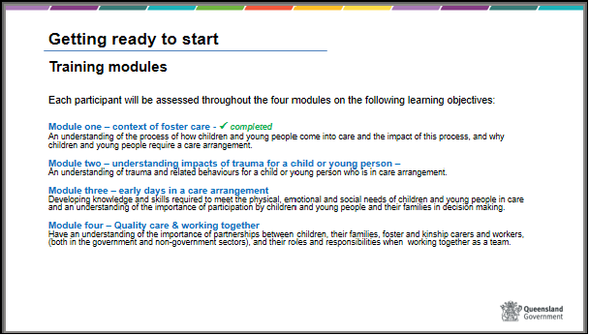

 | Slide 3  Learning outcomes – module 2  Show and discuss the learning outcomes for this module | Slide 3  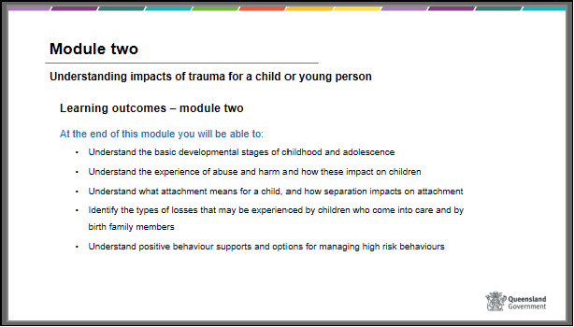
30 mins  40 mins  40 mins  30 mins | Slide 4  Understanding the past for a child or young person – content and timeframes  Module 2 will focus on understanding the past of a child coming into care and the impact of this on their current and future care needs.  Children in care often respond to situations in ways we are not expecting.  - Understanding trauma for children and young people  - How trauma may impact stages of childhood development  - Attachment  - Stages of grief and loss  - The experience of abuse  - Sexualised behaviours  - Self-harm  - Responding to disclosures  - Responding to challenging behaviours  - Positive behaviour supports  - Managing high risk behaviours | Slide 4  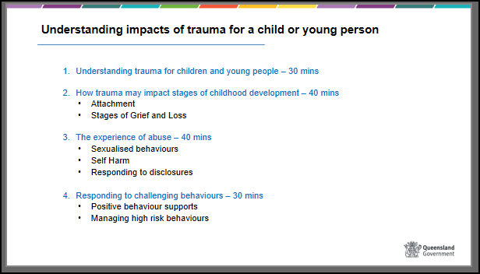

30 mins | Slide 5  Most children in care have experienced harm or neglect. Often their relationships and attachments to significant people have been disrupted which impacts on their wellbeing, emotional and behavioural responses.  Their experiences of abuse, grief, loss, and separation will impact significantly on their fears, anxiety, behaviour, sense of self and wellbeing. | Slide 5  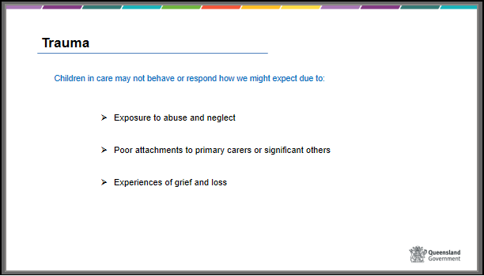
 | Slide 6  The impacts of these experiences mean that children in care might be at different stages of development than other children their age and might struggle with relationships and to regulate their behaviour and emotions. | Slide 6  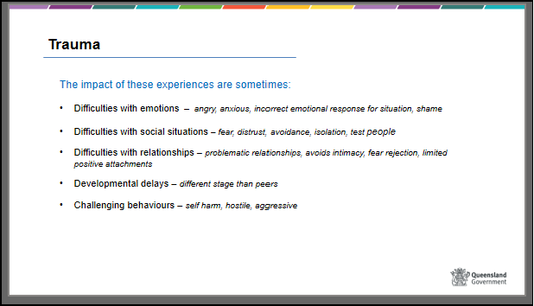

 | Slide 7  Trauma – What can carer’s do?  The child’s wellbeing, behaviours and care experiences are enhanced when carers can understand the complex interplay of the child’s past, grief and loss, child development and attachment issues, particularly in times of conflict and stress.  The carers role is to develop a deep understanding of where the child is at, show compassion for the child’s suffering, provide stability and to assist and support the child with new social and behavioural skills.  The child’s new learnt skills will improve their connections to you as a carer and to others by developing skills to manage relationships, rules and boundaries as they age. As you connect with children in new ways, they can also begin to see themselves in a more positive light.  Research conducted by CREATE also shows that 95 per cent of children and young people rated having a say and being listened to whilst in care as ‘very important’.  Maintaining positive relationships with siblings, extended family and community members is also crucial, especially for Aboriginal and Torres Strait Islander children. It is important to remember that children may be connected to, and require contact with, various community and family members as they may have experienced collective parenting from a range of family and community members. | Slide 7  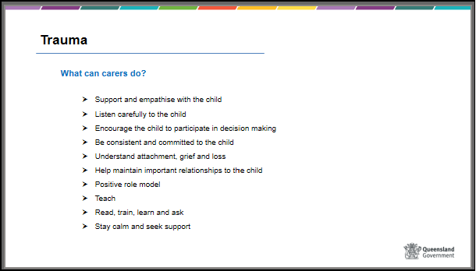
40 mins | Slide 8  How trauma may impact stages of childhood development | Slide 8  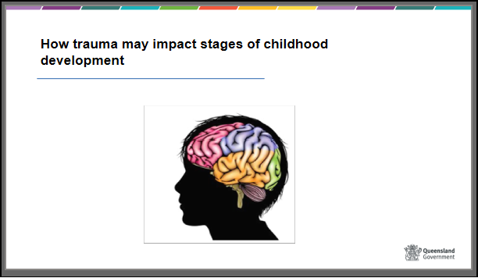

 | Slide 9  Refer to separate activities resource for instructions on activity  BRAINSTORM – Developmental stages  Handouts –  - Child development and trauma | Child Protection Manual (cpmanual.vic.gov.au)  - ChildDevelopmentAndTraumaGuide.pdf (dcp.wa.gov.au)  - Emotional development - handout | Slide 9  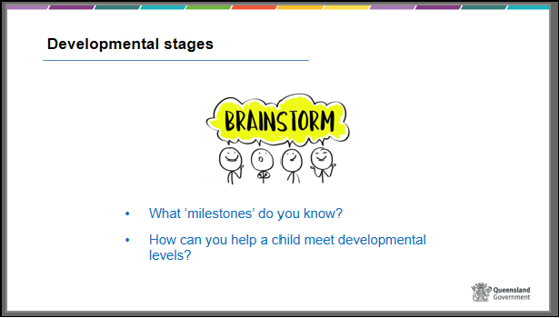
20 mins | Slide 10  Attachment – responding to attachment issues  HANDOUT - Attachment  Trainers can use any resource (video, DVD, handouts, own slides), relevant to their training group, that will assist them to explain this section and meet the required competencies.  This section is to assist you to understand the basic principles of attachment and how attachment occurs. There is an advanced module – ‘Attachment’ that carers should consider which provides more about attachment theory and impacts for children in care.  This attachment session is only one theory on child rearing and development and is relevant mostly to care environments for non-Aboriginal or Torres Strait Islander children.  If you are asked to care for an Aboriginal or Torres Strait Islander child or young person, it is crucial that you understand the collective attachments and child rearing practices relevant for that child or young person. This information can be obtained from the child’s CSO.  Parenting and child rearing practices are very different for Aboriginal and Torres Strait Islanders. Collective practices include a greater tendency to think of oneself in terms of affiliation with others, community, and country. Children are often cared for by a range of women, including older children, as well as their mother. Children may also have lengthy stays away from their birth parents due to cultural ceremonies. Children are encouraged to be self-reliant at an early age. Autonomy in daily functioning is more common, including children feeding themselves at an earlier age. To minimise any cultural biases, it is important to seek out advice prior to agreeing on a care arrangement.  Attachment is often described as the emotional connection developed between an infant and their primary parent or care giver, often starting just hours after birth. While attachment is often talked about in relation to an infant and their parent or primary caregiver, infants, children and young people can and do develop and build attachment relationships with additional people throughout their lives e.g. grandparents, babysitters, uncles/aunts, foster and kinship carers as well as community members and elders.  Attachment is described as a relationship, stronger than a bond which involves a connection between the infant and a caregiver through behaviours such as smiling and cooing. Attachment is the development of a nurturing, soothing and trusting relationship where the infant finds security and safety in the context of this relationship.  For example, an infant becomes hungry (has a need for food) and responds to stress by crying; a responsive carer ensures that the infant is fed (and comforted) and the infant moves into a period of calm.  This is part of what is called the attunement cycle. Attunement is the reading and responding to the cues of another accurately and consistently. | Slide 10  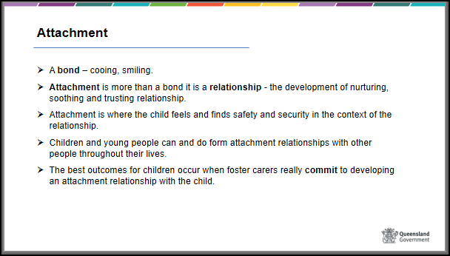
 | Slide 11  The repeated reliable actions of the attachment figure create periods of calmness and stillness for the infant. In time, as the adult reliably responds to the infant’s needs, the infant develops a sense of trust and safety and a specific attachment to the carer.  As children get older, they learn to have their needs met in increasingly independent ways. Secure toddlers learn that it works to ask for something to eat rather than cry and later they are able to get some food for themselves. Older children may need less frequent reassurance but still may need support if upset with friends.  Attachment theory suggests that a child’s behaviour, emotional responses and psychological development, both positive and negative, is learnt through attachment relationships throughout the life course. Understanding that behaviour is learnt allows us to move away from viewing a child as ‘bad’ and to understand they are using strategies they have learnt in order to survive very difficult situations.  This means that as foster carers the type of relationship you have and a commitment to a positive relationship or attachment to the child in your care can significantly improve their future relationships, problem solving and behaviour skills as they age, even if you care for them for just a short period.  This is important to remember when things get tough or you are dealing with the behavioural effects of the child’s past relationships. The way you respond in times of conflict or crisis will influence not only your relationship with the child but also how they will see, experience and behave in their own future relationships. | Slide 11
 | Slide 12  Where care giving is sensitive responsive and attuned to the child’s needs the attachment is considered to be secure (solid, healthy and comforting) leading to emotional stability and adaptable behaviours to new experiences.  However, other attachment relationships are considered to be insecure (chaotic, avoidant, distressing and confusing) sometimes leading to behavioural, emotional, psychological and social challenges for the child (avoidance of intimacy, fearful, anxious, hyper vigilant, frustrated, hostile behaviours).  Attachment issues can occur when something goes wrong in the attunement cycle and the parents or carers response is not congruent with the infant’s or the child’s needs. Some children learn extreme behaviours in an attempt to secure their parent’s attention and/or learn there is no point in expecting adults to respond. | Slide 12  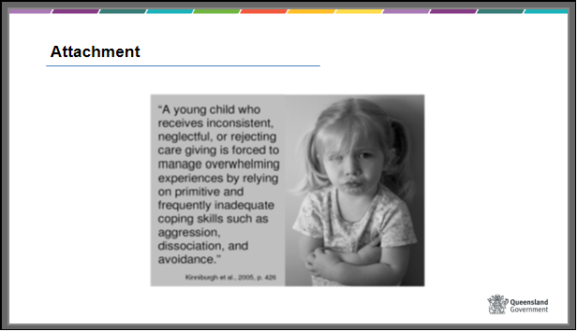

 | Slide 13  Attachment theorists describe Three Insecure Attachment Style including:  - Avoidant/Resistant style: where infants have experienced parenting that is poorly attuned to their needs. Such babies show little distress when their primary care giver leaves them and pay no particular attention or actively turns away when they return.  - Anxious/Ambivalent style: where carer attunement has been erratic, over stimulated or inconsistent to the infant’s needs. Infant behaviours include clinging to their carer, distress when they leave and show little joy upon the carers return.  - Disorganised/Disoriented style: in which infants have experienced parenting that is chaotic, intrusive or hostile in nature. These infants display negative and overwhelmed reactions to all new experiences and often spend time as if in a trance. Infants can freeze or engage in motions such as rocking or head shaking. They also engage in “approach avoidance” behaviour, unsure of whether they should approach the carer when they appear (Noller et al, 2001) | Slide 13  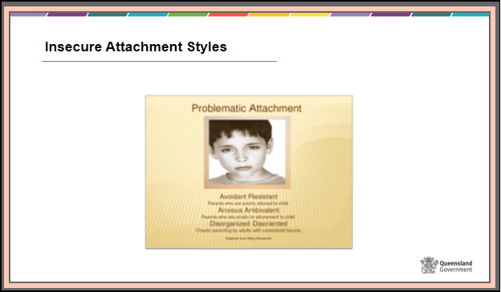
 | Slide 14  Refer to separate activities resource for instructions on activity  Activity - Matching | Slide 14  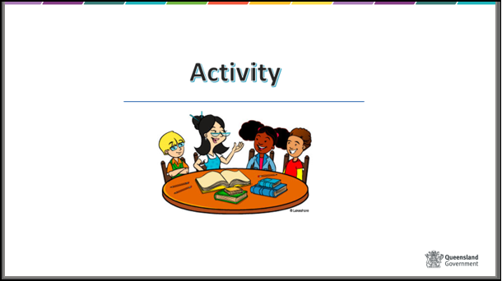

 | Slide 15  Proceed with discussion of how help can be given to children and young people with attachment difficulties  Discuss with the group what a carer can do to help children with attachment difficulties?  - Preserve attachments. E.g., every effort should be made to maintain and further strengthen existing attachment relationships. This is equally the responsibility of the CSO, foster carer and family.  - Provide consistent, predictable and repetitive environments. This may make a child feel safer and know what to expect.  - Understand why a child could be behaving in a certain way. This may change the way you respond to their behaviours and their issues.  - Remember that the child or young person may display emotional behaviour that is not consistent with their age level. For this reason, it is important to respond according to their emotional level.  E.g. it may be inappropriate to reason with a child who is tearful and overwhelmed.  - Be patient and have realistic expectations. Model appropriate behaviour and explain what you are doing and why. Try not to make a child or young person feel bad or guilty about their behaviour.  In the case of Aboriginal and Torres Strait Islander children and young people it is important to remember that attachment may occur within a broader context of extended family and community. Preservation of relationships within that context becomes critical in order to maintain positive attachments with others. | Slide 15  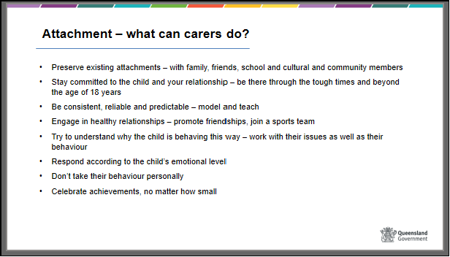

 | Slide 16  Stages of grief and loss  HANDOUT – refer participants to handout “The longing to belong – loss and grief reactions” and “Considerations when caring for Aboriginal and/or Torres Strait Islander children or young people”  As we have seen, sometimes children and young people who come into care have not had the opportunity to develop secure attachments.  Rejection or perceived rejection by the person who provides primary care can lead to insecure attachment.  If a child or young person experiences rejection or abuse, or lives with inconsistencies in care, it is likely that they will feel confused about their relationship with the person providing that care. On the one hand they may not be able to get close to that person, but they still feel some attachment to them. A sense of loss and pain can occur.  Be careful though when thinking about these stages. People rarely move neatly into the next stage and in an upward direction to acceptance.  It is very common that a child or young person will move in and out of stages depending on the situation.  For example, a child may show anger and withdrawal after family contact. This can be seen by carers that the experience of contact wasn’t good. However, it could be that contact was good but the experience of separation from family again sends the child back into denial, anger and sadness. Children can also be triggered into a grief reaction by sight, smell, touch and taste stimulus. A memory of a parent may be recalled if they can smell their favourite dinner cooking. | Slide 16  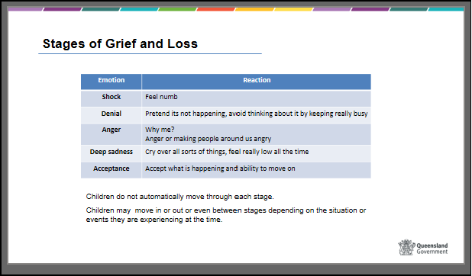

 | Slide 17  When a child or young person has to leave home to live with foster carers there are further losses for them.  Existing bonds – even though those bonds may themselves be unsatisfactory - are disrupted, and children or young people may struggle to maintain an attachment to a harmful family situation or unavailable parent.  The following behaviour may be evident:  - Running away from a care arrangement to return home  - Strong defence of parental behaviour, even when promises are broken  - Fantasising about parents and the home situation  - Self-harming behaviour  - Fear of getting close to others  The loss of a relationship with parents or significant others will be compounded by changes in other familiar things, such as schooling, friends, and shops.  There is also a loss of a sense of belonging and a rupture of “what is known”.  For a child or young person coming into care there may be a number of crises, separations, moves and losses. They may not have dealt with one before another happens.  Thus, children or young people in care may be far more emotionally vulnerable when another loss occurs.  Some common reactions of children and young people:  - “It’s all my fault – I’m no good”.  - “Everyone is against me”.  - “I don’t need anyone”.  - “I hate everyone”. | Slide 17  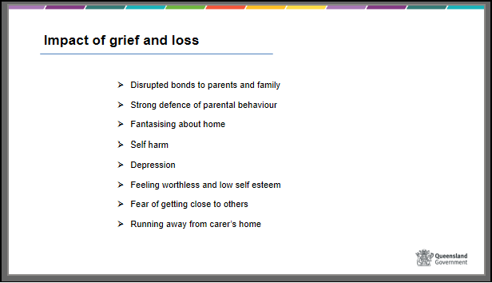

 | Slide 18  After a significant loss there is a period of grief that is an important part of moving forward to cope with a changed world. It is not a matter of just learning information about the new world, but more a process of learning how to “be and act” differently in this changed world.  There are 4 significant areas of “re-learning” that a child or young person must cope with when they move to a care arrangement.  - Re-learning physical surroundings. Ask participants to think about the things that have changed in the physical environment when a child or young person moves. What new things will they need to “learn” about their physical environment?  - Re-learning relationships with parents, other family members, carers and others. Ask participants how relationships may have changed with natural family and what might be difficult about learning new relationships.  - Re-learning self. Often a child or young person who comes into care is still learning how to be themselves in a chaotic and unpredictable world. Suddenly they are challenged to adjust to new unknown situations and there can be impacts on sense of self, confidence and self-esteem.  - Re-learning place in space and time. Often a child or young person is confused and wishes they were somewhere else. Memories can be triggered at any time and a child or young person may be  Needs of Aboriginal and Torres Strait Islander children  Issues of care arrangements outside extended family networks take on greater significance in terms of grieving, especially where a care arrangement cannot always occur within the same community grouping. Highlight the importance of placing a child with their family and community and how reunification is the primary goal of child protection work. | Slide 18  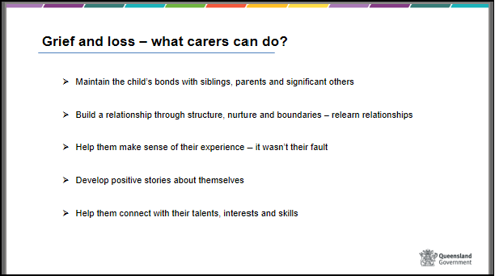

Summary – the experience of abuse

One of the most challenging parts of foster and kinship care is understanding the past of a child in care and dealing with the behaviour they have learnt to survive their pain, fear, confusion and hurt.

We have just discussed the impact an abusive past can have on developmental milestones, social skills, maintaining relationships, attachments and grief and loss.

The behaviours highlighted in today’s module are indicators only and it is always important to see these in the context of normal behaviour patterns for each individual child or young person. For example – temper tantrums/ aggression are often present in normal developmental milestones. It is important to consider not only the impacts of abuse, attachment issues and grief and loss but also the normal development milestones that were discussed earlier.
 | Slide 19  Refer to separate activities resource for instructions on activity  HANDOUTS – Case study 1,2 and 3 - PART 2 | Slide 19  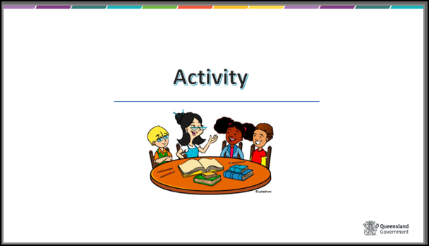
40 mins | Slide 20  Experience of sexual abuse  Sexual abuse is common in our community. While exact figures of sexual abuse towards children are unknown some research suggests that one in four girls and one in seven boys will have experienced some form of sexual abuse before the age of eighteen years.  Highlight that this issue may evoke strong feelings in participants and offer de-briefing for anyone who may feel the need to talk to someone afterwards. Make it clear that participants do not need to reveal anything about their own experiences in the group.  Refer participants to visit the True – relationships and reproductive health website to access fact sheets about sexual assault to learn more. | Slide 20  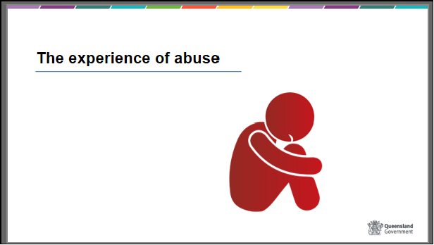
 | Slide 21  Refer to separate activities resource for instructions on activity  Activity – Myths and facts about sexual abuse | Slide 21  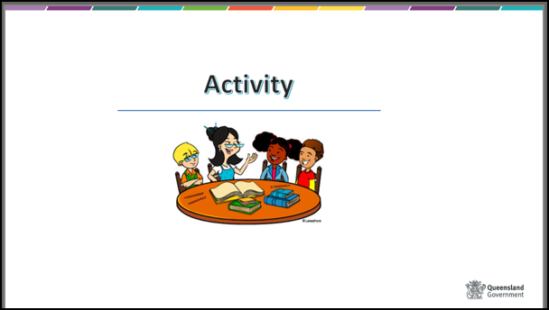
 | Slide 22  HANDOUTS – The experience of sexual abuse and Indicators of Child Sexual Abuse  The effects of sexual abuse can last a lifetime and may be observed in children and young people as:  - A pre-occupation with sexual matters that are not age appropriate, including a detailed knowledge of adult sexual behaviour. Ask the group to identify sexual behaviours that are both age, and not age, appropriate.  - Sexual themes in play, artwork etc. It is important to bear in mind that the behaviour must be persistent, and the child must appear obsessed with acting out sexual themes.  - Inappropriate sexualised behaviour that is persistent e.g. at school, with friends, siblings.  - A fear of going to bed, bathing, getting changed, being left alone with an adult. Sleep disturbances can also occur.  Evidence of one of these behaviours is not an automatic indication that sexual assault has occurred. However, it would alert you to the possibility and you should discuss it immediately with the CSO. | Slide 22  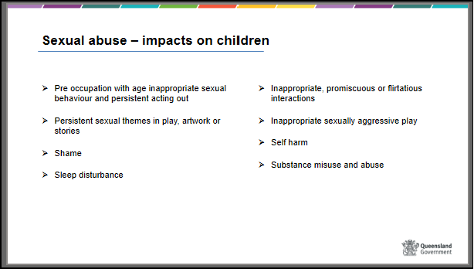

 | Slide 23  What the foster carer can do:  - How you respond to a disclosure or behavioural indicators will have a significant effect on the child or young person’s adjustment. It is important to listen to what the child or young person is saying or doing. Experienced foster carers may give examples of what might be said by the child or young person to communicate the problem. Facilitate group discussion.  - Define rules and boundaries in the home to allow respect for individual privacy, particularly around dressing, bathing and sleeping. Be aware of the appropriateness of touching or personal space, particularly with respect to kissing, touching, hugging. Children and young people who have experienced sexual abuse may not know how to interpret this behaviour.  The experienced carer might want to give examples of the rules and boundaries they use and how to avoid misinterpretation of behaviour and possible allegations.  Refer to Indicators of Child Sexual Abuse from the handout.  - Assist the child or young person by building self-esteem, teaching assertiveness and teaching self- protective skills and behaviours.  - Discuss the need for sexual abuse counselling. This is usually required to ensure that the child or young person deals with feelings about the abuse and becomes a “survivor”. A carer can assist in the healing process by being respectful and available to the child or young person according to their needs.  - Be aware that children and young people who have been sexually abused may be vulnerable in a number of ways. Refer to Indicators of Child Sexual Abuse from the handout. One possible behavioural indicator may be that the child or young person has a preoccupation with sexual activity and may engage in inappropriate actions with other children in the placement. Carers must carefully consider the level of supervision required in the household. | Slide 23  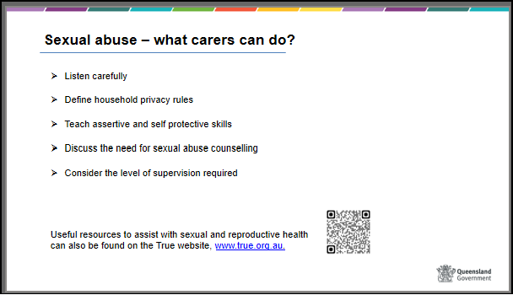

 | Slide 24  Refer to separate activities resource for instructions on activity  Optional Activity – misunderstandings or allegations | Slide 24  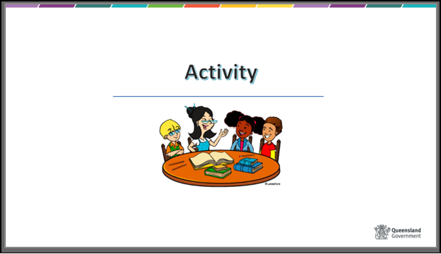
 | Slide 25  Self- harming behaviours  There is no universal definition of self-harm or age that a child may start self-harm or suicidal behaviours.  Generally, self-harm is understood to involve a person deliberately causing themselves physical pain as a means of managing difficult or painful emotions, or as a way of communicating distress.  Risk Factors  Reasons for self-harming are often diverse and may be a response to low self-esteem, family and relationship breakdowns, anger, emotional difficulties, traumatic life experiences or grief.  Self-harming behaviours can be linked to substance abuse and mental health issues, for example, depression, personality disorders, eating disorders and anxiety.  Slide 26  Usually, the motivation for self-harming behaviour is to cope with painful emotions and distressing personal experiences and not to result in death. E.g. If I physically hurt, it’s better than crying or yelling.  Any action deliberately intended to cause death is regarded as a suicide attempt. Any deliberate attempt on one’s life that results in death is suicide.  Indicators of Self Harm – things for carers to look out for: Discuss the content of the slides with participants. | Slide 25  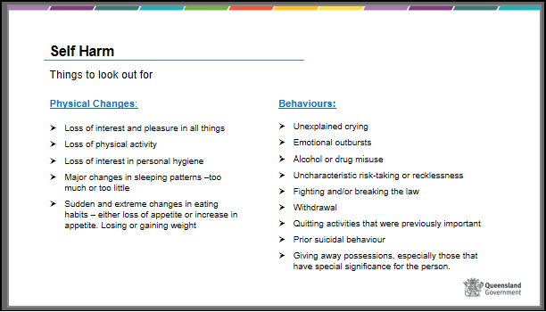  Slide 26  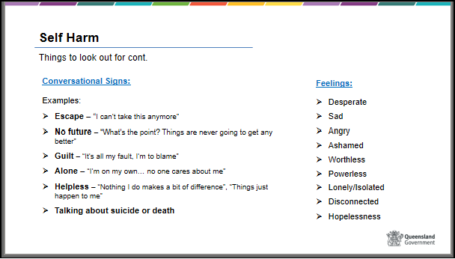

 | Slide 27  Some basic practical strategies to use if a child is self-harming or has suicide ideation include:  - Act straight away and talk to the child or young person  - Be open with your concerns, because you wish to keep them safe you will need to talk to others  - Take any threats, suicide talk or actions seriously  - Contact your CSO immediately to discuss your concerns if during work hours, or contact CSAHS if after hours  - Ask for strategies to help talk to the child  - Talk openly with others - CSO, school staff, child’s counsellor  - Use resources available - Foster carer support line, Information for existing carers, LIFE – Living is for everyone and Beyond Blue  Trainer can refer to or use the following information and fact sheets  Alive and Well – Living is for Everyone  Explore articles | ReachOut Australia – self-harm | Slide 27  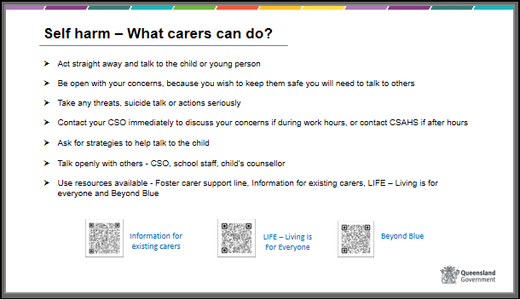
 | Slide 28  “Responding to disclosures”  As per slide information | Slide 28  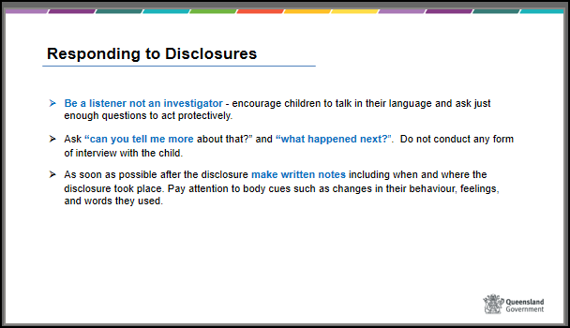

 | Slide 29  “Responding to disclosures” – continued  As per slide information  Ensure participants are aware of the new legislation that has been enacted regarding all adults being required to report sexual offending against a child.  From July 5, 2021 it is an offense for any adult not to report sexual offending against a child by another adult to police. This means that all adults have the responsibility to report sexual offences against children to police – unless they have a reasonable excuse not to.  For more information please scan the QR code. | Slide 29  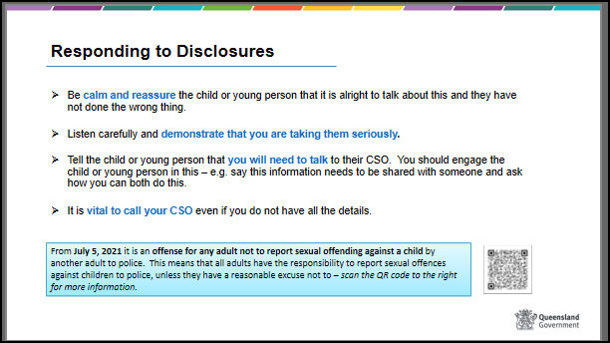
 | Slide 30  Refer to separate activities resource for instructions on activity  Activity – Role Play | Slide 30  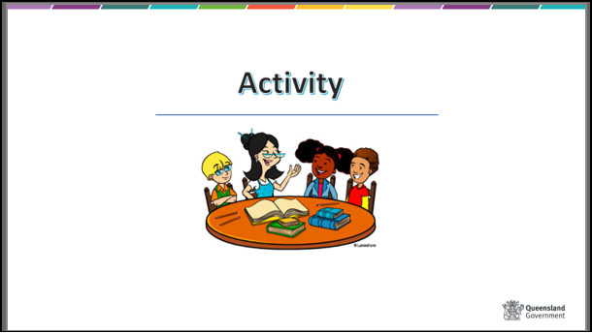
30 mins | Slide 31  Responding to challenging behaviours | Slide 31  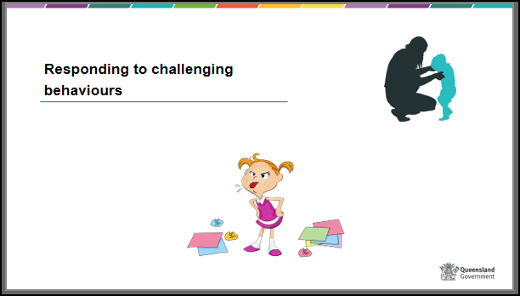
 | Slide 32  Positive behaviour support  HANDOUT – Positive Behaviour Support Policy 604  In previous sessions we have looked at the impact of abuse, poor attachments and the experience of loss and grief for children and young people. As discussed, these experiences can have a significant impact on a child or young person’s behaviour and actions.  Carers need to consider these issues when deciding on suitable behaviour management and support strategies. Children and young people in foster care may present with behaviour that is extreme and more difficult to manage than one would expect from one’s own children.  Handover to the experienced foster carer to discuss some experiences they have had, strategies they use and to facilitate brainstorm exercise. Ensure experienced foster carer is utilised well throughout this session. | Slide 32  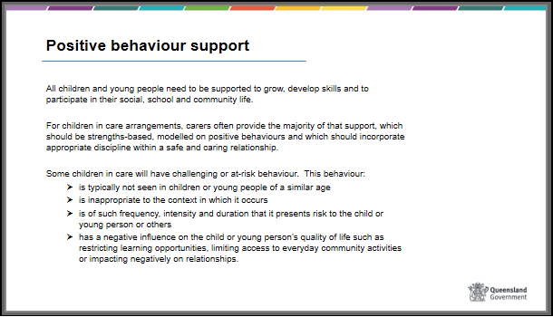
 | Slide 33  Refer to separate activities resource for instructions on activity  BRAINSTORM – Challenging behaviours | Slide 33  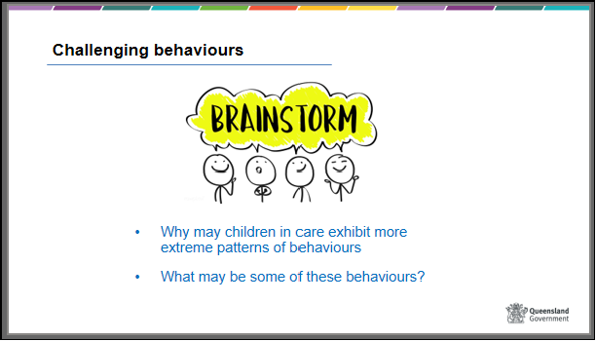
 | Slide 34  Positive behaviour support  At-risk or challenging behaviour is often related to environmental factors, such as interpersonal relationships, physical environment, responses from others and the way in which services are delivered. All children require support to develop skills to able to participate in social, school and community life. For children in care, carers will often provide the majority of this support.  Positive behaviour support is a holistic approach with a focus on understanding the purpose of the behaviours and increasing positive behaviours through skill development rather than punishing negative behaviours and uses a proactive, rather than reactive or crisis driven strategies. The focus is on skill development and modifying the environment or context to better support the child and reduce the need for them to engage in at risk behaviour. | Slide 34  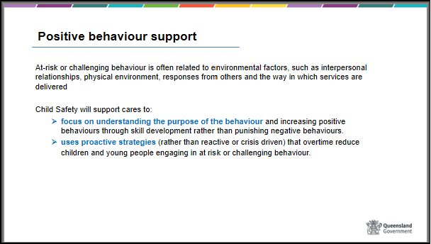
 | Slide 35  Children in care will have been assessed to identify if the child or young person will engage in any challenging or high-risk behaviour. The information from this assessment will be used to inform the Positive behaviour support plan if one is required and if so, identify strategies and services that can respond to the child’s behavioural needs and ensure these are included in case planning. | Slide 35  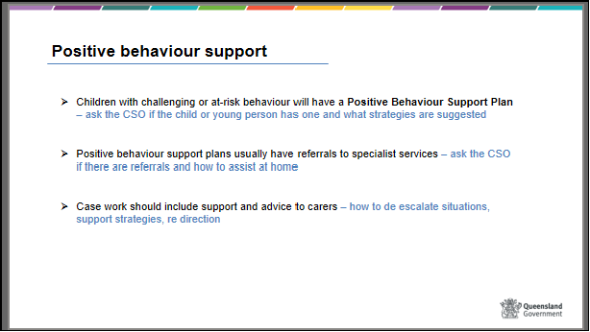
 | Slide 36  Positive behaviour support plan  A positive behaviour support plan may include case work support for carers. The plan will assist with planning and implementing strategies to manage behaviours through positive responses such as:  - primary preventative strategies that aim to change the environment and improve quality of life for the child. These strategies include building strong relationships, recognising positive behaviours rather than negative ones, focussing on strengths, clear and consistent boundaries and assisting with problem solving.  - skill development in areas such as communication, self-regulation and coping  - graded approaches to responding to at risk behaviour. This includes identifying early warning signs of at-risk behaviour and effective strategies to alleviate the situation when the behaviour presents low risk.  - non-aversive reactive strategies that aim to bring about resolution and return to safety when the child engages.  The strategies that are incorporated into the Positive behaviour support plan must comply with the requirements as set out in the Statement of standards, the Charter of Rights for a child in care and the Positive Behaviour Support policy. | Slide 36  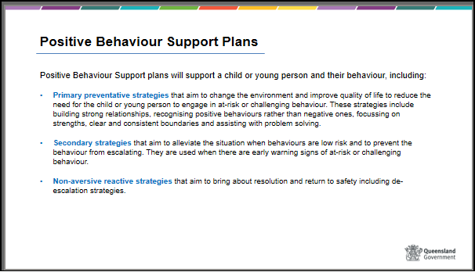
 | Slide 37  NDIS  A child who engages in challenging or high-risk behaviour as a result of a disability or a range of factors including trauma and mental health issues will need to have a positive behaviour support plan that provides strategies to assist with responding to high-risk behaviour early in the escalation, where their behaviours are of a lower risk to themselves and others.  Children and young people engaged with NDIS may have part of their positive behaviour support plan allocated to disability-specific training funded through their NDIS plan for their carers as well as any other allied health funding required to support the development of the positive behaviour support plan and skill development.  Carers will need to ensure they are provided with a copy of the child or young person’s positive behaviour support plan and can ask their CSO or care service staff to have one provided.  Carers will also need to be aware that the use of physical restraint (with the exception of some high risk physical restraints) and restricted access to items can only occur as an emergency response, where there is immediate risk of harm to the child or others and the reporting requirements for any use of a prohibited practice or an emergency use of a restrictive practice. | Slide 37  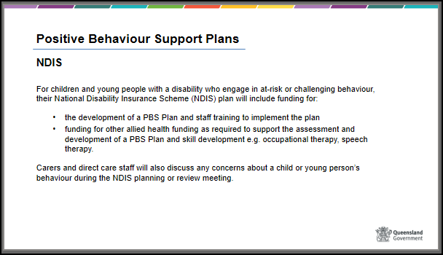
 | Slide 38  Prohibited practices  Prohibited practices are unlawful and unethical practices and practices which cause a high level of discomfort and trauma. Any action which is contrary to section 122 of the Child Protection Act 1999 because it frightens, threatens, or humiliates a child or young person is a prohibited practice.  Prohibited practices must not be used in responding to the behaviour of children who are placed in care under section 82(1) of the Act. | Slide 38  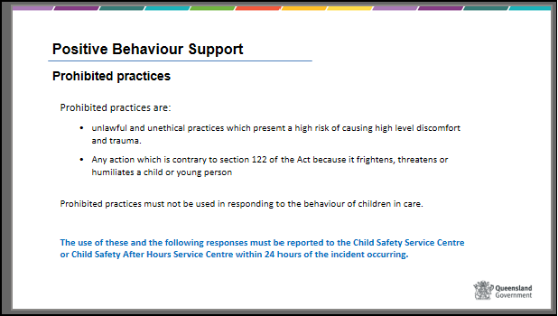
 | Slide 39  Prohibited practices can include:  - corporal punishment  - unethical practices to modify a child or young person’s behaviour  - planned use of physical restraint  - planned use of restriction of access to items (environmental restraint)  - containment (environmental restraint)  - seclusion  - chemical restraint e.g., using medication to manage a child or young person’s behaviour  - mechanical restraint e.g., using a device on a person’s body, or a limb of the person, to restrict the person’s movement i.e., a lap belt or wrist strap etc  - aversive strategies e.g., using an unpleasant physical or sensory stimulus in an attempt to reduce undesired behaviour i.e., a cold bath, cancelling an activity as a punishment for challenging behaviour, pinching, pushing, hitting  Example:  Environmental restraint - Limiting a resident to a particular environment: e.g., confining a resident to their bedroom, excluding a resident from an area to which they want to go; Restricting access to an outside courtyard or sitting room; Preventing a resident from leaving the building. | Slide 39  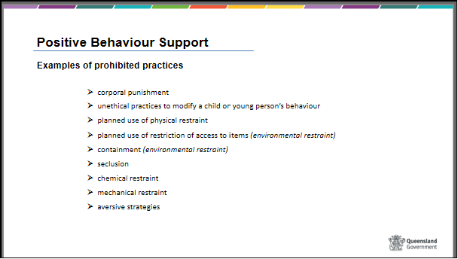

 | Slide 40  Restraints used as intended (such as car seats, safety harness in prams and change tables) are not prohibited. However, these items should be monitored to ensure that they:  - do not convert to being used as a mechanical restraint, for example, a stroller with straps applied to secure the child safely when used should not be used at home to restrict their movement.  - are not used in a way to punish a child or used for lengthy periods of time for example placing a child in a cot for lengthy periods as a form of discipline. | Slide 40  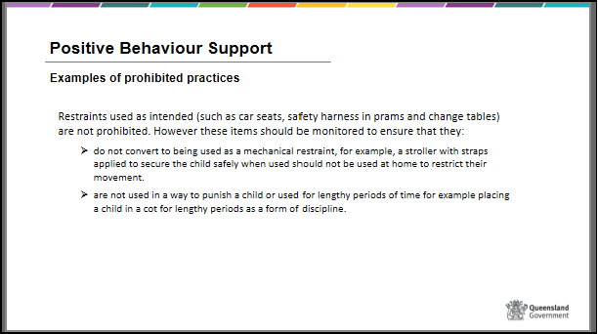
 | Slide 41  Prohibitive practice does not include steps taken by a carer or member of direct care staff in a parenting role to discipline and respond to developmentally appropriate behaviour.  - For example, the short periods of ‘time out’ type strategies consistent with accepted parenting practices such as those promoted through the Triple P Program.  Care must be taken that these strategies do not continue as the child becomes older and that they do not become seclusion. | Slide 41  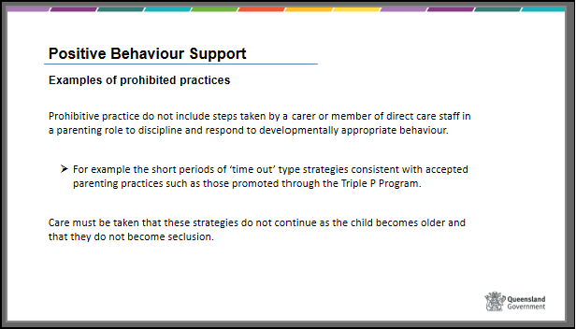
 | Slide 42  Refer to separate activities resource for instructions on activity  Activity – Inappropriate behaviour or Alternative Activity | Slide 42  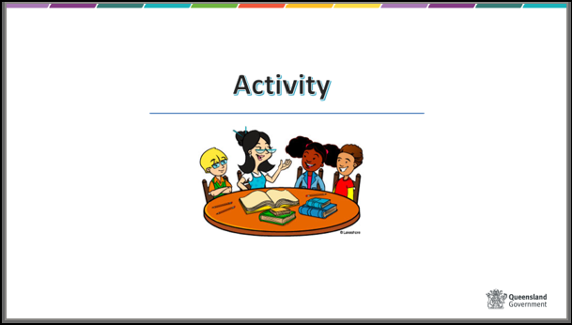
 | Slide 43  As per slide information:  - Ask about the child’s positive support plan – if the child or young person in your care has a PBS, request a copy from their CSO.  - Be a good role model - show what you expect  - Listen and ask questions - what will make you feel better?  - Use positive reinforcement - encourage shared learning  - Focus on the child’s strengths not behaviour  - Establish clear family routines  - Prepare yourself for difficult situations - avoid a battle, don’t prove who’s in charge  - Set limits and stick to them - be consistent with rules and boundaries  - Use available resources - foster carer support line, Information for existing carers webpage, foster and kinship care worker, Evolve, training | Slide 43  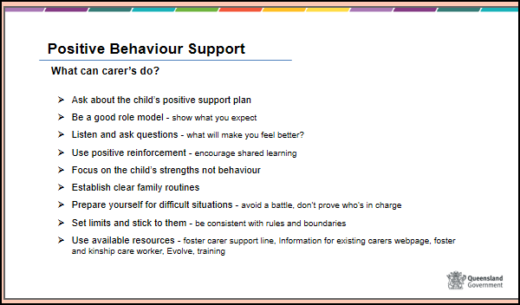
 | Slide 44  Managing high-risk behaviours – restrictive practices.  Positive Behaviour Support plans provide strategies to assist in responding to the challenging behaviours demonstrated by children and young people in care. Restrictive practices can present risk and also contribute to trauma to the child and those using the restrictive practices.  The PBS plan will assist carers in the management of any restrictive practices, if required.  - Restrictive practices are any intervention that impacts on the rights or freedom of movement of a person with the primary purpose of protecting the person or other people from harm.  - Restrictive practices do not facilitate long-term behaviour change and must not be the sole method used to manage a child or young person’s behaviour.  - For any restrictive practice there must be a strategy to reduce and minimise its ongoing use. | Slide 44  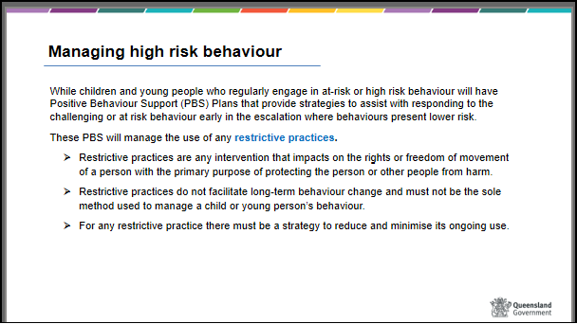

 | Slide 45  Emergency use of restrictive practices  At times, children and young people may display behaviour that could place themselves or others at immediate risk, in these circumstances it may be necessary for carers to respond quickly and take emergency actions to intervene with reasonable force to protect the child or young person, themselves or others.  It’s important to note that reliance on the emergency use of restrictive practices in the absence of a PBS plan is not to be used as a behaviour management strategy nor for convenience or as a retaliation or discipline of the child or young person.  i.e. the emergency use of restrictive practices is not an option when responding to a child or young person’s refusal to comply with an instruction, unless that instruction creates an imminent risk to their safety or that of others. | Slide 45  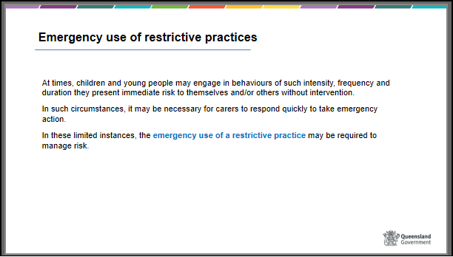
 | Slide 46  Guiding principles for the emergency use of restrictive practices  As per slide information:  The situation in which an emergency use of restrictive practices may be appropriate is when:  - the child or young person is behaving in a way that poses immediate foreseeable risk of harm or actual risk of harm to themselves or others e.g., a young person is upset and is unable to be de-escalated and they go to run out on the road where there is busy traffic, the carer grabs them by the arm and pulls them back from the side of the road and holds them by the arms until support arrives.  - the practice is reasonable in all the circumstances of the behaviour  - where there is no less restrictive measure available to respond the child or young person’s behaviour in the circumstances e.g., a young child has escalated in a shopping centre and begins to bang their head violently on the ground, the carer scoops up the child and holds them in an embrace until they begin to calm down.  - paramount consideration must be given to the best interests of the child. | Slide 46  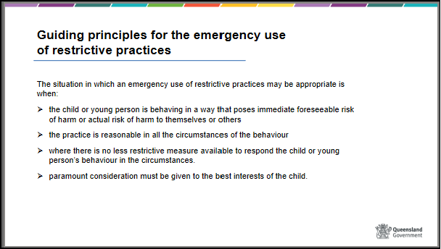

 | Slide 47  Emergency use of restrictive practices – what can we do / what does it mean?  Carers can use emergency responses to manage high risk of immediate harm (risk management response) – as per the previous slide but it must be reported to Child Safety or Child Safety After Hours within 24 hours.  Emergency use of physical restraint, can be used by carers, except for prone (holding a child or young person face down) and supine (holding a child or young person face up) restraints and basket holds which are always prohibited practices, where:  - It is reasonable and necessary  - It is the least restrictive option and proportionate to the level of risk of the behaviours  - It is applied for the shortest period of time  - It is only used where the risk of not using it outweighs the risk of using it  - It must be stopped if a child or young person cannot breathe, vomits, demonstrates signs of distress, starts to change colour or has a medical emergency such as a seizure or asthma attack  - must be reported to Child Safety or Child Safety After Hours within 24 hours  Emergency removal of an item – If there is need to remove an object when there is imminent risk or actual harm (e.g., a young person with a history of self-harm, holding a knife and threatening to cut her wrists):  - it will be removed for the shortest amount of time possible; and  - will be returned to the child or young person’s environment once the risk has reduced  - the removal of the object may be accompanied by the emergency use of physical restraint and the principles related to this will be considered.  - must be reported to Child Safety or Child Safety After Hours within 24 hours  Emergency removal of an object does not include removal:  - due to the child or young person not having the relevant safety skills, as appropriate to their developmental age for example locking chemicals up when there are young children in the house; or  - items that may be used for illegal purposes such as weapons; or  - items that need to be locked away to ensure carers are compliant with relevant licensing requirements.  Minimum force – e.g., a child is having a seizure and their head is banging on the ground, the carer places their hand under the child’s head with just enough force in an attempt to protect the child’s head from repeatedly hitting the ground.  - is the least restrictive option, in that it is the minimum level of force which is reasonable and necessary to protect the child or young person against danger  - must be reported to Child Safety or Child Safety After Hours within 24 hours  The requirement to report the emergency use of a restrictive practice does not include actions taken by carers and direct care staff in the context of age and developmentally appropriate parenting, for example removing scissors from a toddler. | Slide 47  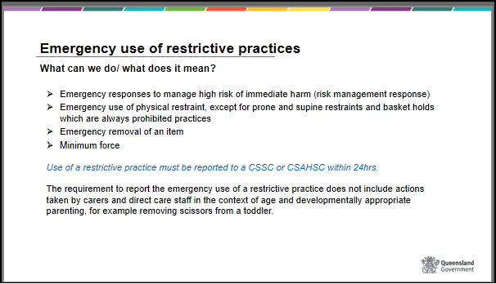
 | Slide 48  Refer to separate activities resource for instructions on activity  BRAINSTORM – Discipline vs Punishment | Slide 48  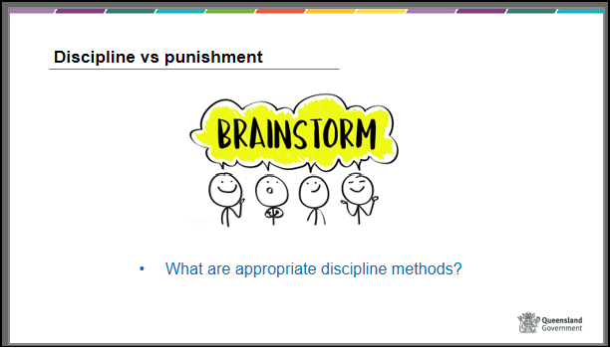

Summarise the content

The experience of managing grief, loss and challenging behaviours can be difficult and frustrating at times. It is always important to reinforce progress that the child or young person has been making and assure the child or young person that they are still on the right track, in spite of any setbacks.

Remember that the child or young person may be expecting to be rejected – and may even behave in a way that seems to provoke that – so it is important to reinforce trust, commit to positive attachment and provide stability and security.

When managing challenging behaviours appropriate discipline can assist the child or young person to feel safe and secure and in turn support the child or young person’s development. Appropriate discipline helps to keep children and young people safe from danger while supporting their emotional self-regulation and responsibility.

You do not have to deal with this by yourself. Support should be sought from your worker at the foster and kinship care agency or Child Safety about strategies to use to manage behaviour. If necessary, you should advocate for professional help for yourself and the child or young person.

 | Slide 49  Learning outcomes  - Understanding the basic developmental stages of childhood and adolescence  - Understanding the experience of abuse and how it impacts on children  - Understanding what attachment means for a child, and how separation impacts on attachment  - Identifying the variety of losses that may be experienced by children who come into care and by birth family members  - Understanding and responding to challenging behaviour | Slide 49  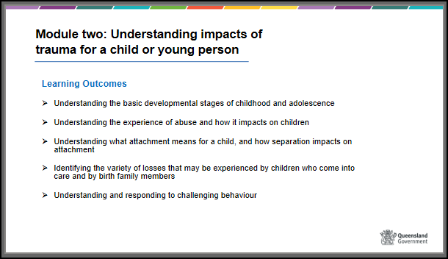

 | Show side 50  Thank you  Thank participants for their input and work during the course and for their concern for children and young people.  Participant Evaluation forms should be handed out and collected at the end of the session | Slide 50

