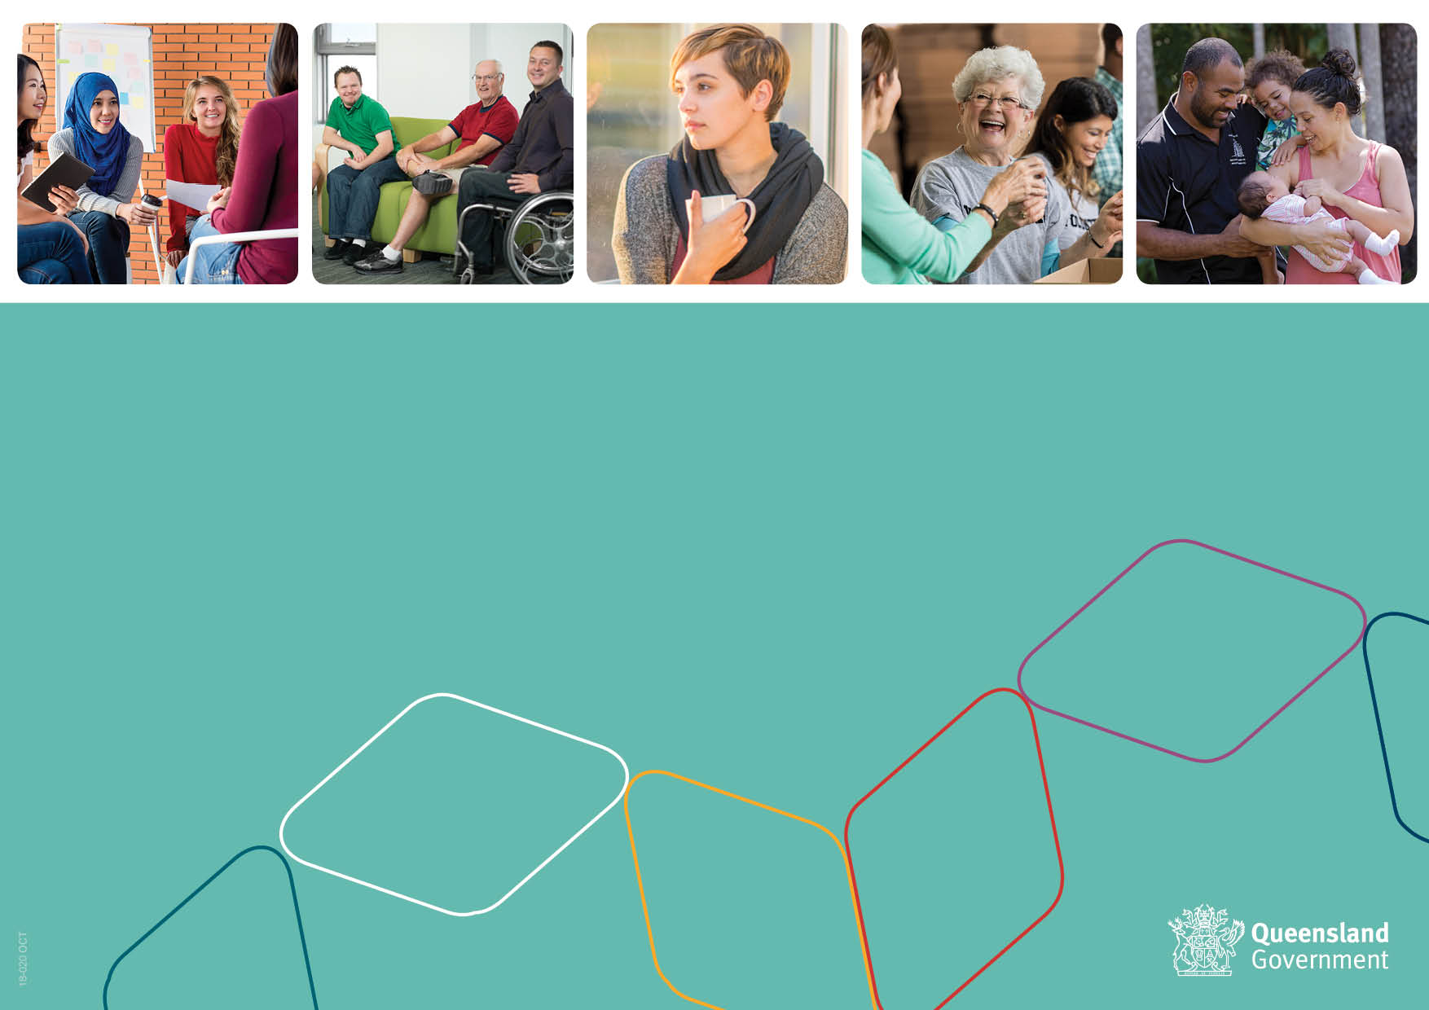
Human Services
Quality Framework
Self-Assessment Workbook
Self-Assessable Organisations (only)

Version: 4.0

Self-Assessment and Organisation Details
Organisation name (legal entity)
Trading name (where applicable)
Australian Business No (ABN)
Service details | Service outlet name/s |  | Service outlet number/s | Funding department
Organisation postal, email and telephone contact details
Organisation contact person for the self-assessment
Please record submission details for your self-assessment below. If your organisation receives funding under multiple funding streams and/or from different departments e.g. Young People DCYJMA and Community Services DCHDE, you are only required to complete and submit one self-assessment for all of your self-assessable services. Please submit your completed self-assessment to all your Contract Officer/s.
Contract Officer/s name |  | Contract Officer/s email
Self-assessment due date |  | Date submitted
Is the Continuous Improvement Plan (initial) being submitted with the self-assessment? | Yes  No | Updated Continuous Improvement Plan due date 12 months after self-assessment due date

Declaration of Accountable/Authorised Officer
I Click here to enter text. hereby declare the following:
1. I am the Accountable/Authorised Officer for Click here to enter text. (the Organisation); and
2. the information provided in the Self-Assessment Workbook is true and correct to the best of my knowledge; and
3. as at Click here to enter text., the Organisation has developed, and will fully implement, the policies, procedures and management systems detailed in this Self-Assessment Workbook in accordance with the requirements of the Human Services Quality Standards; and
4. I have provided the completed Self-Assessment Workbook to the Governing Body (if any) of the Organisation and the Governing Body is aware that these policies, procedures and management systems have been developed and the Governing Body is committed to the implementation of those policies, procedures and management systems.
Signed: ………………………………… Date: …………………………  Name: ……………………………..…… Position: ……………………… | Witness: ………………………..… Date: ……………………
Privacy Notice: The Queensland Government is collecting your personal information to assess the completeness of this self-assessment against the Human Services Quality Standards as required in your service agreement with the department/s. The department/s will handle your personal information in accordance with the Information Privacy Act 2009.

Self-assessment checklist
Please check before submitting your self-assessment | Where can I find this? | Check
The HSQF User Guide – Self-Assessable Organisations and the Guide to Self-Assessment and Continuous Improvement – Self-Assessable Organisations were used to complete this self-assessment | On the HSQF website at: www.dsdsatsip.qld.gov.au/our-work/human-services-quality-framework
Evidence examples are recorded for each standard indicator | Self-Assessment Worksheets
A self-assessment rating has been given for each standard indicator | Self-Assessment Worksheets
An action item is entered in the continuous improvement plan template for any standard indicators rated as Partially Met or Not Met | Continuous Improvement Plan (template)
Organisation and departmental contact details used to submit the self-assessment are complete | Self-Assessment Workbook (coversheet)
The declaration has been completed and signed by the accountable person | Above on this page

Self-Assessment Worksheets

Note: You should use the HSQF User Guide – Self-Assessable Organisations and the Guide to Self-Assessment and Continuous Improvement - Self-Assessable Organisations to complete your self-assessment.
Standard 1 | Governance and management
Indicator | 1.1 The organisation has accountable and transparent governance arrangements that ensure compliance with relevant legislation, regulations and contractual arrangements.
What practices and processes does your organisation have in place to meet this indicator?
Consider all common and service stream/service type mandatory requirements in the HSQF User Guide – Self-Assessable Organisations
Self-rating | Met Partially met Not met
What needs to be recorded in the Continuous Improvement Plan?

Standard 1 | Governance and management
Indicator | 1.2 The organisation ensures that members of the governing body possess and maintain the knowledge, skills and experience required to fulfil their roles.
What practices and processes does your organisation have in place to meet this indicator?
Consider all common and service stream/service type mandatory requirements in the HSQF User Guide – Self-Assessable Organisations
Self-rating | Met Partially met Not met
What needs to be recorded in the Continuous Improvement Plan?

Standard 1 | Governance and management
Indicator | 1.3 The organisation develops and implements a vision, purpose statement, values, objectives and strategies for service delivery that reflect contemporary practice.
What practices and processes does your organisation have in place to meet this indicator?
Consider all common and service stream/service type mandatory requirements in the HSQF User Guide – Self-Assessable Organisations
Self-rating | □ Met Partially met Not met
What needs to be recorded in the Continuous Improvement Plan?

Standard 1 | Governance and management
Indicator | 1.4 The organisation’s management systems are clearly defined, documented and monitored and (where appropriate) communicated including finance, assets and risk.
What practices and processes does your organisation have in place to meet this indicator?
Consider all common and service stream/service type mandatory requirements in the HSQF User Guide – Self-Assessable Organisations
Self-rating | □ Met Partially met Not met
What needs to be recorded in the Continuous Improvement Plan?

Standard 1 | Governance and management
Indicator | 1.5 Mechanisms for continuous improvement are demonstrated in organisational management and service delivery processes.
What practices and processes does your organisation have in place to meet this indicator?
Consider all common and service stream/service type mandatory requirements in the HSQF User Guide – Self-Assessable Organisations
Self-rating | □ Met Partially met Not met
What needs to be recorded in the Continuous Improvement Plan?

Standard 1 | Governance and management
Indicator | 1.6 The organisation encourages and promotes processes for participation by people using services and other relevant stakeholders in governance and management processes.
What practices and processes does your organisation have in place to meet this indicator?
Consider all common and service stream/service type mandatory requirements in the HSQF User Guide – Self-Assessable Organisations
Self-rating | □ Met Partially met Not met
What needs to be recorded in the Continuous Improvement Plan?

Standard 1 | Governance and management
Indicator | 1.7 The organisation has effective information management systems that maintain appropriate controls of privacy and confidentiality for stakeholders.
What practices and processes does your organisation have in place to meet this indicator?
Consider all common and service stream/service type mandatory requirements in the HSQF User Guide – Self-Assessable Organisations
Self-rating | □ Met Partially met Not met
What needs to be recorded in the Continuous Improvement Plan?

Standard 2 | Service access
Indicator | 2.1 Where the organisation has responsibility for eligibility, entry and exit processes these are consistently applied based on relative need, available resources and the purpose of the service.
What practices and processes does your organisation have in place to meet this indicator?
Consider all common and service stream/service type mandatory requirements in the HSQF User Guide – Self-Assessable Organisations
Self-rating | □ Met Partially met Not met
What needs to be recorded in the Continuous Improvement Plan?

Standard 2 | Service access
Indicator | 2.2 The organisation has processes to communicate, interact effectively and respond to the individual’s decision to access and/or exit services.
What practices and processes does your organisation have in place to meet this indicator?
Consider all common and service stream/service type mandatory requirements in the HSQF User Guide – Self-Assessable Organisations
Self-rating | □ Met Partially met Not met
What needs to be recorded in the Continuous Improvement Plan?

Standard 2 | Service access
Indicator | 2.3 Where an organisation is unable to provide services to a person, due to ineligibility or lack of capacity, there are processes in place to refer the person to an appropriate alternative service.
What practices and processes does your organisation have in place to meet this indicator?
Consider all common and service stream/service type mandatory requirements in the HSQF User Guide – Self-Assessable Organisations
Self-rating | □ Met Partially met Not met
What needs to be recorded in the Continuous Improvement Plan?

Standard 3 | Responding to individual need
Indicator | 3.1 The organisation uses flexible and inclusive methods to identify the individual strengths, needs, goals and aspirations of people using services.
What practices and processes does your organisation have in place to meet this indicator?
Consider all common and service stream/service type mandatory requirements in the HSQF User Guide – Self-Assessable Organisations
Self-rating | □ Met Partially met Not met
What needs to be recorded in the Continuous Improvement Plan?

Standard 3 | Responding to individual need
Indicator | 3.2 The organisation formulates service delivery that respects and values the individual (e.g. identity, gender, sexuality, culture, age and religious beliefs).
What practices and processes does your organisation have in place to meet this indicator?
Consider all common and service stream/service type mandatory requirements in the HSQF User Guide – Self-Assessable Organisations
Self-rating | □ Met Partially met Not met
What needs to be recorded in the Continuous Improvement Plan?

Standard 3 | Responding to individual need
Indicator | 3.3 The organisation ensures that services to the individual/s are delivered, monitored, reviewed and reassessed in a timely manner.
What practices and processes does your organisation have in place to meet this indicator?
Consider all common and service stream/service type mandatory requirements in the HSQF User Guide – Self-Assessable Organisations
Self-rating | □ Met Partially met Not met
What needs to be recorded in the Continuous Improvement Plan?

Standard 3 | Responding to individual need
Indicator | 3.4 The organisation has partnerships and collaborates to enable it to effectively work with community support networks, other organisations and government agencies as relevant and appropriate.
What practices and processes does your organisation have in place to meet this indicator?
Consider all common and service stream/service type mandatory requirements in the HSQF User Guide – Self-Assessable Organisations
Self-rating | □ Met Partially met Not met
What needs to be recorded in the Continuous Improvement Plan?

Standard 3 | Responding to individual need
Indicator | 3.5 The organisation has a range of strategies to ensure communication and decision-making by the individual is respected and reflected in goals set by the person using services and in plans to achieve service delivery outcomes.
What practices and processes does your organisation have in place to meet this indicator?
Consider all common and service stream/service type mandatory requirements in the HSQF User Guide – Self-Assessable Organisations
Self-rating | Met Partially met Not met
What needs to be recorded in the Continuous Improvement Plan?

Standard 4 | Safety, wellbeing and rights
Indicator | 4.1 The organisation provides services in a manner that upholds people’s human and legal rights.
What practices and processes does your organisation have in place to meet this indicator?
Consider all common and service stream/service type mandatory requirements in the HSQF User Guide – Self-Assessable Organisations
Self-rating | Met Partially met Not met
What needs to be recorded in the Continuous Improvement Plan?

Standard 4 | Safety, wellbeing and rights
Indicator | 4.2 The organisation proactively prevents, identifies and responds to risks to the safety and wellbeing of people using services.
What practices and processes does your organisation have in place to meet this indicator?
Consider all common and service stream/service type mandatory requirements in the HSQF User Guide – Self-Assessable Organisations
Self-rating | □ Met Partially met Not met
What needs to be recorded in the Continuous Improvement Plan?

Standard 4 | Safety, wellbeing and rights
Indicator | 4.3 The organisation has processes for reporting and responding to potential or actual harm, abuse and/or neglect that may occur for people using services.
What practices and processes does your organisation have in place to meet this indicator?
Consider all common and service stream/service type mandatory requirements in the HSQF User Guide – Self-Assessable Organisations
Self-rating | □ Met Partially met Not met
What needs to be recorded in the Continuous Improvement Plan?

Standard 4 | Safety, wellbeing and rights
Indicator | 4.4 People using services are enabled to access appropriate supports and advocacy.
What practices and processes does your organisation have in place to meet this indicator?
Consider all common and service stream/service type mandatory requirements in the HSQF User Guide – Self-Assessable Organisations
Self-rating | □ Met Partially met Not met
What needs to be recorded in the Continuous Improvement Plan?

Standard 4 | Safety, wellbeing and rights
Indicator | 4.5 The organisation has processes that demonstrate the right of the individual to participate and make choices about the services received.
What practices and processes does your organisation have in place to meet this indicator?
Consider all common and service stream/service type mandatory requirements in the HSQF User Guide – Self-Assessable Organisations
Self-rating | □ Met Partially met Not met
What needs to be recorded in the Continuous Improvement Plan?

Standard 5 | Feedback, complaints and appeals
Indicator | 5.1 The organisation has fair, accessible and accountable feedback, complaints and appeals processes.
What practices and processes does your organisation have in place to meet this indicator?
Consider all common and service stream/service type mandatory requirements in the HSQF User Guide – Self-Assessable Organisations
Self-rating | □ Met Partially met Not met
What needs to be recorded in the Continuous Improvement Plan?

Standard 5 | Feedback, complaints and appeals
Indicator | 5.2 The organisation effectively communicates feedback, complaints and appeals processes to people using services and other relevant stakeholders.
What practices and processes does your organisation have in place to meet this indicator?
Consider all common and service stream/service type mandatory requirements in the HSQF User Guide – Self-Assessable Organisations
Self-rating | □ Met Partially met Not met
What needs to be recorded in the Continuous Improvement Plan?

Standard 5 | Feedback, complaints and appeals
Indicator | 5.3 People using services and other relevant stakeholders are informed of and enabled to access any external avenues or appropriate supports for feedback, complaints or appeals and assisted to understand how they access them.
What practices and processes does your organisation have in place to meet this indicator?
Consider all common and service stream/service type mandatory requirements in the HSQF User Guide – Self-Assessable Organisations
Self-rating | □ Met Partially met Not met
What needs to be recorded in the Continuous Improvement Plan?

Standard 5 | Feedback, complaints and appeals
Indicator | 5.4 The organisation demonstrates that feedback, complaints and appeals processes lead to improvements within the service and that outcomes are communicated to relevant stakeholders.
What practices and processes does your organisation have in place to meet this indicator?
Consider all common and service stream/service type mandatory requirements in the HSQF User Guide – Self-Assessable Organisations
Self-rating | □ Met Partially met Not met
What needs to be recorded in the Continuous Improvement Plan?

Standard 6 | Human resources
Expected outcome | Effective human resource management systems, including recruitment, induction and supervisory processes, result in quality service provision.
Context | The organisation has human resource management systems that ensure people working in services (including volunteers) are recruited appropriately and are suitable for their roles within the organisation. Once appointed, people working in the organisation have access to support, supervision, opportunities for training and development and grievance processes.

Indicator | 6.1 The organisation has human resource management systems that are consistent with regulatory requirements, industrial relations legislation, work health and safety legislation and relevant agreements or awards.
What practices and processes does your organisation have in place to meet this indicator?
Consider all common and service stream/service type mandatory requirements in the HSQF User Guide – Self-Assessable Organisations
Self-rating | □ Met Partially met Not met
What needs to be recorded in the Continuous Improvement Plan?

Standard 6 | Human resources
Indicator | 6.2 The organisation has transparent and accountable recruitment and selection processes that ensure people working in the organisation possess the knowledge, skills and experience required to fulfil their roles.
What practices and processes does your organisation have in place to meet this indicator?
Consider all common and service stream/service type mandatory requirements in the HSQF User Guide – Self-Assessable Organisations
Self-rating | □ Met Partially met Not met
What needs to be recorded in the Continuous Improvement Plan?

Standard 6 | Human resources
Indicator | 6.3 The organisation provides people working in the organisation with induction, training and development opportunities relevant to their roles.
What practices and processes does your organisation have in place to meet this indicator?
Consider all common and service stream/service type mandatory requirements in the HSQF User Guide – Self-Assessable Organisations
Self-rating | □ Met Partially met Not met
What needs to be recorded in the Continuous Improvement Plan?

Standard 6 | Human resources
Indicator | 6.4 The organisation provides ongoing support, supervision, feedback and fair disciplinary processes for people working in the organisation.
What practices and processes does your organisation have in place to meet this indicator?
Consider all common and service stream/service type mandatory requirements in the HSQF User Guide – Self-Assessable Organisations
Self-rating | □ Met Partially met Not met
What needs to be recorded in the Continuous Improvement Plan?

Standard 6 | Human resources
Indicator | 6.5 The organisation ensures that people working in the organisation have access to fair and effective systems for dealing with grievances and disputes.
What practices and processes does your organisation have in place to meet this indicator?
Consider all common and service stream/service type mandatory requirements in the HSQF User Guide – Self-Assessable Organisations
Self-rating | Met Partially met Not met
What needs to be recorded in the Continuous Improvement Plan?

