Family Participation Program

Client Engagement Tool Information Sheet update
What is the Client Engagement Tool?
It is a short anonymous survey which provides the department with feedback directly from the participants about their experience and satisfaction with the program. Feedback provided by families can be very powerful and can demonstrate the need for the service.
The client Engagement Tool (CET) is one way to engage with families that have been supported by the Family Participation Program (FPP).
The survey can be offered in two different modes:
- Online through the link provided in this document. The link is service specific.
- A paper-based survey, which has been provided as a PDF document to each service, and a reply-paid envelope to allow families to take away the survey and complete in the privacy of their own home.
There are four (4) sections in the survey seeking basic information.
- Simple demographic information about the person completing the survey.
- The family’s feelings about their experience with the Family Participation Program.
- The family’s outcome from the Family Participation Program.
- A free text box for any additional information/feedback.

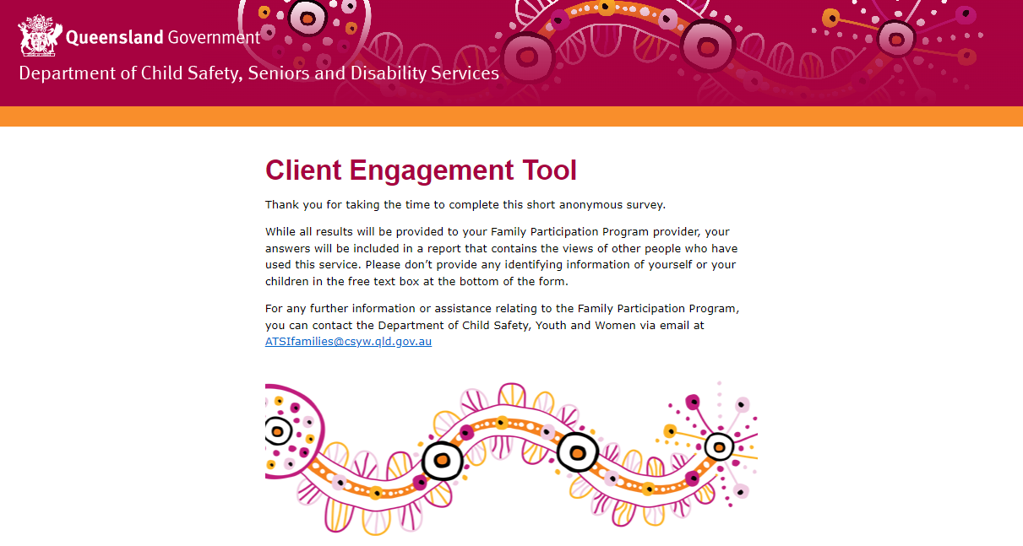

Is the survey confidential?
Yes. The survey is completely confidential and is provided back to the Aboriginal and Torres Strait Islander Families team to collect the responses, either online or by post.
The survey does not ask for any identifying elements in the answer selections offered. The answers provided cannot identify them, the staff, or any persons involved in the FPP process unless this information is mentioned in the free text box.
Please ensure any family member that receives the survey is made aware to not provide their names or any details of the children involved.

What do I tell my FPP participants?
The feedback provided will ensure effective and culturally safe practices are exercised when working with Aboriginal and Torres Strait Islander families. All feedback is important and valued and will ensure that this program is working well in the community and creating successful outcomes for Aboriginal and Torres Strait Islander families.
Participant answers will be provided to the Aboriginal and Torres Strait Islander Families team and the FPP in a report which may highlight:
- the participants involvement in the process
- the outcome of the process
- an opportunity for the participant to share their experience of the program.
It will let the department know how well they were supported during the FPP process.

Contact
For any further information or assistance relating to the Family Participation Program, you can contact the department via email at ATSIfamilies@cyjma.qld.gov.au

Family Participant Program provider links
Aboriginal and Islanders Development and Recreational Women's Association Mount Isa and District Inc.
https://www.dcssds.qld.gov.au/our-work/child-safety/aboriginal-torres-strait-islander-families/family-participation-program/client-engagement-tool?id=471486
Aboriginal and Torres Strait Islander Community Health Service Brisbane Limited (Brisbane)
https://www.dcssds.qld.gov.au/our-work/child-safety/aboriginal-torres-strait-islander-families/family-participation-program/client-engagement-tool?id=471484
Aboriginal and Torres Strait Islander Community Health Service Brisbane Limited (Logan/Beenleigh/Browns Plains)
https://www.dcssds.qld.gov.au/our-work/child-safety/aboriginal-torres-strait-islander-families/family-participation-program/client-engagement-tool?id=471485
Central Queensland Indigenous Development Ltd (Maryborough and Bundaberg)
https://www.dcssds.qld.gov.au/our-work/child-safety/aboriginal-torres-strait-islander-families/family-participation-program/client-engagement-tool?id=471488
Central Queensland Indigenous Development Ltd (Rockhampton Gladstone and Emerald)
https://www.dcssds.qld.gov.au/our-work/child-safety/aboriginal-torres-strait-islander-families/family-participation-program/client-engagement-tool?id=471487
Cherbourg Regional Aboriginal and Islander Community Controlled Health Services Ltd
https://www.dcssds.qld.gov.au/our-work/child-safety/aboriginal-torres-strait-islander-families/family-participation-program/client-engagement-tool?id=471489
Goolburri Aboriginal Health Advancement Company Limited
https://www.dcssds.qld.gov.au/our-work/child-safety/aboriginal-torres-strait-islander-families/family-participation-program/client-engagement-tool?id=471490
Kalwun Development Corporation Limited (Beaudesert)
https://www.dcssds.qld.gov.au/our-work/child-safety/aboriginal-torres-strait-islander-families/family-participation-program/client-engagement-tool?id=797014906
Kalwun Development Corporation Limited (Gold Coast)
https://www.dcssds.qld.gov.au/our-work/child-safety/aboriginal-torres-strait-islander-families/family-participation-program/client-engagement-tool?id=471492
Kambu Aboriginal and Torres Strait Islander Corporation for Health
https://www.dcssds.qld.gov.au/our-work/child-safety/aboriginal-torres-strait-islander-families/family-participation-program/client-engagement-tool?id=471491
Marabisda Inc.
https://www.dcssds.qld.gov.au/our-work/child-safety/aboriginal-torres-strait-islander-families/family-participation-program/client-engagement-tool?id=471493
Mura Kosker Sorority Inc.
https://www.dcssds.qld.gov.au/our-work/child-safety/aboriginal-torres-strait-islander-families/family-participation-program/client-engagement-tool?id=471761
Palm Island Community Company Limited
https://www.dcssds.qld.gov.au/our-work/child-safety/aboriginal-torres-strait-islander-families/family-participation-program/client-engagement-tool?id=471495
REFOCUS Aboriginal and Torres Strait Islander Corporation
https://www.dcssds.qld.gov.au/our-work/child-safety/aboriginal-torres-strait-islander-families/family-participation-program/client-engagement-tool?id=471496
Townsville Aboriginal and Torres Strait Islander Corporation for Health Services
https://www.dcssds.qld.gov.au/our-work/child-safety/aboriginal-torres-strait-islander-families/family-participation-program/client-engagement-tool?id=471497
WuChopperen Health Service Ltd
https://www.dcssds.qld.gov.au/our-work/child-safety/aboriginal-torres-strait-islander-families/family-participation-program/client-engagement-tool?id=471498

