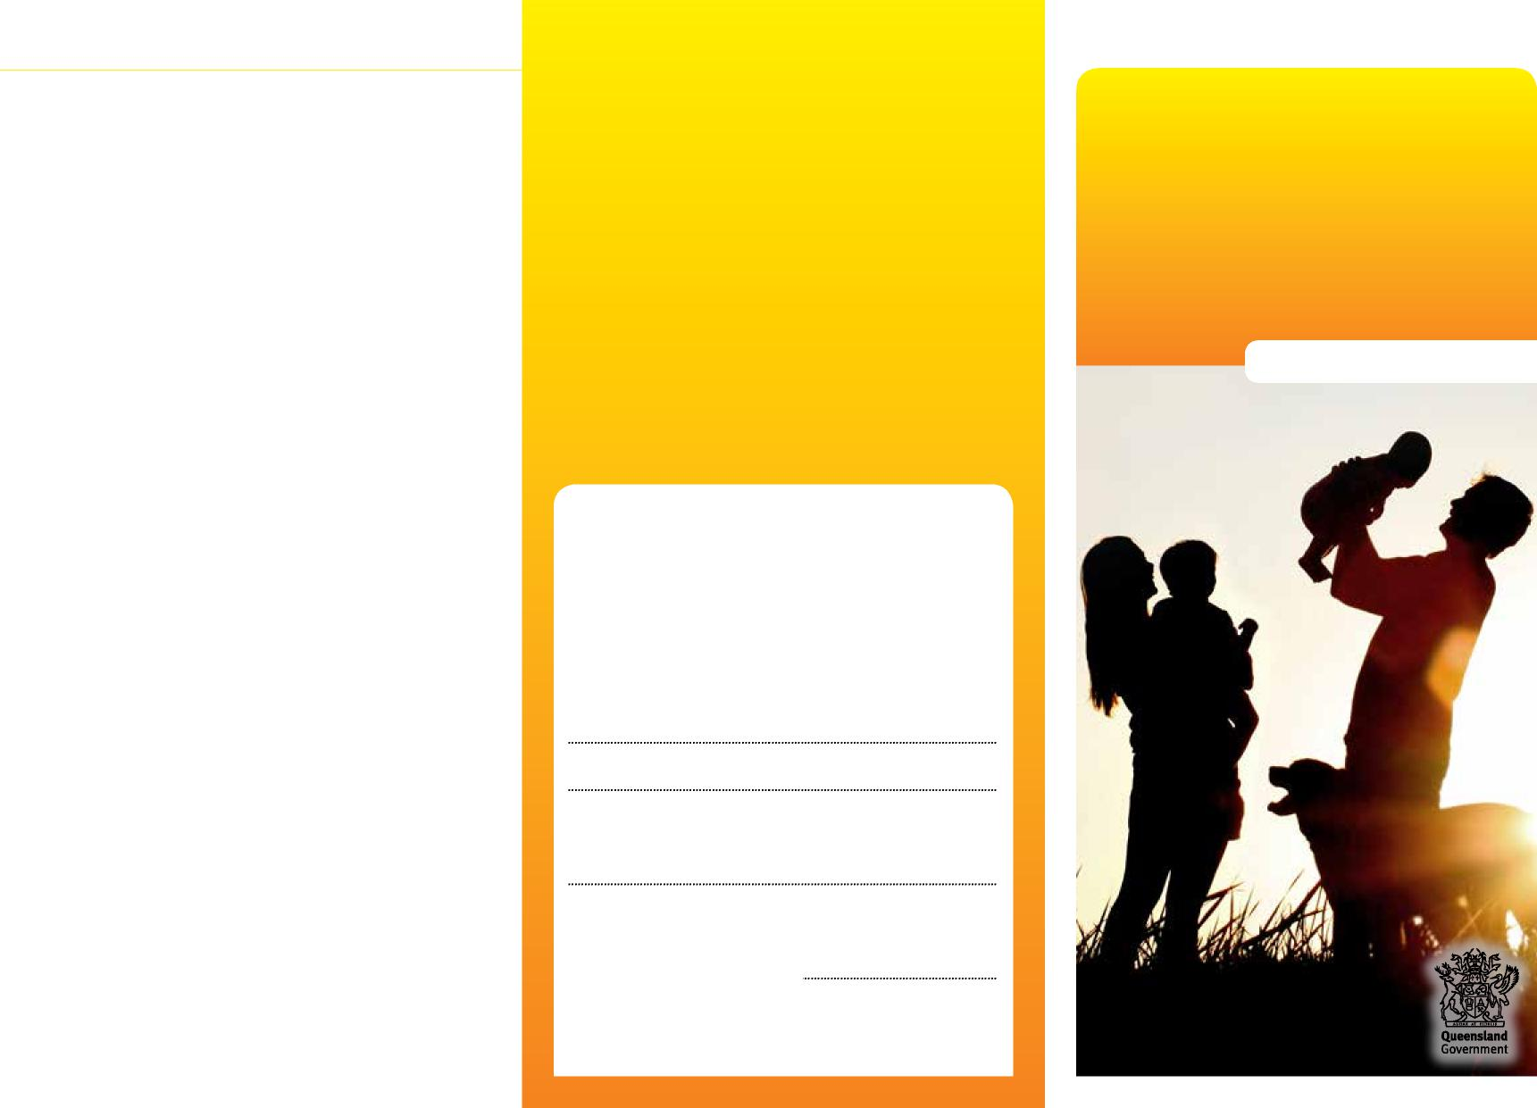
Department of Children, Youth Justice and Multicultural Affairs
Family contact
Is contact reviewed?
Yes, your family contact is usually reviewed as part of your child’s case plan review, or more frequently, if required. You can tell us if there’s any changes you’d like to make with family contact.
Family contact
What if I’m unhappy with the contact arrangements?
Please talk with our Child Safety Officer about your concerns. If this doesn’t help, you can talk to the Senior Team Leader or manager of our child safety service centre.
Information for parents
If you still have concerns and you’re unhappy with the response, you can make a formal complaint to our Complaints Unit by calling 1800 080 464 or email feedback@cyjma.qld.gov.au
More information
If you’re unhappy with how we’ve handled your complaint, you can contact the Queensland Civil Administrative Tribunal to review specific decisions about your contact arrangements by calling 1300 753 228. For more information, go to www.qcat.qld.gov.au
We recognise that this may be a worrying time for you, and we want to work with you to do what’s best for your child. You can talk to us at any time about what’s happening.
Child Safety Officers:
Senior Team Leader:
Child Safety Service Centre:
Phone:
Child Safety After Hours Service Centre: Phone: 3235 9999 or freecall 1800 177 135
0959_MAY2022

Family contact

Children and young people tell us that having contact with their families while they’re in care has a positive impact on how they see themselves and their sense of self-value and identity. It also helps them deal with feelings of grief or loss in not living with their own families.
It’s very important to us that all children in care maintain positive and meaningful contact with their families and community as often as appropriate and where it’s safe to do so.
What is family contact?
Family contact is the time you and your family spend with your child while they’re in care. It includes face-to-face visits, telephone calls, SMS messaging, letters and emails.
Other people in your child’s life, such as siblings, grandparents, aunts and uncles, other family and friends are also encouraged to be part of the family contact arrangements.
The contact is agreed to as part of your child’s case plan and can help you as a family achieve your goals.
Family contact may be supervised or unsupervised. It can take place at our child safety service centre, at your home or at a location such as the library, a park, a community centre or playground.
Having contact with your child allows you to:
- share enjoyable and meaningful time together
- maintain and strengthen your connection with your child
- share good things that have happened
- stay up-to-date with your child’s progress and important activities in their life
- support your child’s learning and development.
Suggestions for positive family contact
- Arrive on time — children sometimes feel quite worried about family contact. If you’re running late, your child might worry that something has happened to you, or that you’re not coming to see them.
- Be drug and alcohol free before and during your contact visit — this will help you to give your full attention to your child’s needs during the contact visit and keep them safe.
- Ask your child about what’s going on in their life — this shows your child that you’re interested in what’s happening (for example, talk to them about who their school friends are, books they enjoy and activities they like to do).
- Praise and encourage your child — they’ll feel appreciated and loved.
- Share some positive things about what’s happening in your life — this will help your child feel better about the situation.
- Agree on some ground rules — family contact will be a more positive experience for you and your child if you take turns to speak and there’s no arguing or yelling at each other.
- Prepare for your contact visit — this means thinking about what you might like to do during your time with your child, such as food to bring with you, things to talk about, toys or games to play.
Family contact should be a positive experience for you and your child. It may be an emotional time for you, but it’s important that you:
- remain calm and manage your feelings
- avoid expressing anger towards your child, their carer or our Child Safety Officers — this may upset your child and affect future contact arrangements
- talk about things appropriate for your child — don’t talk about case work or court work as this is for adults to discuss.
If you feel that family contact isn’t going well for you and your child, our Child Safety Officer can talk with you about changes you can make.
Frequently asked questions
What’s expected of me?
The most important thing is to enjoy your time with
your child and make each visit a positive experience.
What happens if I’m late?
Sometimes you can’t avoid being late, but it’s important that you call our Child Safety Officer to let them know what’s happening. If it’s an ongoing problem, talk to our Child Safety Officer about changes you can make to help you to arrive on time.
What’s the role of our Child Safety Officer?
Our Child Safety Officer will support you and your child
to help make your contact visits positive and safe.
Can I bring food?
Yes, you can bring food for your contact visit. Healthy snacks such as fruit, sandwiches, muesli bars, rice crackers and cheese snacks are always a good idea.

