Family Group Meetings
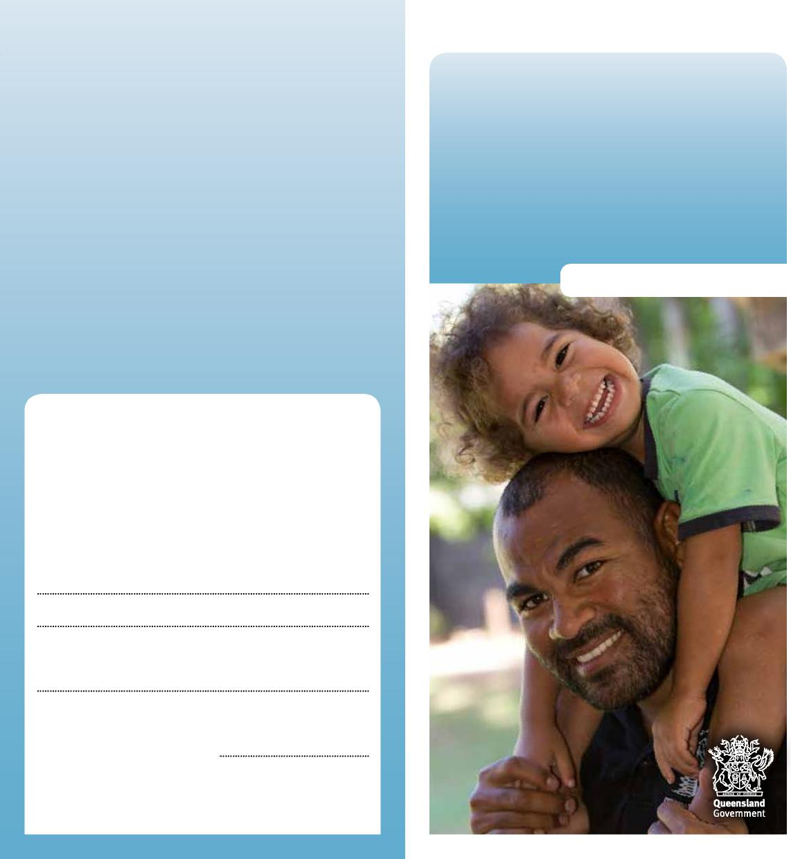
Department of Children, Youth Justice and Multicultural Affairs
Family Group
Meetings
Information for parents
More information
We recognise that this may be a worrying time for you, and we want to work with you to do what’s best for your child. You can talk to us at any time about what’s happening.
Child Safety Officers:
Senior Team Leader:
Child Safety Service Centre:
Phone:
Child Safety After Hours Service Centre: Phone: 3235 9999 or freecall 1800 177 135
0959_JUNE2022
What if I don’t go to the Family Group Meeting?
It’s important that you go to the meeting so you can be involved in the decisions about what your child needs to be safe, happy, healthy and well. If you can’t or don’t want to go to the meeting, you can:
- write down what you want to say and someone can read it out at the meeting
- record a video of yourself to be played at the meeting
- talk to someone attending the meeting so they can share your thoughts and feelings.
What happens after the Family Group Meeting?
You’ll receive a copy of your child’s case plan. Your child’s Child Safety Officer will support you and your child to make the changes agreed in the case plan.
You can call your child’s Child Safety Officer at any time about the case plan or if you have any concerns about it.
The case plan will be reviewed within 6 months of the Family Group Meeting. If the plan isn’t working, another Family Group Meeting may be organised.

All children have the right to be loved, nurtured and protected.
Family Group Meetings
If we’ve decided that your child is in need of protection, we’ll organise a Family Group Meeting to make a plan so we can work with you and your family to keep your child safe and cared for.
What is a Family Group Meeting?
A Family Group Meeting brings together the most important people in your child’s life. It’s organised by a convenor who facilitates the meeting.
Everyone at the meeting will have a chance to talk about what’s working well, what they’re worried about and what changes can be made for your child to be safe.
People who may attend the Family Group Meeting include:
- your child, if they’re old enough to participate, and if appropriate
- other family members or people who are close to your child
- family members or friends who can support you
- your legal representative (if you have one)
- a member of your child’s community if your child is Aboriginal or Torres Strait Islander or from a different cultural background
- our Child Safety Officer or Senior Team Leader
- your child’s teacher
- a family support worker or domestic violence support worker.
What happens before the Family Group Meeting?
We’ll talk to you about our concerns for your child’s safety. We want to support you and help you protect and care for your child.
To prepare for the meeting, the convenor will ask you to think about what’s happening in your family, what’s working well and what isn’t. These are some of the things that will be discussed at the meeting.
You may want to write a letter or ask someone to help you explain your thoughts and feelings.
You can think about who you’d like to invite to the meeting. The people you invite can support you and help you make decisions about keeping your child safe. You’ll be asked if there are any special family customs or traditions you’d like to be included in the meeting.
The convenor will organise with you the time and place for the meeting, and help you understand what will happen at the meeting.
What happens at the Family Group Meeting?
At the meeting, we’ll talk about why your child is in need of protection, what’s happened to help you and your child, what’s worked well and what we’re worried about.
Everyone at the meeting will be asked to share their concerns and hopes for the future of your family.
During the meeting, you and your family will have some time alone to talk about the concerns and what changes you can make for things to be better. It’s important that you take as much time as you need to make the right decisions for your child and family.
A case plan will be put together about what needs to happen for your child to be cared for.
Typically, the plan will set out:
- your child’s needs
- the needs of your family
- what will be done to help your child
- what will be done to help your family
- who will help your child and your family
- when your child and family will receive this help.

