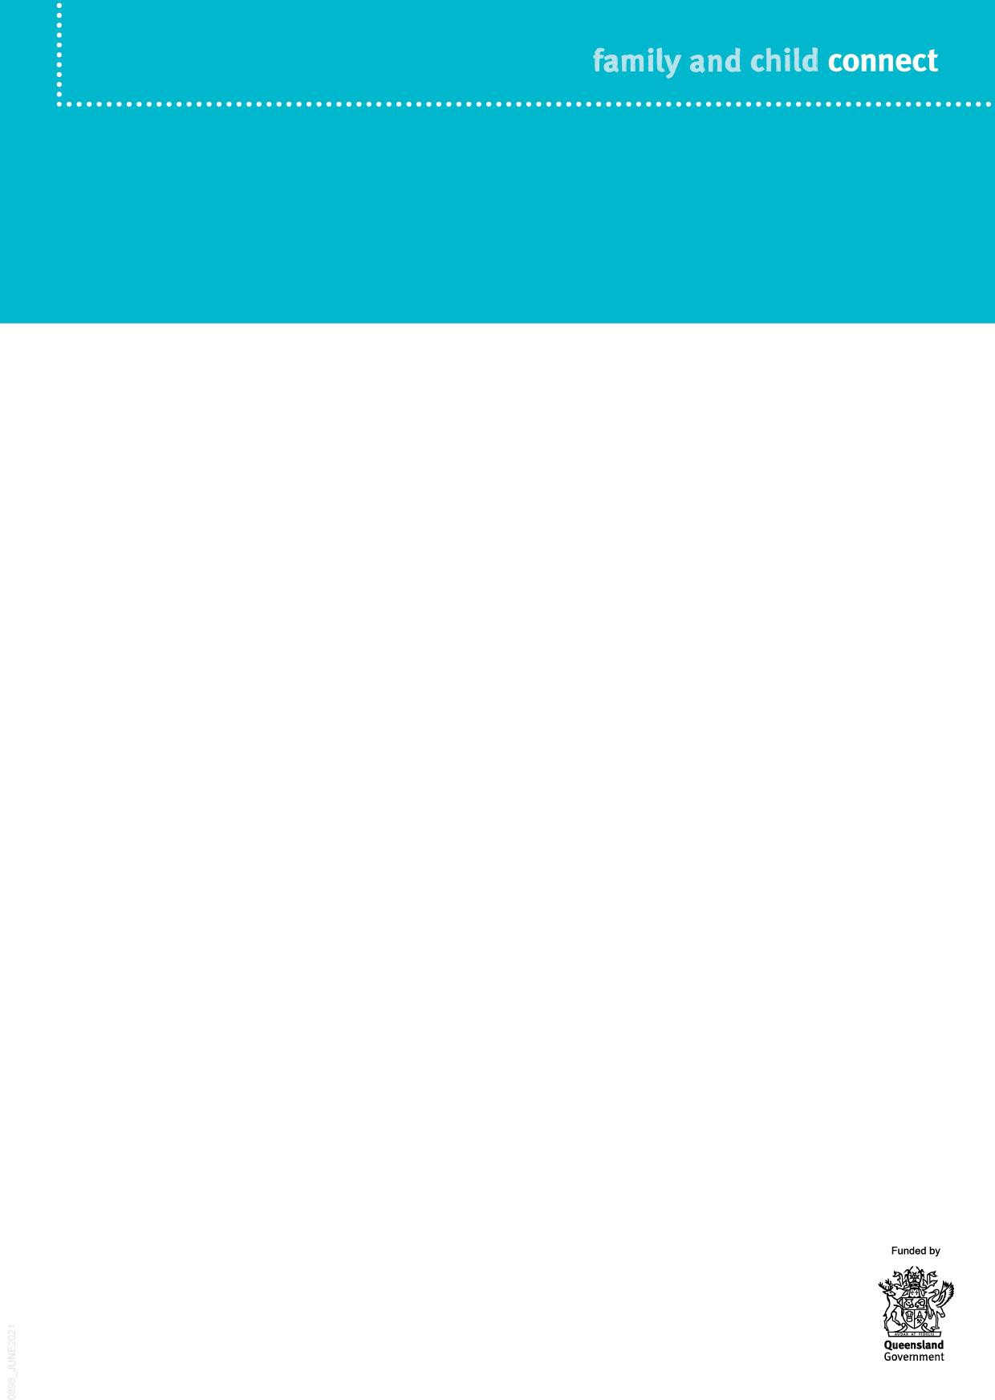

**Principal Child Protection Practitioner**

**Family and Child Connect is an easily accessible referral point for professionals working with families who may need support.**

A Principal Child Protection Practitioner is an experienced practitioner employed by the Department of Child Safety, Seniors and Disability Services (the department), supporting Family and Child Connect, as well as Intensive Family Support and Aboriginal and Torres Strait Islander Family Wellbeing Services.

The Principal Child Protection Practitioner works collaboratively with local government and non-government service providers to support the earlier and more effective intervention with children and families who have been referred for help. The Principal Child Protection Practitioner provides consultancy and advice on child protection matters, as well as education on statutory child protection processes and responsibilities.

Responsibilities

The Principal Child Protection Practitioner is responsible for:

Torres Strait Islander Family Wellbeing Services.

Building the child protection expertise of these services and broader intensive secondary service providers through training and professional development initiatives.

Providing training and education (and/or training and education resources) to schools, early childhood education providers, police and health professionals, on reporting/referral behaviour to support adherence to the Child Protection Guide.

Performing a cross sector co-ordination role, establishing and maintaining effective working relationships with Family and Child Connect, Intensive Family Support and Aboriginal and Torres Strait Islander Family Wellbeing Services, broader intensive secondary services, and other government and non-government agencies to promote better collaboration between services and with the department.

Participating in meetings with these services, broader intensive secondary services, and other government and non-government organisations including the LLA, as a representative of the department.

•

•

•

•

•

Providing expert generic child protection advice and case consultation services to Family and Child Connect, Intensive Family Support and Aboriginal and

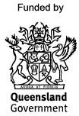

* Beenleigh/Bayside (provided by The Benevolent Society)
* Brisbane (provided by Kurbingui Youth & Family Development and Mercy Community)
* Browns Plains/Beaudesert (provided by Mercy Community)
* Cairns (provided by Act for Kids, Mareeba Community Centre and Community Support Centre Innisfail)
* Charleville (provided by Lifeline Darling Downs & South West QLD)
* Gold Coast (provided by Act for Kids)
* Ipswich (provided by Kummara)
* Logan (provided by The Benevolent Society)
* Mackay (provided by Act for Kids)
* Moreton Bay (provided by Mercy Community)
* Mount Isa (provided by Save the Children)
* Rockhampton/Gladstone/Emerald (provided by UnitingCare Community)
* Roma (provided by Lifeline Darling Downs & South West QLD)
* Sunshine Coast/Gympie (provided by Act for Kids)
* Toowoomba (provided by Mercy Community)
* Townsville (provided by Mercy Community)
* Wide Bay and North Burnett (provided by Churches of Christ Care)

Family and Child Connect service locations

Family and Child Connect operate in the following catchments:

Further information

For more information about Family and Child Connect, go to the website: [www.familychildconnect.org.au](http://www.familychildconnect.org.au/)